LREC 2023 MANDATORY COURSE
Instructor Manual

TRAIN THE TRAINER

This course will consist of four modules:

- Contract Forms Review
- FEMA Flood Insurance
- Advertising
- Misrepresentation

Developed by: Brent Lancaster

ABR, CDEI, GRI, SRS, e-PRO

A Louisiana Real Estate Commission Publication

Table of Contents

Course Syllabus…………………………..……..…………….…..3 Learning Objectives……………………….……..………….…..6 Timed Outline…………………………….…………………….…..7 Part One: Contract Forms Review……….…..……..……9 Part Two: Flood Insurance………………………………….23 Part Three: Advertising………………………….……………47 Part Four: Misrepresentation………………………….….53 Appendix..……………………….……….…………………….…..56

Course Syllabus
Instructors: A copy of the syllabus and the course material must be provided for each student in each of your classes. You must modify to include your personal qualifications, background, and vendor information.

Instructor Qualifications and Background
Brent Lancaster, ABR, GRI, SRS, e-PRO, combines his love of the business of real estate with his passion for education. He believes in delivering tools agents can use immediately to improve the quality and efficiency of their business.

He is broker/owner of his own real estate company, Brent Lancaster and Associates, LLC, and also President/CEO of one of the nation’s oldest real estate schools – Bob Brooks School of Real Estate.

Brent lives in Baton Rouge, Louisiana with his wife of20 years Laura and his two children Leyton (11), and Nate (8).

Course Description
The course focuses on four main topics: (1) an overview of LREC mandated forms and updates; (2) Review Flood Insurance coverage, risk rating 2.0 and the federal obtain and maintain requirement;
- Review the LREC advertising guidelines and the fines associated and (4) Common forms of misrepresentation by licensees, sellers and buyers.

Course Goal
Real estate licensees will review the recent changes to the mandatory forms and institute best practices when presenting and explaining them to clients/customers. Licensee will understand the major changes to FEMA’s flood rating policies and how that will affect properties that require flood insurance. In addition, licensees will review the LREC advertising guidelines checklist and the specific laws referenced. Finally, licensees will learn the most common claims regarding licensee misrepresentation and develop best practices on how to avoid them.

Course Material
All materials needed for this course are included in this manual. The materials include:

  - Course Syllabus
  - Timed Course Outline
  - Course Content Material (Instructor and Student Manuals)
  - PowerPoint Presentation
  - Digital versions of all course materials can be found on the LREC website under the Current Licensees Tab, then select Vendor from the side bar, then click on Mandatory Course Material page or by visiting this link: https://lrec.gov/current-licensees/vendor/mandatory- course-materials/

Course Completion Requirements
Students must be present for the full four (4) hours if a live presentation. Students taking Internet based presentations must complete all quizzes and exams with a score of at least 70%.

Vendor Policies and Regulations:
Prerequisites: There are no educational prerequisites for this course.

Registration: Any attempt to take this course under an assumed identity will forfeit your right to receive a certificate of completion and may result in sanctions by the Louisiana Real Estate Commission.

Attendance: Students attending a live presentation must sign in before the course and sign out after the course; this course is a four (4) hour presentation, and 100% attendance is required to receive credit for completion. Credit shall not be granted for partial attendance. No exceptions!

Tardiness/Absences: Credit shall not be granted for late arrivals, excessive absences, and/or early departures. Students are not allowed to make up missed portions of a course.

Course Participation: Instructors may not, in any venue, answer questions of a personal or legal nature, and students should not interpret any information received from instructors or course content as being legal advice.

Classroom Rules of Conduct: To provide an atmosphere conducive to learning, students must turn off all electronic devices prior to the start of class. Newspapers, books, magazines, or any other reading materials are not permitted during class presentation. Violations may result in loss of continuing education credit.

ADA Compliance
Upon request, reasonable accommodations will be provided to individuals with a documented disability to assure that an equal opportunity to participate in this course is provided. For further information, contact our office at (555) 555-5555.

Vendor Contact Information: (insert your contact information here)

Phone: (555) 555·5555, weekdays between 8:30 a.m. and 5 p.m. central time.

- mail: anyschool@yourschool.com

Address: any town USA

Disclaimer
These materials are to be used for informational purposes and should not be construed as specific legal advice, nor are they designed to cover every aspect of a legal situation or every factual circumstance that may arise regarding the subject matter included.

This publication is for reference purposes only and readers and responsible for contacting their own attorneys or other professional advisors for legal or contract advice. The comments provided herein solely represent the opinions of the authors and are not a guarantee of interpretation of the law or contracts by any court or by the Louisiana Real Estate Commission.

Learning Objectives

Review the recent changes to the mandatory forms and institute best practices when presenting and explaining them to clients/customers.

Grasp agency law and the agency disclosure forms. Understand the salesperson’s role in establishing and maintaining the agency relationship.

Understand the major changes to FEMA’s flood rating policies and how that will affect properties that require flood insurance.

Gain knowledge of the federal obtain and maintain requirements and when it should be given to buyers.

Review the LREC advertising guidelines checklist and the specific laws referenced. Discuss the most common advertising violations and how to best avoid them.
List the most common claims regarding licensee misrepresentation and develop best practices on how to avoid them.

Timed Outline

Contract forms review (50 minutes)
    - Residential Agreement to Buy/Sell
    - Property Condition Disclosure
    - Agency Disclosure/Dual Agency Disclosure 10-minute break

FEMA Flood Insurance (50 minutes)

    - Overview of FEMA Flood Insurance Policy
    - Flooding and the Property Condition Disclosure
    - Risk Rating 2.0
    - Obtain and Maintain Federal Requirement
    - Best practices in listing a flooded home
    - Best practices working with buyers purchasing a previously flooded home 10-minute break

Advertising/Changes to Renewal Period (50 minutes)
  - Advertising guidelines checklist
  - Review the most common violations regarding advertising 10-minute break

Misrepresentation (50 minutes)
  - Common E&O claims regarding agent misrepresentation
  - Home Inspections, Disclosures and Misrepresentations
  - Misrepresentation by listing agents
  - Misrepresentation by buyer’s agent
  - Misrepresentation and teams
  - Case studies 10-minute break

PART ONE: CONTRACT FORMS REVIEW

Residential Agreement to Buy and Sell
Stress the need to use the prescribed form. May want to discuss new construction and builders who have their own forms.

Guidelines regarding the Mandatory Use of the Residential Agreement to Buy/Sell

§3900. Purchase Agreement Forms
A. The purchase agreement form used by licensees representing the buyer or seller in a residential real estate transaction shall be the Residential Agreement to Buy or Sell, or any successor thereof, prescribed by the Louisiana Real Estate Commission.

Additional Guidelines:
- Licensee may not alter the prescribed form
- However, a Licensee may add addendums or amendments to the form.
- No strike-outs or modifications of any kind can be made to the form.
- Use “Additional Terms and Conditions” found at lines 301-307 of the Purchase Agreement.

Presentation of Offers and Counteroffers

Louisiana Real Estate Rules and Regulations – Chapter 39

§3905 B 1.

It shall be the responsibility of the designated agent who transmits or delivers the written offer or counter offer to document the date, time of day, place, and method of delivery.
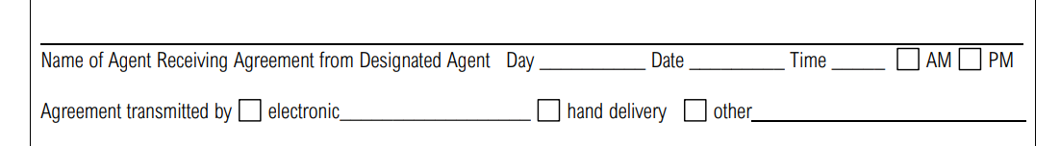
These parts of the contract are required to be completed. Leaving them blank is a violation of LREC rules and regulations.

§3905 A.

Designated agents receiving written offers or counter offers in transactions shall annotate the offers or counter offers to indicate the time of day and date the offers or counter offers were received.

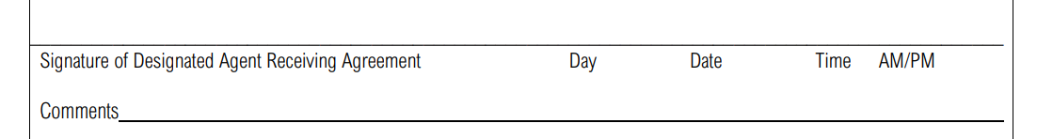
Give examples of disagreements between buyers and
sellers regarding items that one party felt should have stayed with the property.

Property Description Section

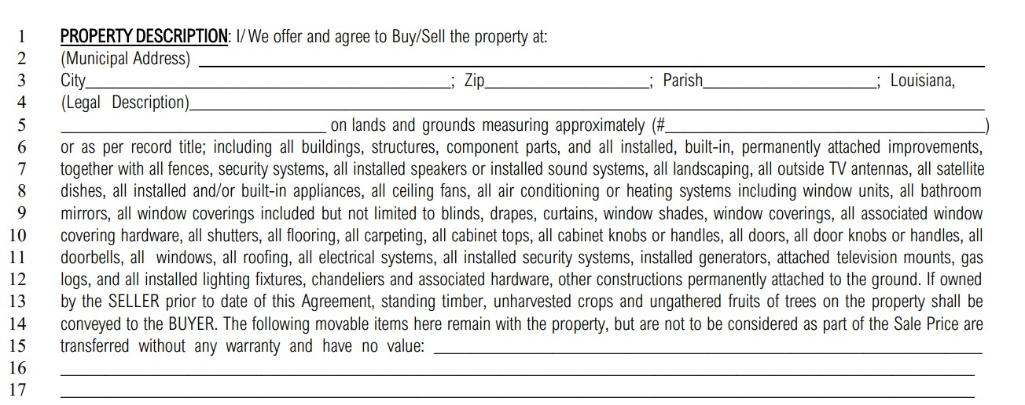

How do I know what is automatically included with the home?

Component Parts
Louisiana Civil Code art. 466, divides component parts of a building into two categories of component parts:

- Things that are attached to a building and that, according to prevailing usages, serve to complete a building of the same general type, without regard to its specific use, are its component parts. Component parts of this kind may include doors, shutters, gutters, and cabinetry, as well as plumbing, heating, cooling, electrical, and similar systems.

- Other things are component parts of a building or other construction if they are attached to such a degree that they cannot be removed without substantial damage to themselves or to the building or other construction

Best Practice:
  - It must be written in the contract.
  - If it is reserved in the REALTOR® Remarks is it not automatically reserved.
  - If there is a picture of it in MLS is it not automatically included.
  - If it is questionable, ask your client and add it to the contract.

Finance Section
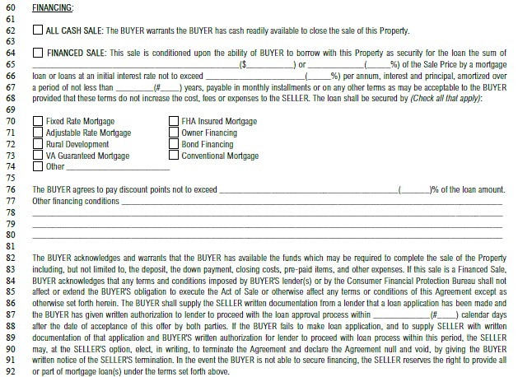This section provides the financial terms of the sales if the property is to be financed by the Buyer. It provides blanks for financing terms and also the type of loan to be obtained by the buyer. The buyer agrees to make good faith financing application to the lender. This includes applying for the loan and authorizing an intent to proceed with the loan. The buyer shall supply the seller this written notice within the specified number of days on line 87. Failure by the buyer to apply for the loan and submit the required notices allows the seller to terminate the agreement.

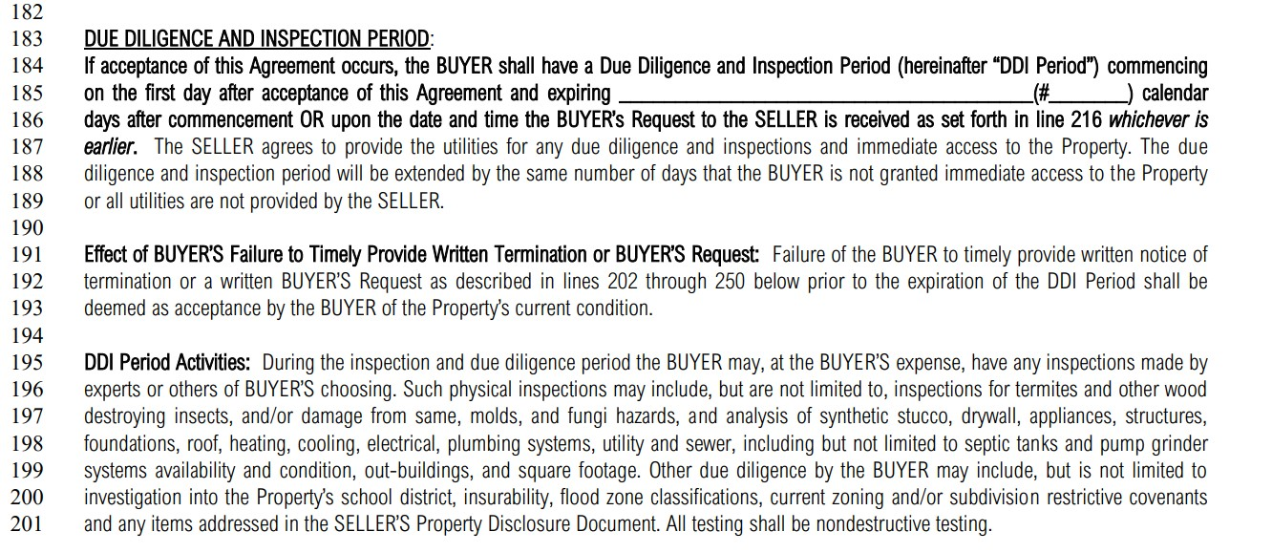Inspection Section
This section was a major update in 2022. Review with students to make sure they understand the inspection timeline.

The due diligence and inspection period has gone through the most significant change recently the major change. In reading lines 184 through 187, the buyers are only allowed “one bite at the apple” and will only be able to submit only submit one request for repairs. Once that request is sent the inspection period ends.

For example, 10 calendar day was input on line 185. The licensee representing the buyer received a home inspection on day three and the submitted the request for repairs was submitted to the listing agent on day four. That means the inspection period would end on day four. The 72-hour review period would begin as set forth beginning on line 202

The inspection period beginning on lines 202 has been spaced out and modified to clear up confusion licensees were having in terms of there not being any end dates. Looking at line 206 to 209 the buyer certainly has the ability to terminate the agreement during the number of days within the inspection period. The major change is on line 216, option two, letter A. “The buyer presents a single complete written list” That means the buyer only gets “one bite at the apple.” Buyers agents need to formulate one single complete list and they get one opportunity to submit that particular list.

The other changes to the inspection and due diligence sections address the failure to respond by either party. The LREC has created a flow chart that helps visualize the different scenarios in the second half of the inspection section of the residential agreement to buy and sell.

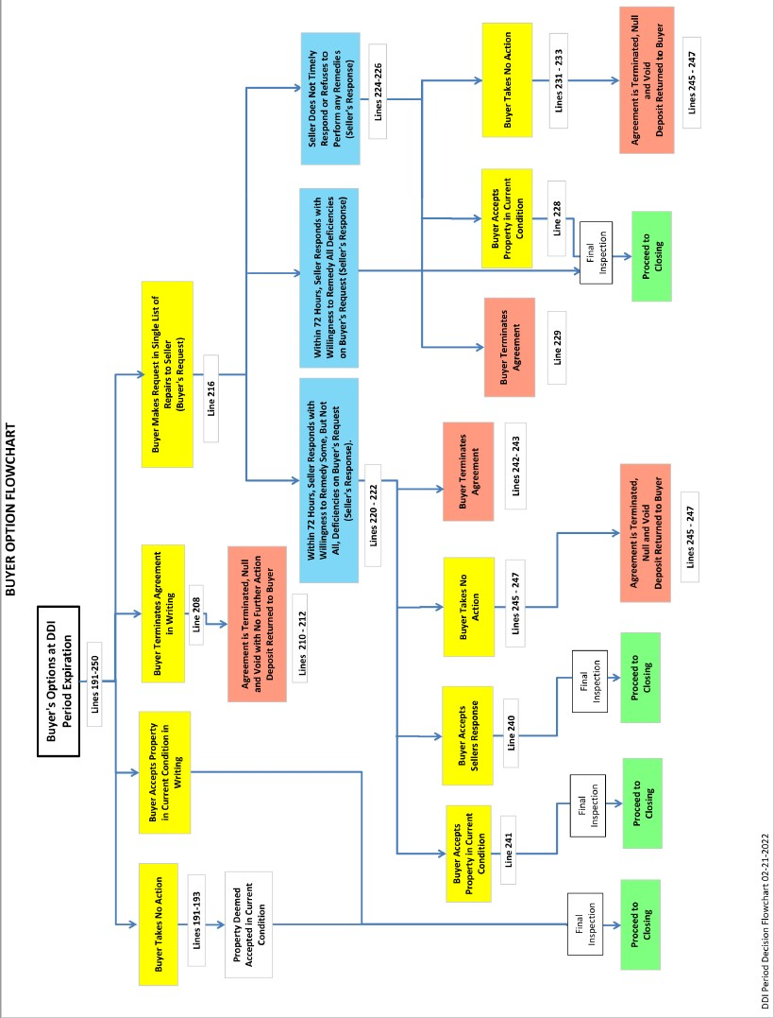

Presenting Offers

§3901. Timely Presentation of Offers and Counteroffers
- All written offers and counter offers for the purchase of real estate shall be presented to all buyers and/or sellers for their consideration and decision immediately, without delay.

This is not to
be left blank.
LREC rules an regulations
require this to be completed.
d
Licensee must submit all offers to sellers and buyers immediately. Failure to complete this section of the Residential Agreement to Buy or Sell is cause for a fine from the LREC.

§3901. C.
The licensee who presents an offer or counteroffer in a real estate transaction shall ensure that the time of day and date the offer or counteroffer was accepted, rejected or countered are included in the document.

§ 3907. A.
All written offers and counteroffers presented to a seller and/or buyer and not accepted shall be clearly marked as rejected and signed by the seller and/or buyer.

In any circumstance in which a seller and/or buyer refuses to sign a rejected offer or counteroffer, the licensee making the presentation of the offer or counteroffer shall annotate this fact indicating the time of day and date of the rejection of the offer or counteroffer by the seller and/or buyer.

A copy of the rejected offer or counter offer signed by the seller and/or buyer, or a copy of the rejected offer or counter offer bearing the annotation of the licensee, shall be provided to the buyer and/or seller, and the rejected offer or counter offer shall be returned to the prospective buyer and/or seller within five days after the signature or annotation is affixed to the document.

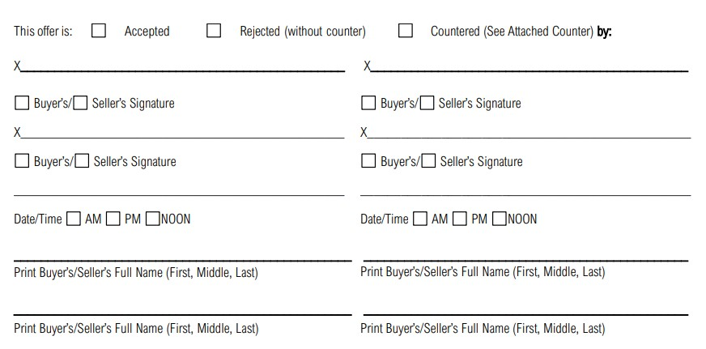
All rejecte offers are required b rules and regulation be returne the offeror

d y
s to d to

within 5 days.
This section is required to be completed. Failure to do so is subject to a fine by the LREC. The offer must be accepted, rejected or countered. Most violations occur when the offer is rejected and this section is left blank. The LREC rule states your client is obligated to sign if rejected. If they refuse to sign, the licensee is then obligated to sign and return to the other party within 5 days.

Broker Retention of Records

All offers and counteroffers shall be retained by the broker for five years.

§1449. E. (1)(b)
E.(1) Partnerships, limited liability companies, associations, corporations, or other legal entities, foreign or domestic, and real estate brokers shall retain the following records, readily available and properly indexed, for a period of five years (b) Copies of all documents that pertain in any way to real estate transactions wherein the partnership, limited liability company, association, corporation, or other legal entity, foreign or domestic, the designated qualifying broker, or licensees sponsored by same, have appeared in a licensing capacity

Specific Changes to the Residential Agreement to Buy and Sell

Changes to the Residential Agreement to Buy and Sell from the previous version can be found here: https://lrec.gov/wp-content/uploads/2021/11/Redline-Buy-Sell-Agreement-v.-2-11-23-2021.pdf

Property Disclosure Document
The property disclosure document underwent an update in 2021. The updated Property Condition Document is required to be used for properties listed after 1/1/2022.

Below is a summary of the changes:

Increased Page Length
Increased font size caused the document to increase from seven to eleven pages in length.

Updated the first two pages to make them easier to understand.
The first two pages are considered the exemption pages but should be filled out by all sellers. If exempt, seller will now check the box located next to the appropriate number(s) if they are exempt. If sellers are not exempt, they are to check the box located next to number 15.

Added additional signature lines and initial lines for both buyer and seller.
The signature lies on page two of the exemption section as well as the last page of the document increase from two lines per buyer/seller to four. In addition, the spaces for initials on each page increased from two to four as well.

Rearranged flood questions into a “Flood” section.
There were questions regarding flood that were asked in various places throughout previous version for the Property Disclosure Document. Those questions have been consolidated into a specific section - Section 6: Flood, Flood Assistance, and Flood Insurance.

Residential Property Disclosure Form (effective 01-01-23)

Per Act No. 581 of the 2022 Regular Session of the Legislature, the Residential Property Disclosure Form has been updated to include an additional question (No. 45) regarding restrictive covenants and/or building restrictions of the subject property. This form is available for use now and will become mandatory on January 1, 2023.

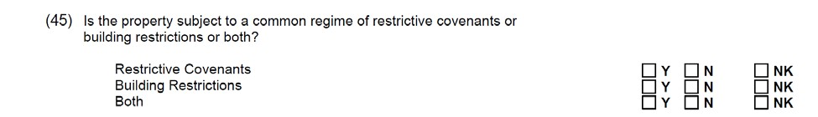
A comparison between the previous version to the current version can be found here: https://lrec.gov/wp-content/uploads/2021/11/PDD-Final-RedLine-11-21.pdf

Agency Disclosure
Agency disclosure is a topic that has not been covered in a few years. You may want to spend extra time here.

What is Agency?
Agency is a relationship in which a real estate broker or licensee represents a client by the client’s consent, whether expressed or implied, in an immovable property transaction. An agency relationship is formed when a real estate licensee works for a buyer/seller in their best interest and represents them.
Agency relationships can be formed with buyers/sellers and lessors/lessees.

Presentation of Agency Disclosure
The agency disclosure must be presented at first substantive contact.

What is substantive contact?
That point in any conversation where confidential information is solicited or received. This includes any specific financial qualifications of the consumer or the motives or objectives in which the consumer may divulge any confidential, personal, or financial information, which, if disclosed to the other party to the transaction, could harm the party’s bargaining position. This includes any electronic contact, electronic mail, or any other form of electronic transmission
Ask students:
When was the last time you read what was in these forms?
What questions do you get from your clients?
Rules and Regulations Chapter 37 - §3703. D.
  - Provide to prospective sellers/lessors and buyers/lessees.
  - At the time when substantive contact is made.
  - Ensure that the recipient signs and dates the pamphlet or form.
  - The licensee shall sign as a witness to the signature of the recipient.
  - The licensee shall retain the signed pamphlet or a copy of the form for five years.

There are two forms that are acceptable – The Agency Disclosure Informational Pamphlet or the Agency Disclosure Form. They can be found here:
Agency Disclosure Form: https://lrec.gov/wp-content/uploads/2021/06/Agency-Disclosure-Form.pdf
Agency Disclosure Informational Pamphlet: https://lrec.gov/wp-content/uploads/2018/08/Agency- Disclosure-Pamphlet.pdf

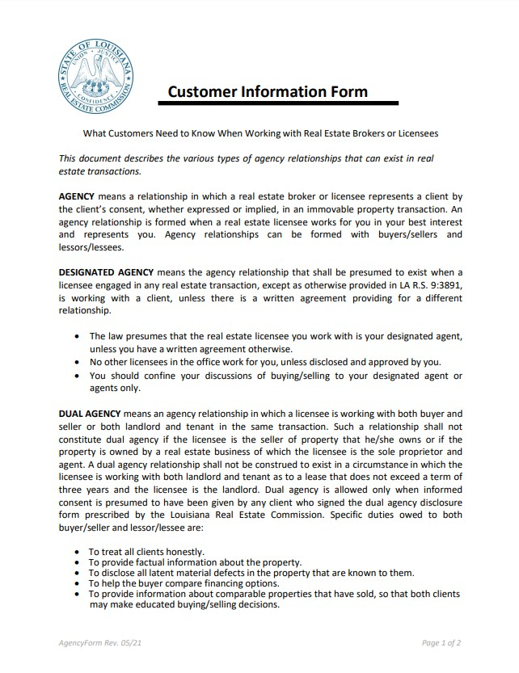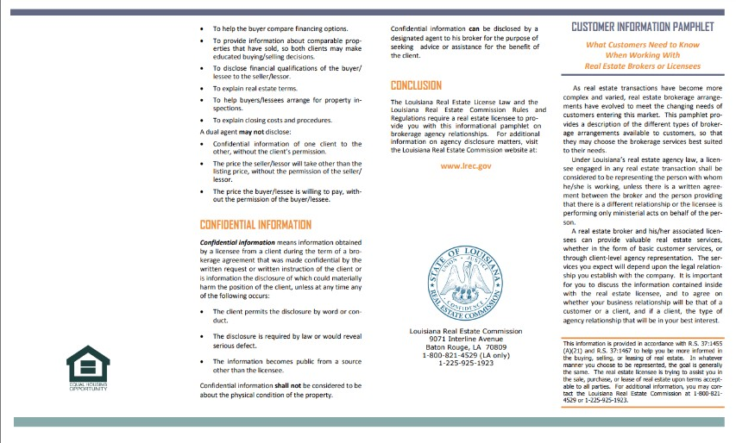

Agency Terms and Concepts
Customer - a person who is not being represented by a licensee but for whom the licensee is performing ministerial acts.
Client - one who engages the professional advice and services of a licensee as his agent.

Designated Agency - the agency relationship that shall be presumed to exist when a licensee engaged in any real estate transaction, except ministerial acts, is working with a client, unless there is a written agreement providing for a different relationship.
 | Stress that this is
Excerpt from the Agency Disclosure Form | Louisiana’s default agency position.
The law presumes that the real estate licensee you work with is your designated agent, unless you have a written agreement otherwise.
No other licensees in the office work for you, unless disclosed and approved by you.
You should confine your discussions of buying/selling to your designated agent or agents only.
Ministerial Acts - Those acts that a licensee may perform for a person that are informative in nature. Examples of these acts include but are not limited to:
    - Responding to phone inquiries by persons as to the availability and pricing of brokerage services.
    - Responding to phone inquiries from a person concerning the price or location of property.
    - Conducting an open house and responding to questions about the property from a person.
    - Setting an appointment to view property.
    - Responding to questions from persons walking into a licensee's office concerning brokerage services offered or particular properties.
    - Accompanying an appraiser, inspector, contractor, or similar third party on a visit to a property.
    - Describing a property or the property's condition in response to a person's inquiry.
    - Completing business or factual information for a person represented by another licensee on an offer or contract to purchase.
    - Showing a person through a property being sold by an owner on his or her own behalf.
    - Referral to another broker or service provider.

Confidential Information - information obtained by a licensee from a client during the term of a brokerage agreement that was made confidential by the written request or written instruction of the client or is information the disclosure of which could materially harm the position of the client, unless at any time any of the following occur:
      - The client permits the disclosure by word or conduct.
      - The disclosure is required by law or would reveal serious defect.
      - The information became public from a source other than the licensee.

Compensation vs. Representation

§ 3896. The payment or promise of payment of compensation to a broker is not determinative of whether an agency relationship has been created.
Compensation and representation are not the same thing.

Dual Agency

Dual agency is an agency relationship in which a licensee is working with both buyer and seller or both landlord and tenant in the same transaction. Such a relationship shall not constitute dual agency if the licensee is the seller of property that he/she owns or if the property is owned by a real estate business of which the licensee is the sole proprietor and agent. A dual agency relationship shall not be construed to exist in a circumstance in which the licensee is working with both landlord and tenant as to a lease that does not exceed a term of three years and the licensee is the landlord. Dual agency is allowed only when informed consent is presumed to have been given by any client who signed the dual agency disclosure form prescribed by the Louisiana Real Estate Commission. Specific duties owed to both buyer/seller and lessor/lessee are:
- To treat all clients honestly.
- To provide factual information about the property.
- To disclose all latent material defects in the property that are known to them.
- To help the buyer compare financing options.
- To provide information about comparable properties that have sold, so that both clients may make educated buying/selling decisions.20
- To disclose financial qualifications to the buyer/lessee to the seller/lessor.
- To explain real estate terms.
- To help buyers/lessees arrange for property inspections
- To explain closing costs and procedures.
Dual agency Disclosure must be given before acting as a Dual agent.

Can I be a dual agent on a property I own or intend to purchase?
No. According to number nine 9 of the 36 ways to lose your license, a relationship “shall not constitute dual agency if the licensee is the seller or lessor of property that he owns or if the property is owned by a real estate business of which the licensee is the sole proprietor and agent and the same is disclosed to the buyer or tenant.”

Exceptions to dual agency disclosure
“A dual agency relationship shall not be construed to exist in a circumstance in which the licensee is working with both landlord and tenant as to a lease which does not exceed a term of three years and the licensee is the landlord.” R.S. 9:3891, R.S. 9:3897

Dual Agency Disclosure
The Dual Agency Disclosure form can be found here: https://lrec.gov/wp- content/uploads/2021/06/Agency-Disclosure-Dual-Agent.pdf

PART TWO: FLOOD INSURANCE

Introduction to Flood Insurance
Floods can cause significant damage to property. A flood brings water, mud, contaminants and high pressure into a building, and can result in a building’s total destruction. A flood can destroy a building’s foundations and reshape the land on which a building rests, causing structural damage. The devastation floods can cause motivated Congress to act in 1968 to develop a National Flood Insurance Program.

Limitations of Private Insurance
Homeowners and Commercial Property insurance excludes coverage for damage due to flooding. For example, the following exclusion is found in the Homeowner’s form:
Flood insurance exists because it is excluded in property insurance policies.

Exclusions – Water Damage
Water damage means:
- flood, surface water, waves, tidal water, overflow of a body of water, or spray from any of these, whether or not driven by wind;
- water which backs up through sewers or drains, or which overflows through a sump; or
- water below the surface of the ground, including water which exerts pressure on or seeps or leaks through a building, sidewalk, driveway, foundation, swimming pool or other structure.

The Commercial Property Form excludes from its causes of loss water, including flooding, mudslide, water under the ground that seeps through floors, etc.

Insurability
The reason flooding is excluded from these coverages is because in order for a risk to be insurable, it must not occur to a large number of people simultaneously, or there will not be sufficient premiums collected to pay for the loss. This is also one of the reasons war is an exclusion from property policies. If a flood or a war occurs, everyone in an area is affected, and an insurer would not be able to cover the losses.

Besides the difficulty of insuring for a risk that happens to many people simultaneously, another reason private flood insurance is not available is because some areas are more at risk of flooding, some areas are more susceptible to flooding than others. People living along a stretch of the Mississippi that has a history of flooding are more at risk from flood damage than those living in the middle of New York City, for example. If private flood insurance were available, the people living along the Mississippi would all want to buy it and no one living in the middle of New York City would buy it. Therefore, only high-risk insureds would purchase the coverage, causing premiums to be unaffordable for most. This condition is known as “adverse selection.”

Because of these factors, private insurers have been unwilling to offer flood coverage. Due to mounting costs to citizens due to flooding, Congress voted to create a federal flood insurance program in 1968, under the National Flood Insurance Act.

National Flood Insurance Program
Over 95% of policies are NFIP policies.

Under the National Flood Insurance Program (NFIP), individuals and businesses are able to purchase flood insurance at rates subsidized by the federal government. The program is administered by the Federal Emergency Management Agency (FEMA).

FEMA determines the risk of flood in various locations across the United States. The areas are mapped and assigned a flood risk category. The risk of flood is based on many factors, including past history of flooding and hydraulic and hydrologic studies. In certain risk categories assigned by FEMA, known as Special Flood Hazard Areas, homeowners and businesses are required to purchase flood insurance if they use federally guaranteed financing for their buildings and property. Many private lenders also require flood insurance as a condition of a loan to businesses and homeowners in the higher risk flood zones, as well.

Community Participation
In order to purchase flood insurance, a community must agree to participate in the National Flood Insurance Program. Any community may participate. The community must then comply with land use and flood control measures. When a community first agrees to participate in the program, limited amounts of flood insurance coverage may be purchased. Once the community meets the program’s flood control standards and a detailed flood risk study is completed, higher limits of insurance are available.

Special Flood Hazard Areas
As mentioned, those homeowners or businesses located in a Special Flood Hazard Area, may be required to purchase flood insurance if they receive federally guaranteed financing, such as through the VA or through FHA. A Special Flood Hazard Area is land within a community in a floodplain that is most likely to be subject to severe flooding.

Private Insurers
Most flood insurance is purchased directly through the NFIP. All Property and Casualty agents are eligible to write directly with the NFIP. However, private insurers are offered incentives to provide flood insurance as well. The federal government reinsures the policies issued by private insurers for 100% of the loss. The private insurers sell the policies, collect premiums, process claims and provide servicing, and keep and invest a portion of the premiums for these activities.

National Flood Insurance Program (NFIP)
The National Flood insurance program provides important protection to individuals and businesses across the United States. Floods are the number one natural hazard that occurs in the U.S. FEMA reports that the NFIP helps reduce flood damage by almost $1 billion per year.

Community Eligibility
In order to be issued a flood insurance policy, an individual must live in a community that has been designated by FEMA as participating in the National Flood Insurance Program. In recent years, FEMA’s standards for designating participants have relaxed, so that more areas and building types are eligible for coverage. More than 19,000 communities participate in the NFIP program.

Flood Zone Classifications

High Risk Area - Special Flood Hazard Area (SFHA) - There is at least a 1 in 4 chance of flooding during a 30-year mortgage. All home and business owners are required to buy flood insurance. Shown on maps beginning with ‘A’ or ‘V’

Moderate to Low Risk Area - Non-special Flood Hazard Area (NSFHA) – Risk of flooding is reduced but not completely removed. These areas submit more than 20 percent of National Flood Insurance Program claims. Shown on maps beginning with ‘B’, ‘C’ or ‘X’ (or a shaded X)

Undetermined Risk Areas – Possible flooding but undetermined flood hazards or unstudied areas. Rates reflect the uncertainty of the flood risk. Shown on maps beginning with ‘D.’

Risk Rating 2.0 FEMA’s new rating system.
FEMA has updated the NFIP risk rating methodology through the implementation of a new pricing methodology called Risk Rating 2.0. The methodology leverages industry best practices and cutting-edge technology to enable FEMA to deliver rates that are actuarily sound, equitable, easier to understand and better reflect a property’s flood risk.
Spend some time here.
This is the largest change to flood insurance since its inception.

What has changed under Risk Rating 2.0

New rates
According to FEMA, “policyholders with lower-valued homes are paying more than their share of the risk while policyholders with higher-valued homes are paying less than their share of the risk. Because Risk Rating 2.0 considers rebuilding costs, FEMA can equitably

distribute premiums across all policyholders based on home value and a property’s unique flood risk.”
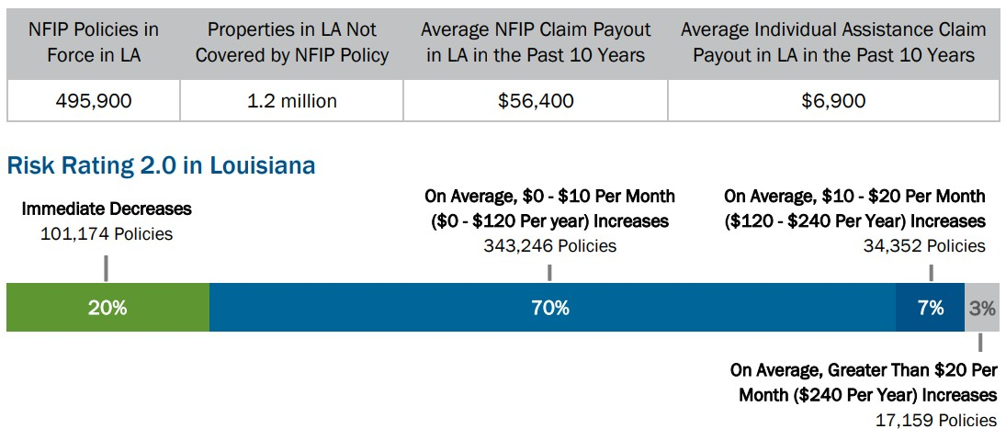
New methodology for determining rates
According to FEMA, with Risk Rating 2.0, “FEMA now has the capability and tools to address rating disparities by incorporating more flood risk variables. These include flood frequency, multiple flood types—river overflow, storm surge, coastal erosion and heavy rainfall—and distance to a water source along with property characteristics such as elevation and the cost to rebuild.”

Even though the rates may have increased, they will not increase more than 18% per year.

What has not changed under Risk Rating 2.0

Limiting Annual Premium Increases
Existing statutory limits on rate increases require that most rates not increase more than 18% per year.

Using Flood Insurance Rate Maps (FIRMs) for Mandatory Purchase and Floodplain Management
FEMA’s flood map data informs the catastrophe models used in the development of rates under Risk Rating 2.0. That is why critical flood mapping data is necessary and essential for communities. It informs floodplain management building requirements and the mandatory purchase requirement.

Maintaining Features
FEMA is maintaining features to simplify the transition to Risk Rating 2.0 by offering premium discounts to eligible policyholders. This means:

Subsidized rates for pre-FIRM properties
FEMA is continuing to offer premium discounts for pre-FIRM subsidized and newly mapped properties.

Assumption of NFIP policies
Policyholders are still able to transfer their discount to a new owner by assigning their flood insurance policy when their property changes ownership.

Types of NFIP Flood Policies
There is more than one type of flood policy issued by FEMA.

Standard Flood Insurance Policy
The Standard Flood Policy is issued to non-preferred risks. It includes a Dwelling Form, a General Property Form and a Residential Condominium Building Association Policy Form.

Preferred Risk Policy
Properties in low to moderate-risk flood zones B, C and X may be issued a preferred risk policy. The coverage is lower cost than the Standard Policy. Eligibility is based on being part of a moderate-risk flood zone and on loss history.

Residential Condominium Building Association Policy
Condominiums can obtain coverage through the Residential Condominium Building Association Policy. It covers the common elements and all structural items of the units within a building. It also covers contents owned in common.
You don’t have to spend a lot of time here unless you want to.
This helps licensees understand how rates can be different and what may be covered under flood insurance.

Covered Buildings under NFIP Policies
Many different types of buildings may be covered by NFIP insurance. All structures that are covered must meet the following criteria:
- The structure must have two or more outside rigid walls and a fully secured roof that is affixed to a permanent site
- The buildings must resist flotation, collapse and lateral movement
- At least 51% of the actual cash value of buildings, including machinery and equipment that are part of the buildings, must generally be above ground level.

Detached Garages
A detached garage at the described location in the policy can be covered under the Dwelling Form. Coverage cannot exceed 10% of the limit of liability on the dwelling, and this amount reduces the limit of liability on the building. To be covered, the garage may not be used or held for use as a dwelling, or for business or farming purpose.

Manufactured (Mobile) Homes / Travel Trailers
Manufactured homes and travel trailers can be covered by NFIP policies. A manufactured home is defined as a structure built on a permanent chassis, transported to its site in one or more sections, and affixed to a permanent foundation.

A travel trailer is a trailer without wheels, built on a chassis and affixed to a permanent foundation, that is regulated under the community’s floodplain management and building ordinances or laws.

Buildings Entirely or Partially Over Water
Buildings entirely over water that have a construction start date on or after October 1, 1982 are ineligible for coverage. However, buildings entirely over water built or substantially improved before this date may be eligible for coverage.

Buildings partially over water are also eligible for coverage.

Boathouses Located Partially Over Water
Certain portions of a boathouse located partially over water are eligible for coverage. The non- boathouse parts of a building into which boats are floated are eligible for coverage if the building is partly over land and is also used for residential, commercial or municipal purposes. The area above the boathouse that is used for purposes unrelated to the boathouse use, such as a residence, is insurable from the floor joists to the roof, including walls.

Buildings in the Course of Construction
Certain buildings in the course of construction are eligible for flood insurance coverage. If the building has yet to be walled and roofed, it is eligible under this coverage unless construction has been halted for more than 90 days and/or the lowest floor is below the defined Base Flood Elevation.

Single Building Coverage
The policy includes single building limits of coverage when a single building is insured. To qualify as a single building, the building must be separated from other buildings by intervening clear wall space or solid, vertical, load bearing division walls.

If a building is separated into divisions by solid, vertical load bearing walls that extend from the lowest level to the highest ceiling, each building division can be insured as a separate building. If the wall has a door or other opening or provides access from one building or room to another, the building must be insured as a single building.

Additions and Extensions
Additions and extensions can be insured separately if they are attached to and in contact with the dwelling by means of a rigid, exterior wall, a solid load-bearing interior wall, a stairway, an elevated walkway, or a roof. These types of additions and extensions can be covered as part of the single building coverage or may be separately insured, at the insured’s option. If an addition or extension is attached to and in contact with a dwelling by means of a common interior wall that is not a solid load-bearing wall, it must be covered as part of the single building coverage.

Occupancy
Coverage and rates are affected by the way a building’s occupancy is classified. Classifications include Single Family Dwellings, Two to Four Family Dwellings, Other Residential Buildings and Non- Residential Buildings.

Single Family Dwellings
Single family dwellings are non-condominium residential buildings designed for principal use as a dwelling place for one family, or a single-family dwelling place for one family, or a single-family dwelling unit in a condominium building. Incidental occupancies are permitted, such as structures with office, professional, private school or studio occupancies, including a small service operation, if the occupancy is limited to less than 50% of the building’s total floor area.

Two to Four Family Dwellings
Two to four family dwellings are non-condominium residential buildings designed for principal use as a dwelling place of two to four families. Most family dwellings are allowed incidental occupancies as long as the incidental occupancy is limited to less than 25% of the total floor area within the building.

Other Residential Buildings
For coverage purposes, Other Residential Buildings are buildings such as dormitories and assisted living facilities, and include hotels or motels where the normal occupancy of a guest is six months of more, or a tourist home or rooming house which has more than four roomers. Also included are residential buildings, excluding hotels and motels with normal room rentals for less than six months’ duration and containing more than four dwelling units. Incidental occupancies in Other Residential Buildings are limited to less than 25% of the total floor area within the building.

Non-Residential Buildings
The category of Non-Residential Buildings includes all other eligible occupancies, including garages, pool houses, recreational buildings, agricultural buildings, licensed bed and breakfasts and nursing homes.

Contents Coverage
The policy provides coverage for certain contents. The contents must be located in a fully enclosed building or secured to prevent flotation out of the building. Vehicles and equipment that are not licensed for use on public roads and are self-propelled vehicles or machines are covered if they are used mainly to service the described location or are designed and used to assist handicapped persons. Eligible vehicles and equipment are only covered if inside a building at a described location.

Contents within silos, grain storage buildings and cisterns are also insurable.

Ineligible Property
Certain buildings are ineligible for coverage under the Dwelling policy.

Buildings
If a building would otherwise by insurable, but has been placed on a 1316 Property List, it is not eligible for NFIP coverage. A 1316 Property List is made up of property that falls under Section 1316 of the National Flood Insurance Act of 1968. Under Section 1316, states may declare a structure to be in violation of a law, regulation or ordinance. Once the violation is corrected, the Section 1316 declaration can be rescinded and the building can be covered by flood insurance.

Container-Type Buildings
Gas and liquid tanks, chemical or reactor container tanks or enclosures, brick kilns and similar units and their contents may not be covered under the NFIP policy.

Buildings Partially Underground
Buildings whose actual cash value is 50% or more below ground are ineligible for coverage unless the lowest level is at or above the Base Flood Elevation and is below ground due to earth being used as insulation material in conjunction with energy efficient building techniques.

Examples of Ineligible Risks
Some specific examples of ineligible risks are provided below:

Building Coverage
- Boat Repair Dock
- Boat Storage Over Water
- Boathouses
- Camper
- Cooperative Unit Within Cooperative Building
- Decks (except for steps and landing; maximum landing area of 16 sq. ft.)
- Drive-In Bank Teller Unit (located outside walls of building)
- Fuel Pump
- Gazebo (unless it qualifies as a building)
- Greenhouse (unless it has at least two rigid walls and a roof)
- Hot tub or spa (unless it is installed as a bathroom fixture)
- Open Stadium
- Pavilion (unless it qualifies as a building)
- Pole Barn (unless it qualifies as a building)
- Pumping Station (unless it qualifies as a building)
- Storage Tank--Gasoline, Water, Chemicals, Sugar, etc.
- Swimming Pool Bubble
- Swimming Pool (indoor or outdoor)
- Tennis Bubble
- Tent
- Time Sharing Unit Within Multi-Unit Building

- Travel Trailer (unless converted to a permanent onsite building meeting the community's floodplain management permit requirements)
- Water Treatment Plant (unless 51 percent of its actual cash value is above ground)

Coverage Amounts
Residential homes can be insured up to a maximum of $250,000 under the NFIP policy’s Building Coverage.

The maximum personal property Contents Coverage limit available is up to $100,000 for contents with a Standard Flood Insurance Policy
Highlight these limits.

Increased Cost of Compliance
When a structure is repaired or replaced, current laws and regulations may dictate standards the repaired or replaced structure must meet. The NFIP policy includes Increased Cost of Compliance (ICC) coverage to help the insured meet the financial burden of complying with these laws or regulations. For all new and renewing policies effective on or after May 1, 2003, the ICC limit of liability is $30,000. ICC coverage is included on all Standard Flood Insurance Policies with a few exceptions.

FEMA’s Obtain and Maintain Requirement
As a condition of the receiving FEMA Public Assistance funding, owners must obtain and maintain insurance coverage at least equal to eligible amounts for the hazard specified for a permanent facility

If the seller or former owner received federal assistance through FEMAs Public Assistance funding, that assistance was conditioned upon obtaining and maintain flood insurance on the property.
(42 U.S.C. 4012a)

The requirement of maintaining flood insurance applies to all owners of the property, regardless of transfer of ownership.

Federal law (42 U.S.C. 5154a) requires the buyer/transferor of the property be notified in writing of the requirement to obtain and maintain insurance. The buyer must maintain flood insurance coverage on the property and contents in at least the amount of the disaster assistance previously received and provide notice of this requirement to any party to whom he/she sells the property

Failure to obtain or maintain flood insurance as required by law will result in the property owner's ineligibility for Federal disaster assistance.

Failure to comply with the notice requirements to subsequent buyers/transferees may create an obligation on the buyer to reimburse the Federal Government for disaster assistance provided to a subsequent buyer/transferor.

The failure to provide the Flood Insurance Purchase Requirement Addendum could be a very costly error.

The Property Disclosure Document was updated a few years ago to reflect this requirement.

Should agents see that the property received federal assistance, they should use an addendum where the seller notifies the buyer of the obtain and maintain requirement.

Standard Flood Policy
This is a good “time check.” Depending on how much time you have will determine how much time you spend here.
There is a lot of additional information if you need more time.

For a copy of the most recent FEMA Dwelling Policy form click here:

https://www.fema.gov/sites/default/files/documents/fema_F-122-Dwelling-SFIP_2021.pdf

The Standard Flood Policy coverage is available through a Dwelling Form, a General Property Form and a Residential Condominium Building Association Form.

The Dwelling Form
The Dwelling Form covers a non-condominium residential building designed for principal use as a dwelling place for one to four families, or a single-family dwelling unit in a condominium building.

Definition of Flood
A flood is defined as:
- A general and temporary condition of partial or complete inundation of two or more acres of normally dry land or of two or more properties (at least one of which is the insured’s property) from:
  - Overflow of inland or tidal waters
  - Unusual and rapid accumulation or runoff of surface waters from any source
  - Mudflow
- Collapse or subsidence of land along the shore of a lake or similar body of water as a result of erosion or undermining caused by waves or currents of water exceeding anticipated cyclical levels that result in a flood as defined in 1.a above

Mudflow is defined as:
A river of liquid and flowing mud on the surface of normally dry land areas, as when earth is carried by a current of water. Other earth movements, such as landslide, slope failure, or a saturated soil mass moving by liquidity down a slope, are not mudflows.

Coverage A – Building Property
The Dwelling form covers a dwelling at the described location, and additions and extensions attached to and in contact with the dwelling by means of a rigid exterior wall, a solid load-bearing interior wall, a stairway, an elevated walkway, or a roof. A detached garage at the described location is also covered, and the coverage limit can be no more than 10% of the limit of liability on the dwelling.

Materials and supplies that are to be used for construction, alteration, or repair of the dwelling or a detached garage are covered while the materials and supplies are stored in a fully enclosed building at the described location or on an adjacent property.

Buildings Under Construction
A building under construction, alteration or repair and at the described location is covered if the structure is not yet walled or roofed, and only while such work is in progress, or if the work is halted, only for a period of up to 90 continuous days after it is halter. Buildings under construction are not

covered if the lowest floor, including the basement, is below the specified base flood elevation for the zone within which it resides.

Manufactured homes and travel trailers are covered buildings. If a manufactured home or travel trailer is in a special flood hazard area, it must be anchored in place at the time of loss.

Items Covered Under the Building Property Coverage
The following items are covered under the Building Property Coverage:
- Awnings and canopies
- Blinds
- Built-in dishwashers
- Built-in microwaves
- Carpet permanently installed over unfinished flooring
- Central air conditioners;
- Elevator equipment;
- Fire sprinkler systems;
- Walk-in freezers;
- Furnaces and radiators;
- Garbage disposal units;
- Hot water heaters, including solar water heaters;
- Light fixtures;
- Outdoor antennas and aerials fastened to
- buildings;
- Permanently installed cupboards, bookcases,
- cabinets, paneling, and wallpaper;
- Plumbing fixtures;
- Pumps and machinery for operating pumps;
- Ranges, cooking stoves, and ovens;
- Refrigerators; and
- Wall mirrors, permanently installed.

Coverage B - Personal Property Coverage
Personal property coverage can be purchased under the Dwelling Form. The coverage applies to property owned by the insured or household family members. Optional coverage for property owned by guests of servants can also be purchased.

If a building is not fully enclosed, property must be secured to prevent flotation out of the building during the flood in order to be covered.

Covered Property
The following property is covered under the Personal Property coverage:
- Air conditioning units, portable or window type
- Carpets, not permanently installed, over unfinished flooring
- Carpets over finished flooring

- Clothes washers and dryers
- “Cook out” grills
- Food freezers, other than walk-in, and food in any freezer
- Portable microwave ovens and portable dishwashers

Basements
The National Flood Insurance Program (NFIP) defines a basement as any area of a building with a floor that is below ground level on all sides. While flood insurance does not cover basement improvements, such as finished walls, floors or ceilings, or personal belongings that may be kept in a basement, such as furniture and other contents, it does cover structural elements, essential equipment and other basic items normally located in a basement. Many of these items are covered under building coverage, and some are covered under contents coverage. The NFIP encourages people to purchase both building and contents coverage for the broadest protection.

The following items in a basement are covered under building coverage, as long as they are connected to a power source and installed in their functioning location:
- Sump pumps
- Well water tanks and pumps, cisterns and the water in them
- Oil tanks and the oil in them, natural gas tanks and the gas in them
- Pumps and/or tanks used in conjunction with solar energy
- Furnaces, hot water heaters, air conditioners, and heat pumps
- Electrical junction and circuit breaker boxes and required utility connections
- Foundation elements
- Stairways, staircases, elevators and dumbwaiters
- Unpainted drywall and sheet rock walls and ceilings, including fiberglass insulation
- Cleanup
- The following items in a basement are covered under contents coverage:
- Clothes washers
- Clothes dryers
- Food freezers and the food in them

Special Limits
Special limits apply to certain types of personal property. No more than $2500 will be paid for any one loss to one or more of the following kinds of personal property:
- Artwork, photographs, collectibles, or memorabilia, including but not limited to, porcelain or other figures, and sports cards;
- Rare books or autographed items;
- Jewelry, watches, precious and semiprecious stones, or articles of gold, silver, or platinum;
- Furs or any article containing fur which represents its principal value; or
- Personal property used in any business. Antiques are only covered for their functional value.

Coverage C – Other Coverages
Other coverages under the Dwelling policy include Debris Removal, Loss Avoidance Measures and Condominium Loss Assessments. These coverages do not increase the limits of the policy.

Debris Removal
Debris removal coverage includes paying for removal of non-owned debris off of the insured property and removing owned debris from anywhere.

Loss Avoidance Measures
Various loss avoidance measures are paid for by the policy under Other Coverages.

Sandbags, Supplies and Labor
The coverage provides payment of up to $1000 for costs incurred to protect an insured building from flood or imminent danger of flood. The expense for the following items used for this purpose are covered:
- Sandbags, including sand to fill them
- Fill for temporary levees
- Pumps, and
- Plastic sheeting and lumber used in connection with these items

Work performed by the insured or family members to protect the insured building are paid at the federal minimum wage level.

Property Removed to Safety
Up to $1000 is payable for expenses to move insured property to a place other than the insured location in order to protect the property from flood or the imminent danger of flood. The property moved is covered for 45 days from the date it is first moved to the new location.

Condominium Loss Assessments
A condominium association may assess unit owners for costs incurred due to direct physical loss by a flood to the building’s common elements, in accordance with the condominium associations articles, declarations and the insured’s deed. The policy generally covers the insured’s share of these losses.

Coverage D – Increased Cost of Compliance
A structure needing repairs or reconstruction due to suffering flood damage may be subject to State or local floodplain management laws or ordinances. The policy includes payment of up to $30,000 to pay for the costs of complying with these laws or ordinances. Compliance activities that are eligible for payment are elevation, flood proofing, relocation or demolition.

Property Not Covered
All of the following property types are not covered under the Dwelling form:
- Personal property not inside the fully enclosed building;
- A building, and personal property in it, located entirely in, on, or over water or seaward of mean high tide if it was constructed or substantially improved after September 30, 1982;
- Open structures, including a building used as a boathouse or any structure or building into which boats are floated, and personal property located in, on, or over water;
- Recreational vehicles other than travel trailers, whether affixed to a permanent foundation or on wheels
- Self-propelled vehicles or machines, including their parts and equipment. However, we do cover self propelled vehicles or machines not licensed for use on public roads that are:
  - Used mainly to service the described location, or
  - Designed and used to assist handicapped persons, while the vehicles or machines are inside a building t the described location;
- Land, land values, lawns, trees, shrubs, plants, growing crops, or animals;
- Accounts, bills, coins, currency, deeds, evidences of debt, medals, money, scrip, stored value cards, postage stamps, securities, bullion, manuscripts, or other valuable papers;
- Underground structures and equipment, including wells, septic tanks, and septic systems;
- Those portions of walks, walkways, decks, driveways, patios, and other surfaces, all whether protected by a roof or not, located outside the perimeter, exterior walls of the insured building or the building in which the insured unit is located;
- Containers, including related equipment, such as, but not limited to, tanks containing gases or liquids;
- Buildings or units and all their contents if more than 49 percent of the actual cash value of the building or unit is below ground, unless the lowest level is at or above the base flood elevation and is below ground by reason of earth having been used as insulation material in conjunction with energy efficient building techniques;
- Fences, retaining walls, seawalls, bulkheads, wharves, piers, bridges, and docks;
- Aircraft or watercraft, or their furnishings and equipment;
- Hot tubs and spas that are not bathroom fixtures, and swimming pools, and their equipment such as, but not limited to, heaters, filters, pumps, and pipes, wherever located;
- Property not eligible for flood insurance pursuant to the provisions of the Coastal Barrier Resources Act and the Coastal Barrier Improvement Act and amendments to these acts;
- Personal property you own in common with other unit owners comprising the membership of a condominium association.

Exclusions
The policy pays only for direct physical loss by or from flood so the following items are excluded:
- Loss of revenue or profits
- Loss of access to the insured property or described location
- Loss of use of the insured property or described location
- Loss from interruption of business or production

- Any additional living expenses incurred while the insured building is being repaired or is unable to be occupied for any reason
- The cost of complying with any ordinance or law requiring or regulating the construction, demolition, remodeling, renovation or repair of property, including removal of any resulting debris, except for eligible activities covered under the Increased Cost of Compliance Coverage
- Any other economic loss

Earth Movement Exclusions
Loss of property caused directly by earth movement, even if the earth movement is caused by a flood, is not covered. The policy does not cover earthquake, landslide, land subsidence, sinkholes, destabilization or movement of land that results from accumulation of water in subsurface land area, or gradual erosion.

Other Exclusions
Direct physical loss caused directly or indirectly by any of the following is excluded:
- The pressure or weight of ice;
- Freezing or thawing;
- Rain, snow, sleet, hail, or water spray;
- Water, moisture, mildew, or mold damage that results primarily from any condition:
  - Substantially confined to the dwelling; or
  - That is within your control, including but not limited to:
    - Design, structural, or mechanical defects;
    - Failure, stoppage, or breakage of water or sewer lines, drains, pumps, fixtures, or
    - equipment; or
    - Failure to inspect and maintain the property after a flood recedes;
- Water or waterborne material that:
  - Backs up through sewers or drains;
  - Discharges or overflows from a sump, sump pump, or related equipment; or
  - Seeps or leaks on or through the covered property;
  - unless there is a flood in the area and the flood is the proximate cause of the sewer or drain backup, sump pump discharge or overflow, or seepage of water;
- The pressure or weight of water unless there is a flood in the area and the flood is the proximate cause of the damage from the pressure or weight of water;
- Power, heating, or cooling failure unless the failure results from direct physical loss by or from flood to power, heating, or cooling equipment on the described location;
- Theft, fire, explosion, wind, or windstorm;
- Anything you or any member of your household do or conspire to do to cause loss by flood
deliberately; or
- Alteration of the insured property that significantly increases the risk of flooding.

The General Property Policy Form
The General Property policy form is used for other-residential and non-residential structures and their contents.

Building Coverage
The building coverage for non-residential structures covers:
- Unfinished drywall for walls and ceilings, including nonflammable insulation
- Electrical junction and circuit breaker boxes, and required utility connections
- Central air-conditioning units
- Furnaces, hot-water heaters, fuel tanks, and the fuel inside tanks and heat pumps
- Light fixtures
- Built-in cabinets
- Foundation elements
- Cleanup

Contents Coverage
The contents coverage under the General Property form covers:
- Furniture and fixtures
- Machinery and equipment
- Stock (including merchandise held in storage for sale)
- Raw materials
- Unfinished or finished goods
- Packing and shipping supplies

The Residential Condominium Association Form
The Residential Condominium Association form provides building coverage for condominium associations.

Building Coverage
Under the Residential Condominium Association policy, a condominium association can purchase building coverage up to $250,000 times the number of units, or the replacement cost of the building, whichever is less. Eligible buildings include garden apartment-type construction, townhouses, row houses and single-family detached buildings owned by the association, as long as 75% of the units are used for residential purposes.

Contents Coverage
Individual unit owners can purchase up to $100,000 in contents coverage, separate from the coverage purchased by the condominium association.

Best Practices when listing a flooded home
Be honest. The first rule when working with sellers of a previously flooded home is to be honest. Failing to disclose is opening both the agent and seller up to a potential lawsuit. The best way to address this is through section six of the Property Disclosure Document.

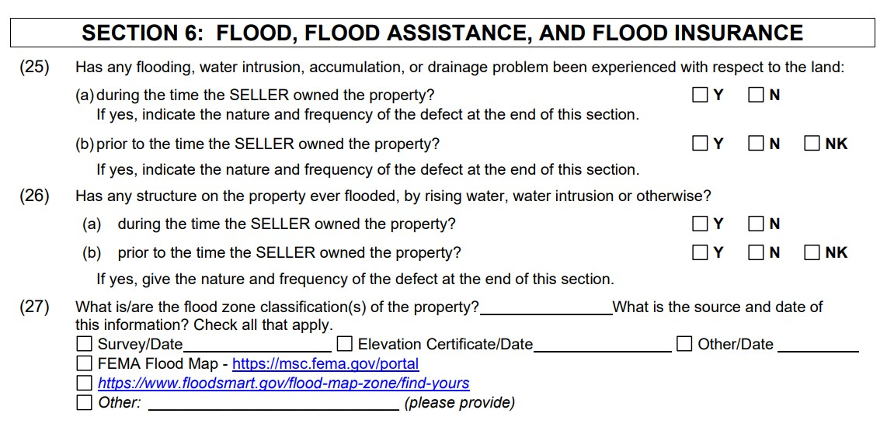

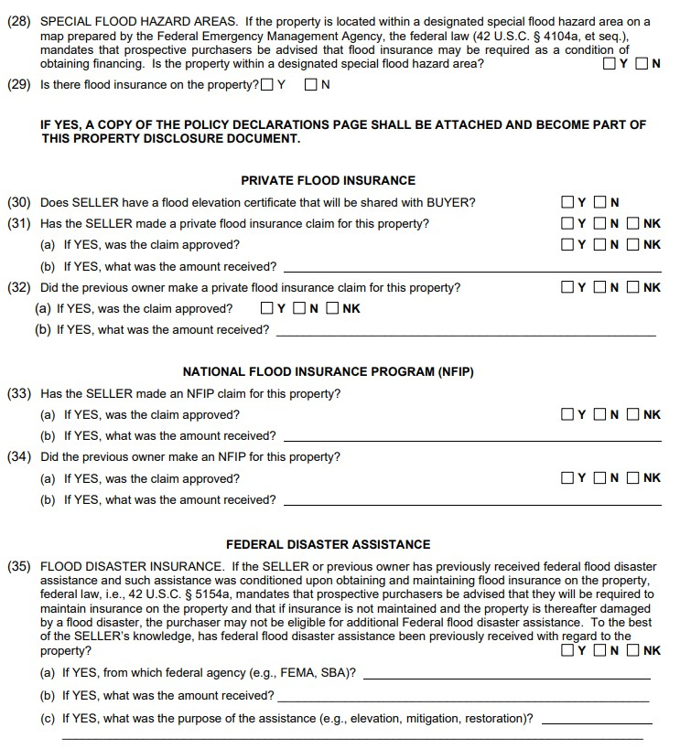

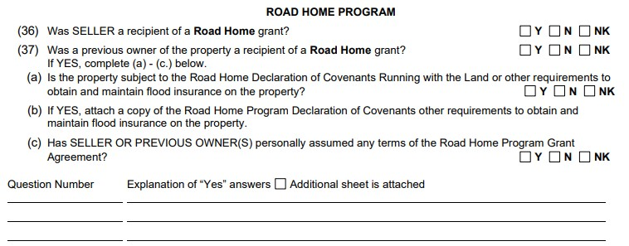

Gather all documentation. When selling a property that has experienced flooding, documentation is key. Sellers can prepare a report or binder of the corrective measures taken after the property flooded. These can include:

- Information required in the PDD – elevation certificate, copy of the declarations page of the flood policy
- Line item of exactly what repairs were done
- A record of contractors who completed the work. This shows the repairs were done correctly.
- Receipts/invoices of expenses incurred
- Mold remediation certificate

As is. Buyers may not have the funds to make any or all of the repairs necessary. If repairs are too costly, the property can be sold “as is.”

Communicate with buyers. Sellers need to understand buyers my have additional questions when purchasing a previously flooded home. It is important to communicate with buyers who may have concerns.

Best practices when working with buyers purchasing a previously flooded home.

Read and understand the Property Disclosure Document. Be sure your buyer understands what they are purchasing. The first place to look is the Property Disclosure Documents.

Ask questions. If the recommendation when listing a previously flooded home was to provide plenty of documentation, it is natural when working with buyers, the best practice is to request documentation. Asking about the extent of the repairs and quality of work can give your buyer piece of mind that the repairs were done correctly.

Get a home inspection. Home inspectors play a vital role in assisting buyers with identifying potential issues and make an informed decision about the home. Buyers can get more information by visiting the Louisiana State Licensing Board for Contractors website - https://lsbhi.state.la.us/.

Mold test/remediation. Mold causes adverse reactions and can be a serious health hazard. Agents can assist buyer by verifying if there has been mold testing and/or remediation by a certified professional.

Insurance. Flood insurance rates are rising in many areas. Buyers can work with their insurance agent to determine the best and most affordable options regarding flood insurance. First, ask the agent if the flood policy is assumable. Next determine the rate and verify if the rate subsidized. If subsidized, ask how much to policy will increase each year the buyers will own the home.

PART THREE: ADVERTISING

All advertising must be approved by the broker
All advertising for property shall be under the direct supervision of and approved by the licensed individual real estate broker or designated qualifying broker.

What is considered advertising?
The term “advertisement,” as used in this checklist, shall mean any oral, written or print and media advertisement, including newspaper and magazine advertisements; correspondence; mailings; brochures; business cards; for sale or for lease signs; sign riders; promotional items; newsletters; telephone directory listings; automobile signage; as well as internet, radio and television advertisement.

What is not advertising?
Agreements between brokers to allow property data to be shared and disseminated to clients, customers, or prospective clients, including but not limited to web-based or email multiple listing service property data, IDX or VOW property data does not constitute advertising or advertisement as to the property data shared.

Logos and Slogans
If allowed by the sponsoring broker, the salesperson or associate broker may include in the advertisement:
- the salespersons or associate broker’s personal logo or insignia, which cannot be construed as that of a company name, and which must include the name and telephone number of the sponsoring broker;
- the salespersons or associate broker’s contact information;
- a group or team name, as long as the advertising complies with all other applicable laws and rules
- a slogan that may not be construed as that of a company name

Discuss what is advertising and what is not.
There are a lot of LREC fines issued regarding advertising so be prepared for student questions.
For review, Chapter 25 of the Rules and Regulations covers most advertising rules.

This is the percentage of violations issued by the LREC from 2018-2021.
Spend time covering each.

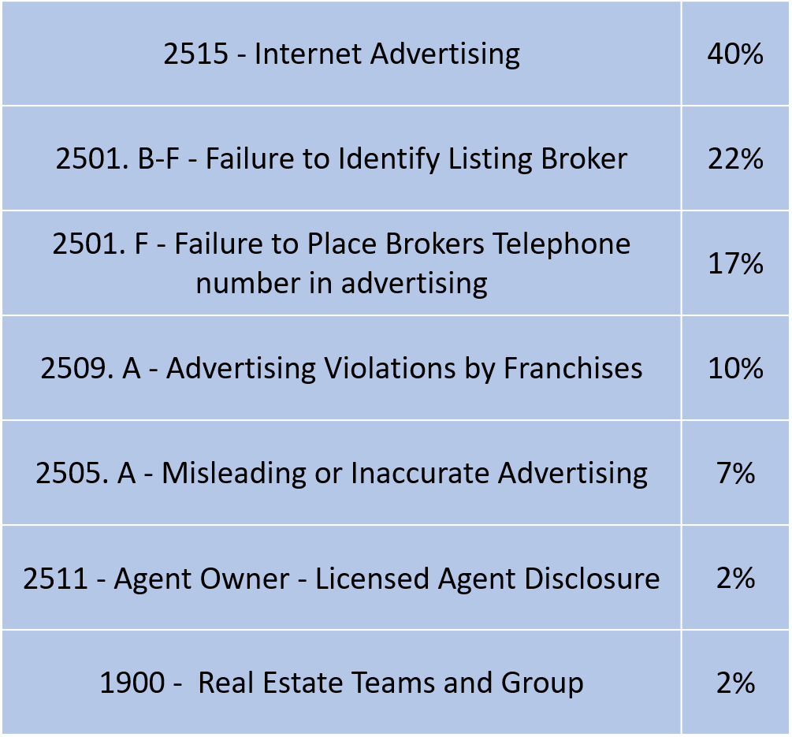
Advertising Violations

Internet Advertising
Brokers advertising or marketing on a site on the internet must include the following data on each page of the site on which the advertisement appears:

- the broker’s name or trade name as registered with the commission;
- the city and state in which the broker’s main office or branch office is located.
- the regulatory jurisdiction(s) in which the broker holds a real estate brokerage license.

Brokers using any internet electronic communication for advertising or marketing, including but not limited to, e-mail, email discussion groups, and bulletin boards, must include the following data on the first or last page of all communications:

- the broker’s name or trade name as registered with the commission;
- the city and state in which the broker’s main office or branch office is located.
- the regulatory jurisdiction(s) in which the broker holds a real estate brokerage license.

Associate brokers or salespersons advertising or marketing on a site on the internet must include the following data on each page of the site on which the licensee’s advertisement or information appears:

- the associate broker’s or salesperson’s name;
- the name or trade name of the licensed broker or agency listed on the license of the salesperson or associate broker;
- the city and state in which the broker’s main office or branch office is located.
- the regulatory jurisdiction(s) in which the broker holds a real estate brokerage license.

Associate brokers or salespersons using any internet electronic communication for advertising or marketing, included but not limited to, e-mail, email discussion groups, and bulletin boards, must include the following data on the first or last page of all communications:

- the associate broker’s or salesperson’ name;
- the name or trade name of the licensed broker or agency listed on the license of the salesperson or associate broker;
- the city and state in which the broker’s main office or branch office is located.
- the regulatory jurisdiction(s) in which the broker holds a real estate brokerage license.

Identify Broker Name and Broker Phone Number

Rules and Regulations Chapter 25.2501(F) states “In all advertising, the salesperson or associate broker must include the name and telephone number of the sponsoring broker. The broker’s name and telephone number must be conspicuous, discernible and easily identifiable by the public.”

The LREC further clarifies in their published Advertising Guidelines Checklist “Note: In accordance with Chapter 25. 2501 (F) There is no definitive guideline about what is “conspicuous, discernible and easily identifiable” and what is not. However, the general rule is that the smaller the sponsoring or qualifying broker’s name and company in comparison with the name and company of the licensee, the more likely the LREC will conclude that the sponsoring or qualifying broker’s name and telephone number is not “conspicuous, discernible and easily identifiable” and that the advertisement is misleading.”

Often, the violation is not that the brokers name is missing, it is that the brokers name is not “conspicuous, discernible and easily identifiable” according to the LREC.
This is subjective and the LREC Advertising Guidelines Checklist give examples of compliant and noncompliant advertisements.
The LREC Advertising Guidelines Checklist is a great resource to reference.

Examples:

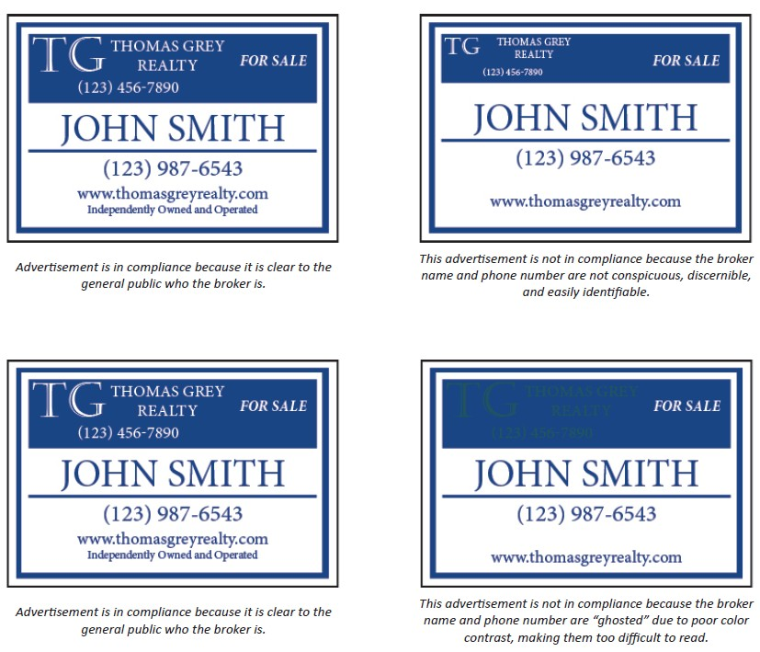

NOTE REGARDING THE BROKER PHONE NUMBER: the broker phone number must be a phone number owned by the broker(age) that enables the public to directly contact the broker without having to go through the affiliated licensees listed in the advertisement.

Advertisements by Franchise Organizations
Any licensed broker or salesperson affiliated with a franchise organization must disclose to the public that the real estate brokerage firm is independently owned and operated in all advertising.

In addition, advertising shall not include any name or trade name of any franchiser or real estate organization or association of which the licensee is not a member or franchisee.

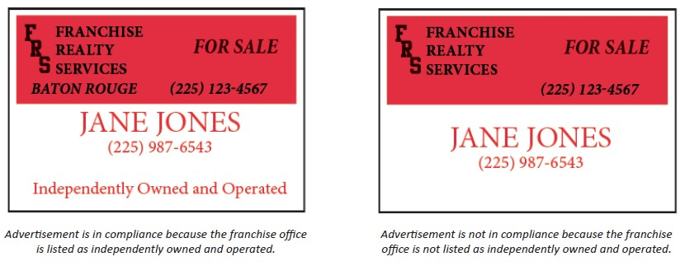

Accuracy in Advertising
All advertising shall be an accurate representation of the property advertised. No broker or licensee shall use advertising which is misleading or inaccurate or in any way misrepresents any property, terms, value, policies, or services of the business conducted.

Advertising Agent-owned Property
A licensed broker or salesperson who offers property in which he or she owns any interest as being for sale or rent shall state in any advertising, and on any sign placed on the property, that he or she is a licensed real estate agent.

Any licensed broker or salesperson that advertises or offers to purchase or rent property for his or her own full or partial interest shall state in any advertisement that he or she is a licensed real estate agent.

Including the term “licensed real estate agent” in any advertisement or on any sign shall be sufficient to satisfy this requirement.

Exceptions: this is not applicable to the sale, rental, or acquisition of property by licensees under a contractual agreement with a licensed Louisiana real estate broker.

Advertising By Real Estate Teams and Groups
A team or group name shall not be used in advertising without the written approval of the sponsoring broker.

The term “team” or “group” may be used to advertise real estate license activities provided that:
- the use of the term does not constitute the unlawful use of a trade name and is not deceptively similar to a name under which any other person or entity is lawfully doing business;

- the team or group is composed of more than one licensee;
- the advertising complies with all other law and rules and regulations.

In addition, an unlicensed person shall not be named, acknowledged, referred to, or otherwise included in any team or group advertising.

Owner Authorization to Advertise
No broker or licensee sponsored by said broker shall in any way advertise property belonging to other persons as being for sale or rent or place a sign on any such property offering the property for sale or rent without first obtaining the written authorization to do so by all owners of the property or their authorized attorney in fact.

Advertisements of Residential Property
All printed advertisements for the sale or lease of residential real estate shall indicate the month and year the advertisement is printed, published, or distributed. Advertisements printed or published in newspapers, real estate trade publications and commercial magazines and brochures bearing an issue or publication date will be considered in compliance with this Section.

PART FOUR – MISREPRESENTATION
Misrepresentation occurs when one party makes a false statement to the other party and that statement is a determining factor used when entering into a contract. In real estate, a misrepresentation can occur when a real estate licensee misstates some material feature of the property. Often lumped in with misrepresentations are failures to disclose, which is when a licensee fails to address or reveal a material feature of the property entirely

Brokers and salespeople face a myriad of potential legal issues, however, lawsuits for misrepresentation are by far the biggest.

The most common types of misrepresentation claims in real estate are:
- foundation and structural issues
The focus of this chapter is to understand what the licensee is obligated to disclose and how to have conversations with clients regarding the disclosure of defects.
- involve property boundaries
- roof issues
- termite problems.
- Omitted disclosures ex. easements,
- renovating without a permit
- environmental problems
- title problems

There three types of misrepresentation

- Innocent -- simple mistakes with no intent and little harm;

- Negligent -- failure to disclose significant property issues due to ignorance;

- Fraudulent-- purposefully misleading a client or hiding a property issue or feature in order to make a sale.

Home inspections, disclosures, and misrepresentation

Listing Agents - When purchasing a property, a buyer is reliant on certain information that can only be provided to them by the seller, which is typically found in the property disclosure document.

The PDD is a great form and helps buyers, sellers and licensees. In most instances, a seller will complete the form as thoroughly and honestly as possible, allowing the buyer to make an informed decision as to whether to go through with the purchase. But what happens when a seller mistakenly or deliberately withholds information or is dishonest?

Case Study

A home is under contract and the buyers get a home inspection. The home inspection report reveals a significant issue with the slab. The buyers decide to back out and the house is put back on the market.

Should the sellers fill out an updated PDD? What if they refuse?

One of the 36 ways to lose your license is failure to disclose material defects. RS 37:1455 (27) states “Failure to disclose to a buyer a known material defect regarding the condition of real estate of which a broker, salesperson, or timeshare interest salesperson has knowledge.”

What happens if the listing agent does not know? According to Louisiana Agency Law, “A licensee shall not be liable to a client for providing false information to the client if the false information was provided to the licensee by a customer unless the licensee knew or should have known the information was false.”

Best Practice Regarding Third Party information - If you receive property information from a third- party source, attribute the information to that source, saying, for example, "According to the seller, the roof is three years old."

Buyers Agents - Advise buyer to get a home inspection. If the buyer chooses not to have a home inspection, a best practice is to have them sign a hold harmless agreement.

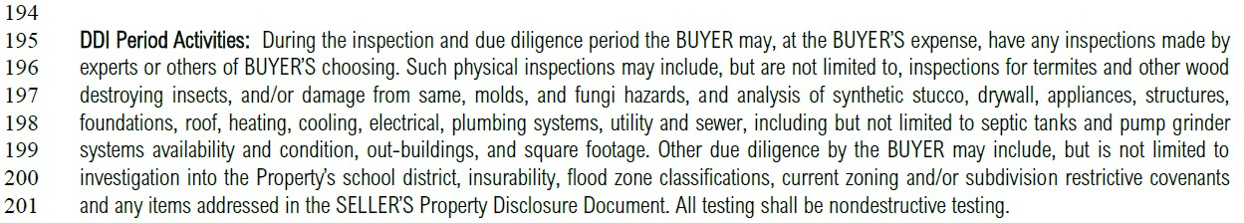

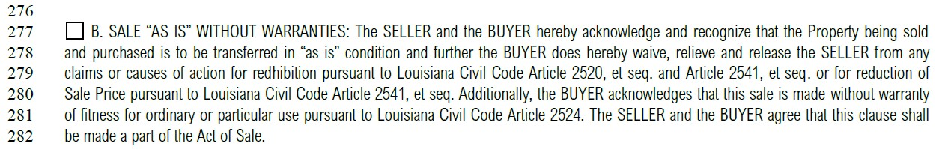“As Is” and waiver of redhibition.

Redhibition is not permitted in cases of fraud. The seller cannot intentionally hide a known defect then use the waiver of redhibition clause if the buyer wishes to rescind the sale.

LA Rev Stat § 9:3169 Rescission for fraud or nullity; redhibition not permitted. Whatever may be the vices of the thing sold on execution, they do not give rise to the redhibitory action; but the sale may be set aside in the case of fraud, and declared null in cases of nullity.

Case Study

A house is under contract for $200,000. According to the listing the home is 2,000 square feet of living area. The appraisal comes back with an appraised value of $205,00 but appraisal indicates the home is 1,800 square feet. The buyer based their purchase price on $100 per square foot and now believes the sellers should reduce the price to $180,000 given the updated square footage given by the appraiser.

Team Misrepresentation

Clients may be confused about exactly who is representing them. Is it the entire team or just a single agent on the team? It is critical for teams to understand their relationship with clients and even more critical for clients to understand who is representing them.

Undisclosed dual agency
RS 37:1455 (9) – Acting in the dual capacity of agent and undisclosed principal in any transaction.

RS 37:1455 (16) – Acting for more than one party in a real estate transaction without the written acknowledgment of all parties to the transaction.

Appendix

Redline Changes to the LREC Agreement to Buy or Sell………………………57 Redline Changes to Property Disclosure Document…………………………...68 Dual Agency Disclosure Form……………………………………………………………..81

Note: All of the documents listed above, including the National Flood Insurance Program (NFIP) - FEMA Dwelling Policy Form can also be found in the back pocket of this binder.

