INSTRUCTOR MANUAL
_________________________
TRAIN THE TRAINER
2021 MANDATORY COURSE
_________________________

Basics of Investment Property and Property Management
(Insert VENDOR name and VENDOR number here)
Developed by CCIM Institute and IREM
A Louisiana Real Estate Commission Publication

Time of Day | Module/Topic | Segmentation | Student Objectives
8:30–8:45 am | Course Introduction*:  - Course Description  - Course Objectives  - Student introductions that include overview of their real estate experience  *Does not count toward course time | 15 minutes | - Discuss overview of course concepts and content  - Explain course objectives and student commitment  - Students can identify the experience level of their colleagues to assist in forming groups for case study
8:45-9:00 am | Overview of Commercial Real Estate:  - Property type markets  - Single family dwelling  - Duplex or four plex  - Office buildings  - Introduction of Four-plex Case Study | 15 minutes | - List the characteristics of each investment property type: single family dwelling, duplex or four plex, and office buildings
9:00-9:15 am | Determining Values of Investment Properties:  - Overview of replacement cost method, sales comparison method, income capitalization method, gross rent multiplier, and annual property operating data (APOD)  - Issues to consider if you only use Cap Rate to determine value | 15 minutes | - Compare the various methods that can be used to identify the value of investment properties and focus on residential investment property
9:15–9:30 am | Resources for Decision-Making  - Purchase agreements  - Disclosures  - Inspections  - Licenses needed by clients | 15 minutes | - Identify the due diligence required to purchase an investment property
9:30-9:45 am | Data for Decision-Making  - How to finance an investment property  Disposition of investment property | 15 minutes | - Define financial leverage  - List the advantages and disadvantages of financing an investment property  - Explain the components of a 1031 Exchange
9:45-10:00 am | Four-plex Case Study | 15 minutes | - Identify the key components required to assess a CRE property
10:00-10:15 am | Morning Break | 15 minutes
10:15-10:45 am | Property Management Overview:  - Overview  - Roles and Responsibilities  - Management Agreement and Management Company | 30 minutes | - Describe the roles and responsibilities of a property manager

10:45-11:20 am | Property Management Best Practices:  - Overview of Louisiana law  - Broker supervision  - Lease agreement  - Trust accounts  - Security deposits  - Eviction proceedings and Notice to Tenants | 35 minutes | - Discuss basic tenants of property management
11:20-11:30 am | - Morning Break | 10 minutes
11:30-11:45 am | Property Management Best Practices:  - Federal Laws  - Fair Housing Act (emotional support animals, service animals)  - Equal Credit Opportunity Act  - Sherman Antitrust Act  - Americans with Disabilities Act  - Lead Based Paint Hazard Reduction Act  - Uniform Residential Landlord and Tenant Act | 15 minutes | - Explain federal laws and regulations that impact property management
11:45-11:55 am | Property Management Best Practices:  - Marketing and leasing  - Conflict resolution  - Maintenance and repairs  - Accounting and taxes | 10 minutes | - Identify property management best practices
11:55-12:25 pm | Case Studies  - Case Study | 30 minutes | - Apply property management best practices to real-world case study scenario
12:25-1:00 pm | Louisiana Real Estate Commission Update  - Legislative Update  - LREC Website & Portal Functionality  Available Online Digital Forms & Applications | 35 minutes | - Review legislative updates, website & portal functionality, and available digital forms and applications
 | Total Content | 4 hours

Basics of Investment Property and Property Management

Louisiana Real Estate Commission
Instructor Manual

Table of Contents

Instructor Qualifications and Background 3
Course Completion Requirements 3
Vendor Policies and Regulations 3
Disclaimer 4
Course Overview and Objectives 5
Course Schedule 9
Part 1: Investment Property 11
Lesson 1: Overview of Commercial Real Estate 12
Lesson 2: Determining Values of Investment Properties 19
Lesson 3: Resources for Decision Making 38
Lesson 4: Data for Decision Making 48
Case Study Part 1: Investment Property 52
Part 2: Property Management 54
Lesson 1: Overview of Property Management 55
Lesson 2: Property Management in Louisiana 70
Lesson 3: Key Federal Laws 85
Lesson 4: Property Management Best Practices 101
Case Study Part 2: Property Management 107
Part 3: Louisiana Real Estate Commission Update 110

Instructor Qualifications and Background
(Insert a short bio and credentials here.)

Course Completion Requirements
Students must be present for the full four (4) hours if a live presentation. Students taking Internet based presentations must complete all quizzes and exams with a score of at least 70%. An identity affidavit attesting to the fact that the student has personally completed the course without assistance must be submitted before a certificate of completion is granted.

Vendor Policies and Regulations

Prerequisites
There are no educational prerequisites for this course.

Registration
Any attempt to take this course under an assumed identity will forfeit your right to receive a certificate of completion and may result in sanctions by the Louisiana Real Estate Commission.

Attendance
Students attending a live presentation must sign in before the course and sign out after the course; this course is a four (4) hour presentation, and 100% attendance is required to receive credit for completion. Credit shall not be granted for partial attendance. No exceptions!

Tardiness/Absences
Credit shall not be granted for late arrivals, excessive absences, and/or early departures. Students are not allowed to make up missed portions of a course.

Course Participation
Instructors may not, in any venue, answer questions of a personal or legal nature, and students should not interpret any information received from instructors or course content as being legal advice.

Classroom Rules of Conduct
To provide an atmosphere conducive to learning, students must turn off all electronic devices prior to the start of class. Newspapers, books, magazines, or any other reading materials are not permitted during class presentation. Violations may result in loss of continuing education credit.

ADA Compliance
Upon request, reasonable accommodations will be provided to individuals with a documented disability to assure that an equal opportunity to participate in this course is provided. For further information, contact our office at (555) 555-5555.
Vendor Contact Information: (insert your contact information here)
Phone: (555) 555·5555, weekdays between 8:30 a.m. and 5 p.m. central time.
E-mail: anyschool@yourschool.com
Address: any town USA

Disclaimer
These materials are to be used for informational purposes and should not be construed as specific legal advice, nor are they designed to cover every aspect of a legal situation or every factual circumstance that may arise regarding the subject matter included.
This publication is for reference purposes only and readers are responsible for contacting their own attorneys or other professional advisors for legal or contract advice. The comments provided herein solely represent the opinions of the authors and are not a guarantee of interpretation of the law or contracts by any court or by the Louisiana Real Estate Commission.
The NAR Equal Professional Service Model and the REALTORS® Code of Ethics are not specifically required by or included in Title VIII of the Civil Rights Act of 1968 (The Fair Housing Act). However, the material is included in this course for informational purposes. LREC did not participate in the creation of either the NAR Equal Professional Service Model or the REALTORS® Code of Ethics and is not verifying their compliance with the Fair Housing Act by inclusion in this course. Further, LREC licensees are not required to be a member of any REALTORS® association.

Course Overview and Objectives
Part 1
Investment Property
Discuss commercial real estate, including how investment property is valued and how investment decisions are made.

Lesson 1: Overview of Commercial Real Estate

Learning objective
- List the characteristics of each investment property type: single-family dwelling, duplex-four-plex, and office buildings

Topics
- Property type markets
  - Single family dwelling
  - Duplex or four plex
  - Office buildings
- Introduction of office building case study

Lesson 2: Determining Values of Investment Property

Learning objective
- Compare the various methods that can be used to identify the value of investment properties

Topics
- Overviews of:
  - Sales comparison method
  - Income capitalization method
  - Gross rent multiplier
  - Annual property operating data (APOD)

Lesson 3: Resources for Decision Making

Learning objective
- Identify the due diligence required to purchase an investment property

Topics
- Purchase agreements
- Disclosures
- Inspections
- Licenses needed by clients

Lesson 4: Data for Decision Making

Learning objectives
- Define financial leverage
- List the advantages and disadvantages of financing an investment property

Topics
- How to finance an investment property
- Disposition of investment property

Case Study Part 1: Investment Property

Learning objectives
- Identify the key components required to assess a commercial real estate property
- Use Annual Property Operating Data Form to calculate value of property
Part 2
Property Management
Examine the role of property management in complying with laws and maximizing the value of investment property.

Lesson 1: Overview of Property Management

Learning objective
- Describe the roles and responsibilities of a property manager

Topics
- Overview
- Roles and responsibilities
- Management company

Lesson 2: Property Management in Louisiana

Learning objective
- Explain Louisiana laws and regulations that apply to property management

Topics
- License law
- Management agreement
- Landlord and tenant law
- Required disclosures
- Landlord trust checking accounts
- Lease termination and eviction

Lesson 3: Key Federal Laws

Learning objective
- Explain federal laws and regulations that impact property management

Topics
- Fair Housing Act
- Sherman Antitrust Act
- Lead Based Paint Hazard Reduction Act
- Equal Credit Opportunity Act
- Americans with Disabilities Act
- Uniform Residential Landlord and Tenant Act

Lesson 4: Property Management Best Practices

Learning objective
- Identify property management best practices

Topics
- Marketing and leasing
- Conflict resolution
- Maintenance and repairs
- Accounting and taxes

Case Study Part 2: Property Management

Learning objective
- Apply property management principles through a case study
Part 3
Louisiana Real Estate Commission Update
Examine the role of property management in complying with laws and maximizing the value of investment property.

Learning objective
- Discuss updates on the Louisiana Real Estate Commission

Course Schedule
Course Introduction
Course Description and Objectives | 8:30-8:35
Introductions | 835-8:45

Part 1: Investment Property
Lesson 1: Overview of Commercial Real Estate | 8:45-9:00
Lesson 2: Determining Values of Investment Properties | 9:00-9:15
Lesson 3: Resources for Decision-Making | 9:15-9:30
Lesson 4: Data for Decision-Making | 9:30-9:45
Case Study Part 1: Investment Property | 9:45-10:00
Break #1 | 10:00-10:15

Part 2: Property Management
Lesson 1: Overview of Property Management | 10:15-10:45
Lesson 2: Property Management in Louisiana | 10:45-11:30
Lesson 3: Key Federal Laws | 11:30-11:45
Lesson 4: Property Management Best Practices | 11:45-12:10
Case Study Part 2: Property Management | 12:10-12:40

Part 3: Louisiana Real Estate Commission Update
LREC Update | 12:40-1:10

Part 1: Investment Property

Lesson 1: Overview of Commercial Real Estate
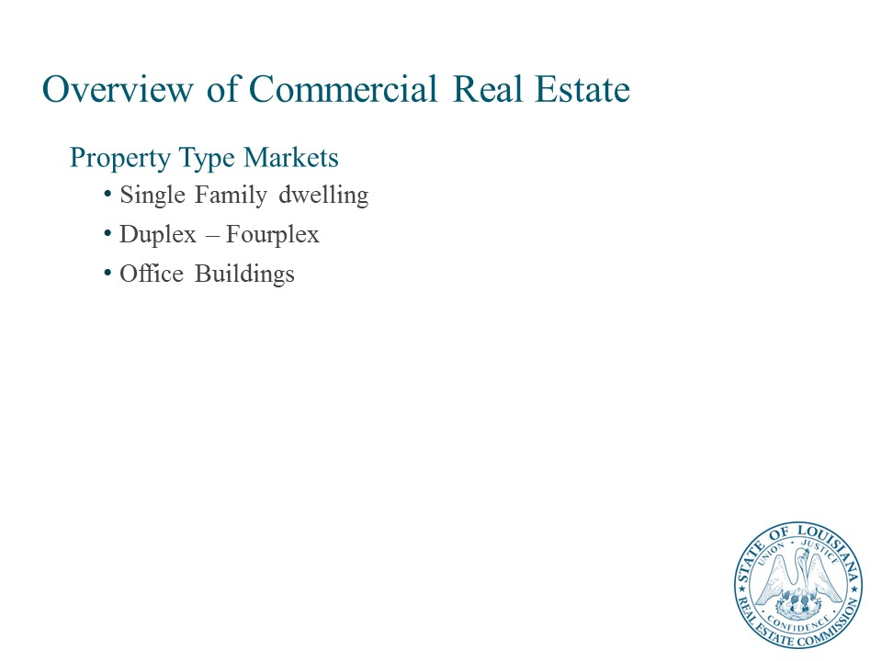

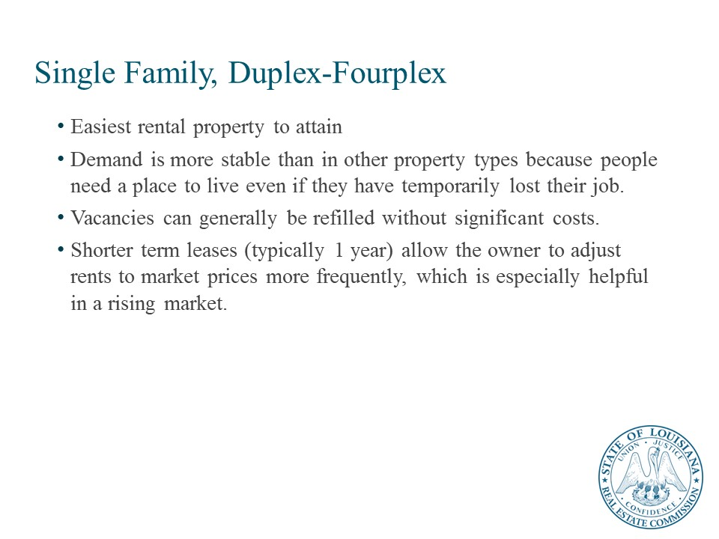

Property Type Markets

Single Family, Duplex-Fourplex, Office
Residential rental real estate, including single family up to fourplexes, are a preferred asset class for many investors. Single family residences to fix and flip, or hold and rent, as well as duplexes, triplexes, and fourplexes and small apartment complexes often serve as a point of entry for first time commercial real estate investors.
Sources for information about multifamily investment include the National Apartment Association (NAA, http://www.naahq.org/) and the National Multi Housing Council (NMHC, http://www.nmhc.org/).
Individual investors and partnerships often own apartment properties of less than 200 units. Large, well-located complexes are owned and operated by large institutional investors and REITs.
Multifamily properties take many forms from suburban complexes of various sizes and quality, in-town mid- or high-rise luxury units, units above office or retail businesses in urban areas, lofts or units redeveloped in older buildings that formerly had other uses such as office or warehouse, government subsidized complexes of various types.
Single family homes, duplexes-fourplexes, and multifamily properties are attractive to Investors for several reasons:
- Residential rental properties, like other types of Investment real estate, are impacted by economic cycles, however, demand is more stable than in other property types because people need a place to live even if they have temporarily lost their job.
- A property with many units is not severely impacted by the move-out of one or a small number of tenants.
- Vacancies can generally be refilled without significant costs.
- Shorter-term leases (typically one year) allow the owner to adjust rents to market prices more frequently, which is especially helpful in a rising market.
Here are several reasons why one might invest in single family properties to rent:
- You can rent a house for much more money than an apartment.
- Single family homes generally cost less and appreciate in value faster than multiple family units.
- The investment isn't as risky because you are spending less money than on an apartment building. Your mortgage will be more manageable and can be covered by your tenants' monthly payments.
- When renting out a single-family home, the tenants are usually responsible for all the utility payments. In an apartment building, the landlord often pays the water, sometimes even the gas and electricity.
- House renters tend to be more responsible than apartment dwellers. They take better care of their yards and are more likely to pay their rent on time.
- People renting a house are more likely to stay longer. You won’t have to deal with turnover, empty space, or interviewing potential renters.
- People renting your house will consider it their home. They will treat it better, especially if they are considering buying it in the future.
- In a single-family home, you will only have to deal with one person or one family. In an apartment building, you have multiple personalities to deal with and they may not get along with each other. You will have to intervene in squabbles and complaints about each other.
- Single family homes almost always have a yard where kids can play. People want yard space for their families.
- Single family homes have only one furnace, one laundry machine and maybe two toilets. Multiple family dwellings have multiple appliances and fixtures which will need your attention. This can be expensive, frustrating, and time-consuming.
- You can easily manage one house on your own.
- One of the appeals of investing in single-family rental homes is you can hire strong local property management firms to handle day-to-day management tasks of rent collection, repairs and maintenance, and leasing.
Property Management Companies
While some people do choose to self-manage, hiring a property manager can save you a lot of time and potentially money in the long run. While property management companies typically charge between 7% and 10% of the rent, they manage properties for a living and can work to ensure the property is leased, in good condition, and the tenants are happy. Additionally, using a local property manager effectively allows you to buy properties outside of where you live, as self-managing is difficult if the property is not nearby.
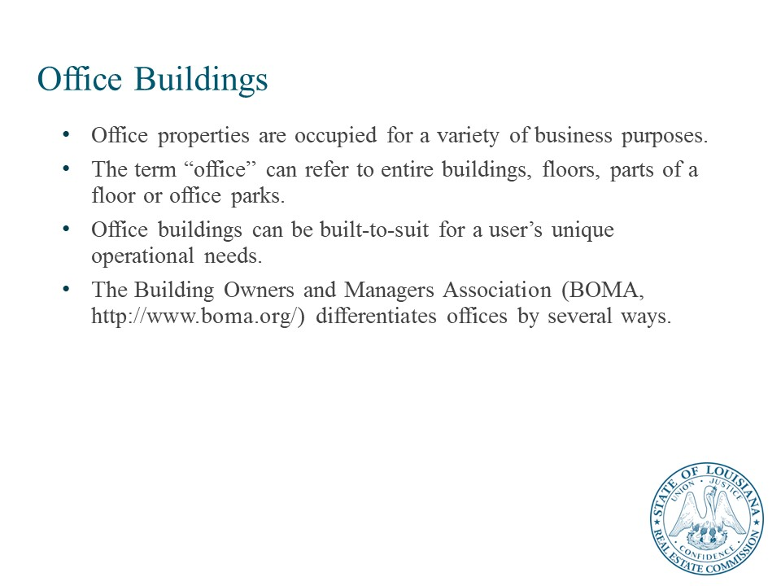

Office Properties
Office properties are occupied for a variety of business purposes. Office users engage in back-office retail enterprises, service businesses, not for profit activities, and industrial oriented activities. The term “office” can refer to entire buildings, floors, parts of a floor or office parks. Office buildings can be built-to-suit for a user’s unique operational needs. The Building Owners and Managers Association (BOMA, http://www.boma.org/) differentiates offices by several ways.
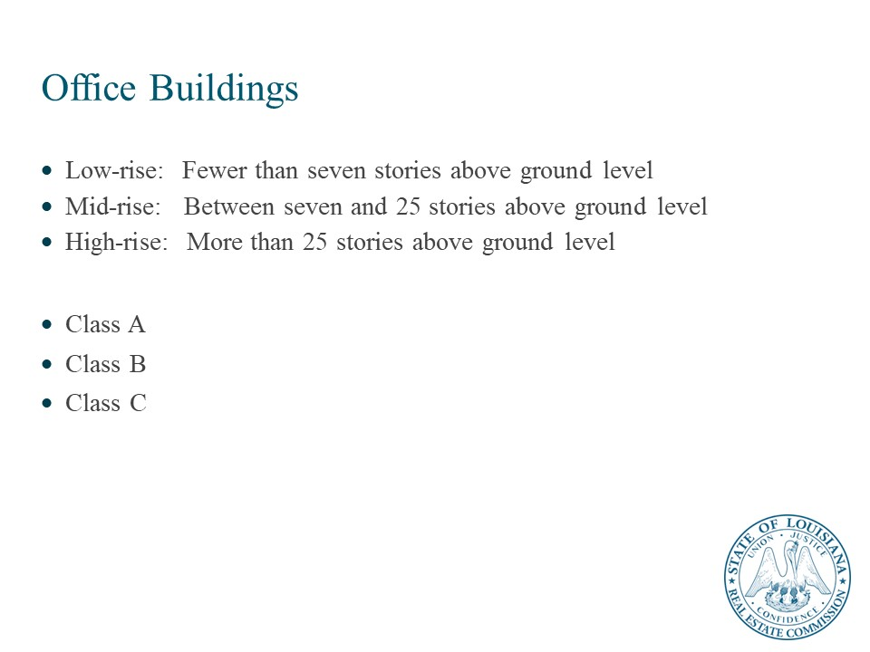
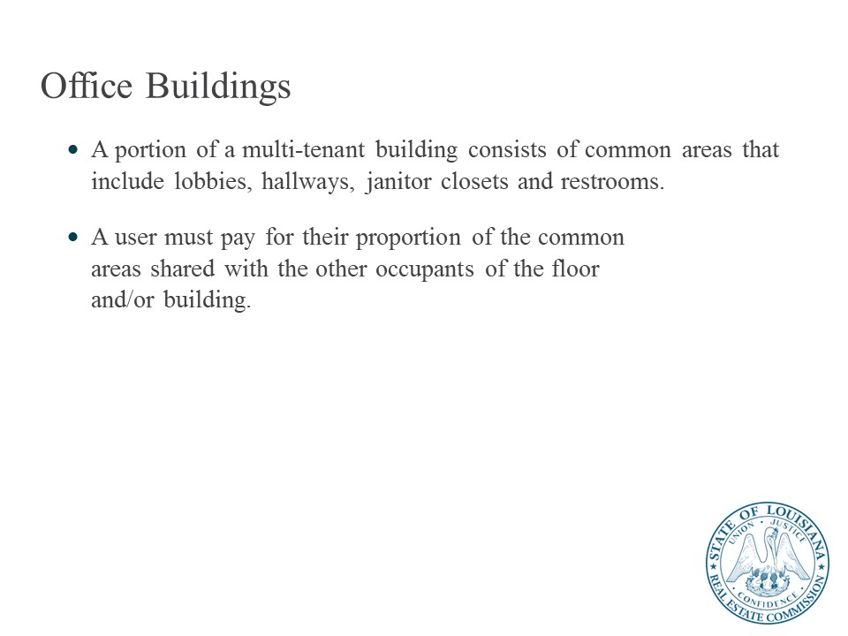
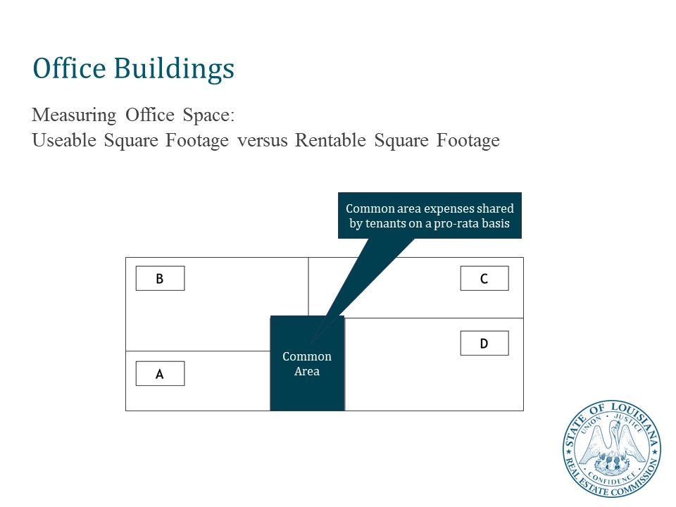
The first distinction is urban (Offices located in downtown areas), and suburban (offices located outside of the city).
Another way is by the number of floors:
Low-rise: Fewer than seven stories above ground level
Mid-rise: Between seven and 25 stories above ground level
High-rise: More than 25 stories above ground level
A third way is by level of finish work.
Class A properties typically accommodate users who need a high-quality finish to attract a specific type of employee or customer. Occupants in a Class A building are likely to be from the fields of law, accounting, energy, financial advisory services, and regional or national headquarters to name a few. The Class A building is normally located close to amenities and enjoys a prestigious area. Rental rates are normally highest for Class A properties.
Class B properties tend to be more functional in nature. Here you will find the typical cube shaped or rectangular building that enjoys the highest amount of efficiency. The finish on the inside of the Class B building can be very nice but tends to have more cost-effective finishes. In addition, users of large quantities of space are often found in Class B buildings due to the economic benefits of lower cost than a Class A building.
Class C properties are those affected by physical, functional, and economic obsolescence. These tend to be in lesser desirable areas, have older facades and limited amenities as compared to the Class A and Class B buildings. The Class C building normally does not have the technological advances or design of newer buildings. Lower rental rates demonstrate the lack of desirability.

Lesson 2: Determining Values of Investment Properties
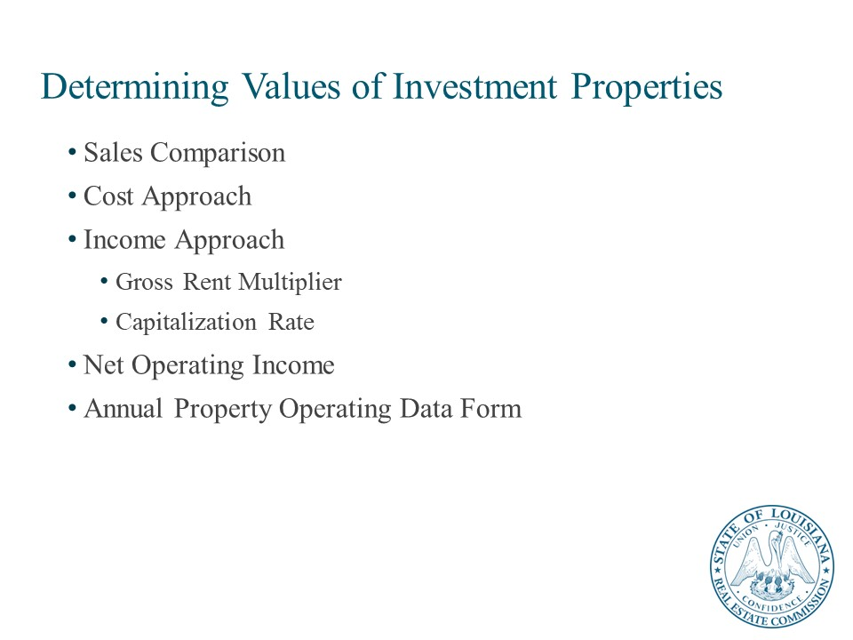
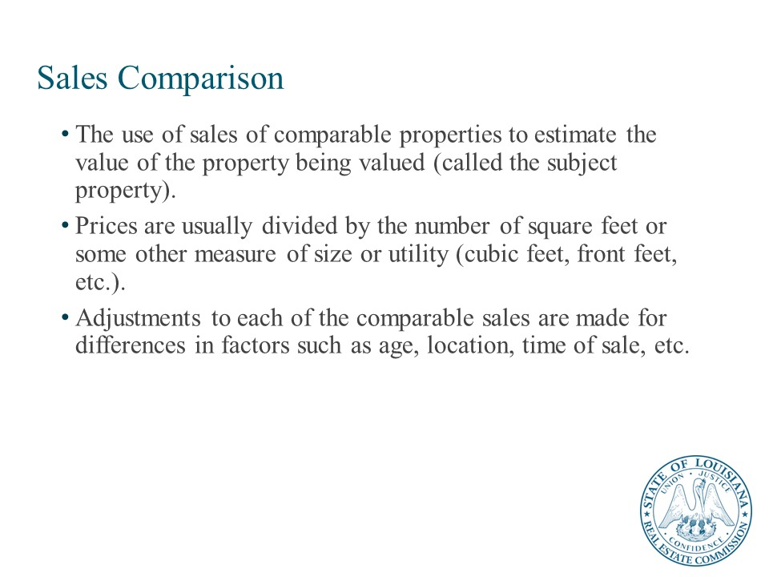
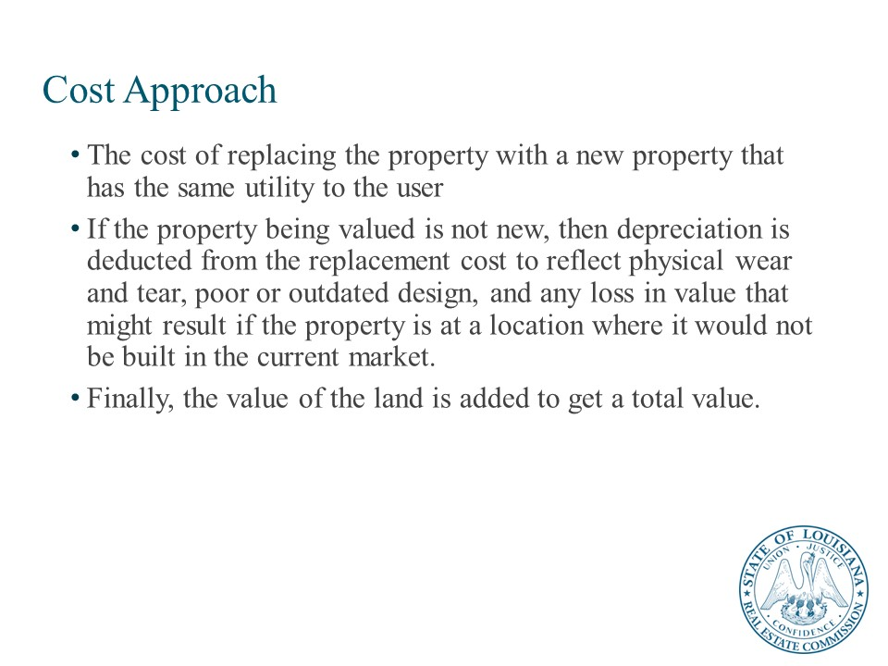

Real Estate Values
The focus of this course is to analyze real estate from the perspective of an investor and what the value of the property is from their perspective. In the case of property owned by an investor, the value from an individual investor’s perspective is referred to as investment value.
When appraisers are asked to value real estate, they are usually asked to estimate the market value for the property. Market value is the value for a typical investor that is most likely to purchase the property based on its highest and best use. It is the most likely selling price of the property.
Investors also care about market value because they do not want to pay more than the property’s market value although they might if the investment value is higher and that is the only way they can acquire the property. For example, the property may be adjacent to one they already own, and they know that the combination of the two properties is more valuable for future development. Also, the investor is likely to want to sell the property at some point in the future and the most likely resale price will be its estimated future market value.

Overview of Valuation Methods
The sales comparison approach relies on the use of sales of comparable properties to estimate the value of the property being valued (called the subject property). Prices are usually divided by the number of square feet or some other measure of size or utility (cubic feet, front feet, etc.) to make the properties even more comparable. Then adjustments to each of the comparable sales are made for differences in factors such as age, location, time of sale, etc. Once these adjustments are made, a value is selected that seems to be the most likely indication of the value of the subject property based on the range of values of the adjusted comparable sale prices. In some cases, this might be an average of the comparable sale prices, although the appraiser may feel that some comparables are more indicative of the value of the subject than others and weigh those more heavily.
The cost approach, which essentially involves starting with the cost of replacing the property with a new property that has the same utility to the user. If the property being valued is not new, then depreciation is deducted from the replacement cost to reflect physical wear and tear, poor or outdated design, and any loss in value that might result if the property is at a location where it would not be built in the current market. Finally, the value of the land is added to get a total value. The land value is usually estimated by the approach we will discuss next which is the sales comparison approach.
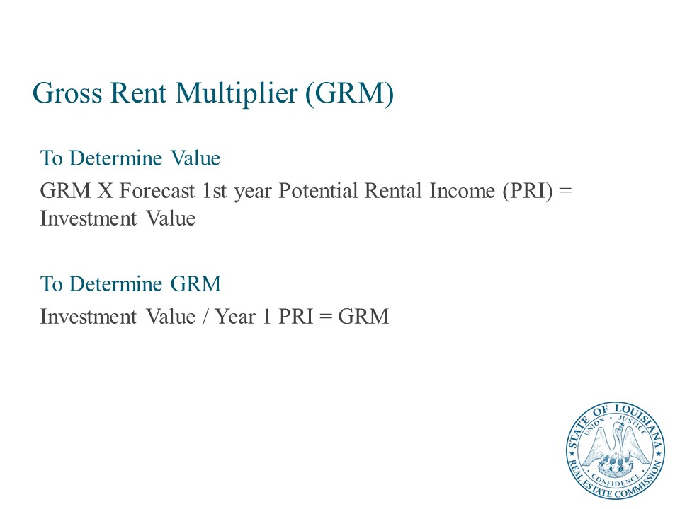
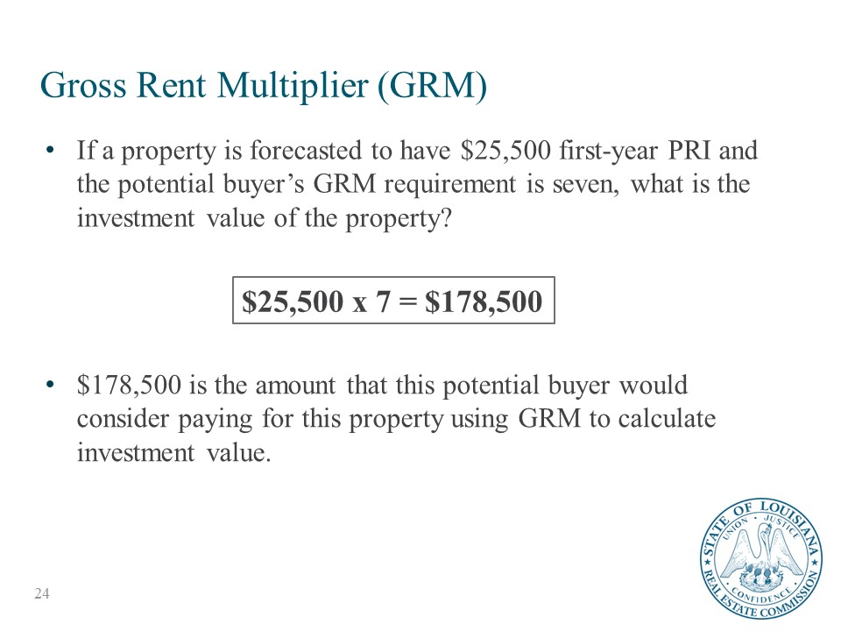
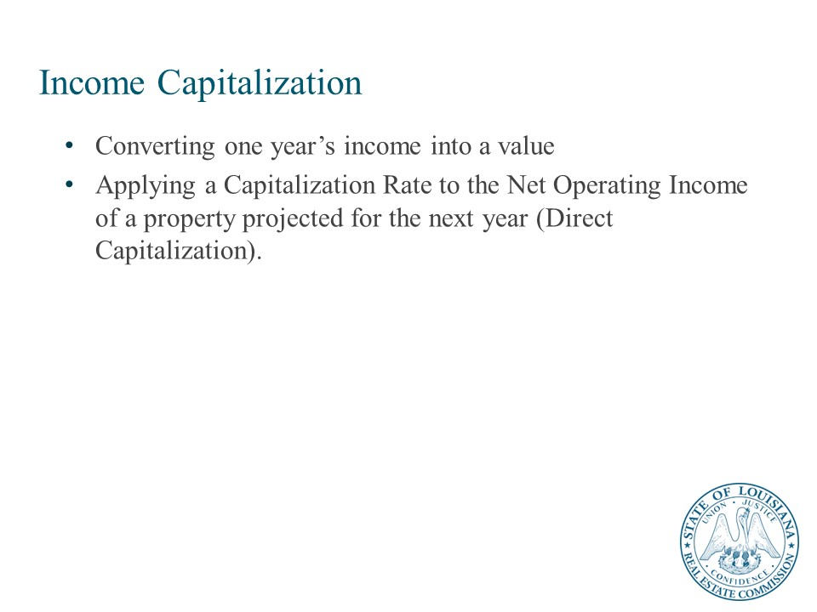
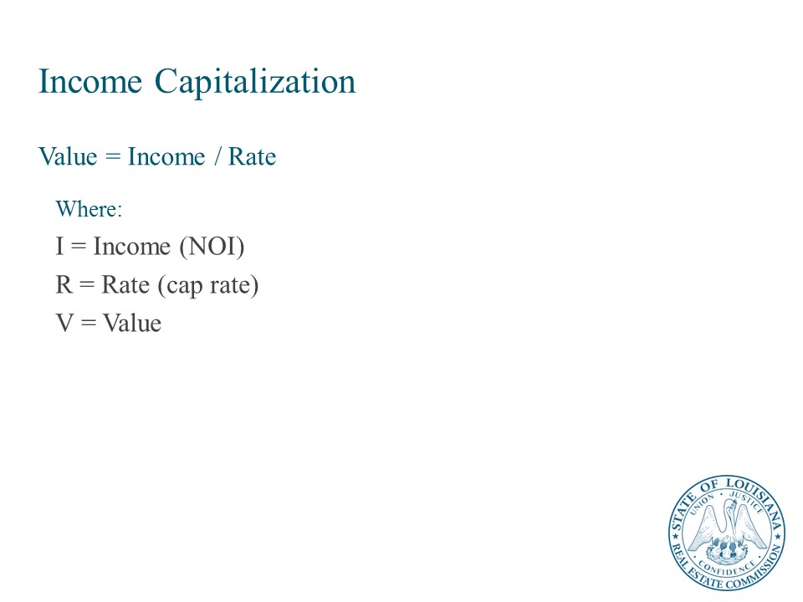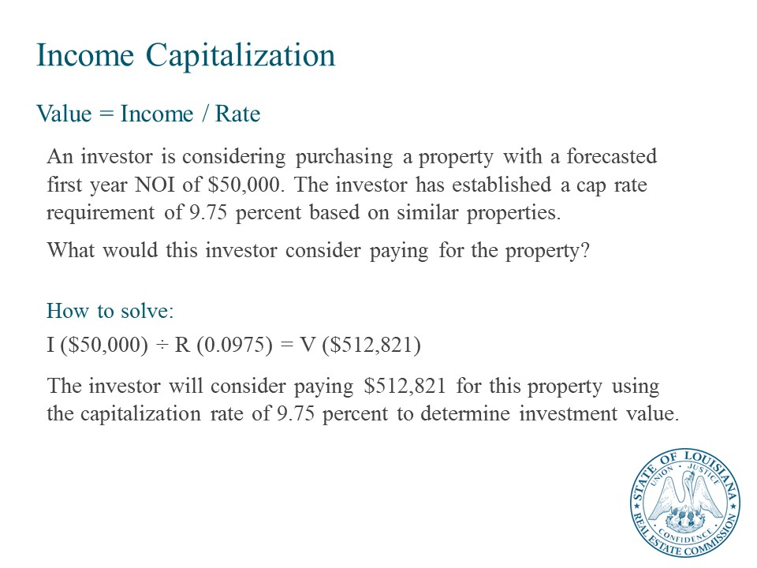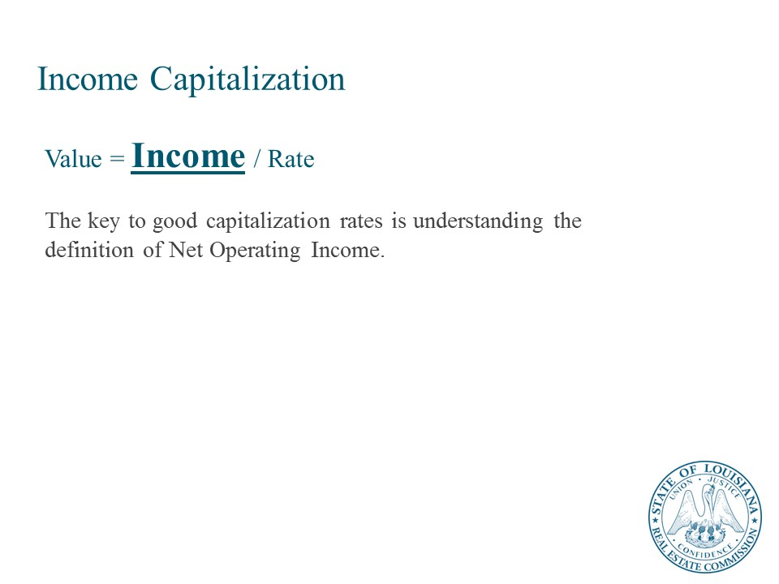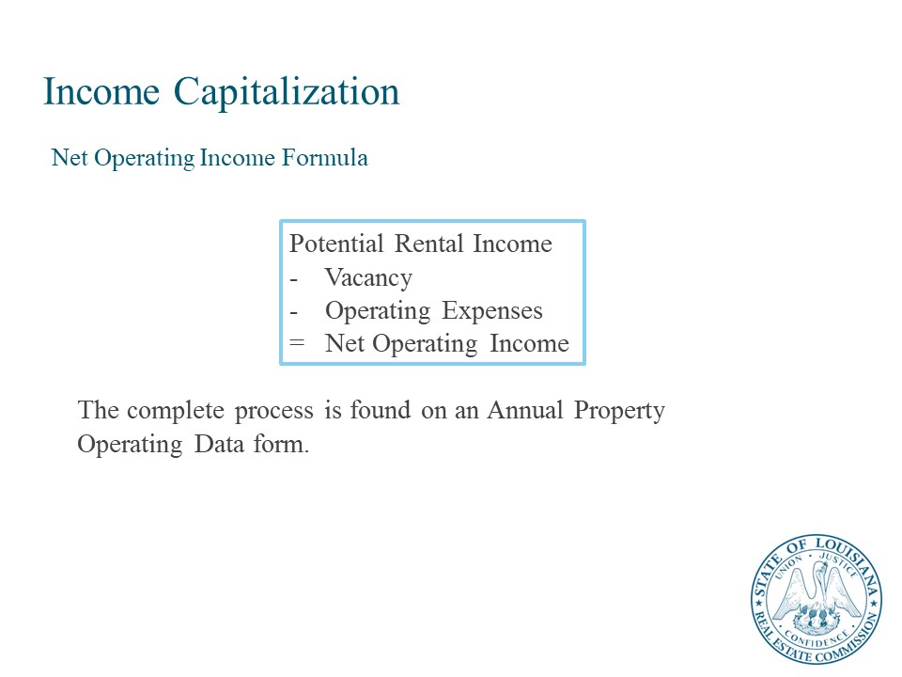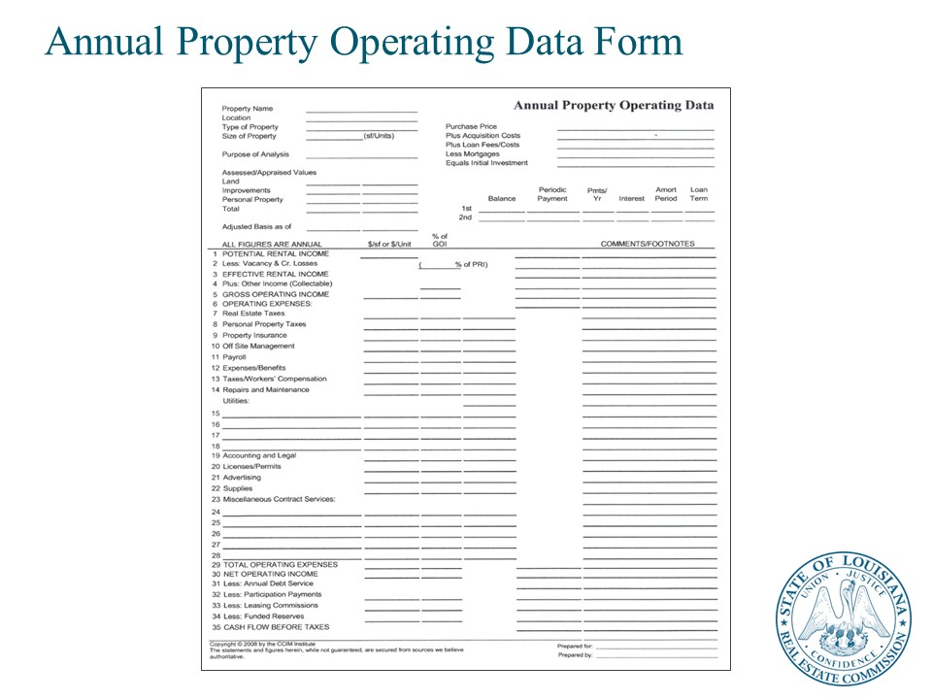
Another approach used to estimate value is the Income Approach. This can involve either projecting cash flows and discounting them (discounted cash flow analysis) or it can be applying a Capitalization Rate to the Net Operating Income projected for the next year.
The appraiser’s final value estimate is based on the results of all three estimates of value, the income approach, cost approach, and sales comparison approach. As noted above, this is usually the market value of the property.
Gross Rent Multiplier and/or cap rate can be applied to determine investment value.

Gross Rent Multiplier
The formula below illustrates how the gross rent multiplier (GRM) is used when determining investment value:
 | GRM
× | Forecast of first-year Potential RentaI Income
= | Investment value

Determining Investment Value Using GRM
If a property is forecasted to have $25,500 first-year PRI and the potential buyer’s GRM requirement is seven, what is the investment value of the property?
How to solve:
 | $25,500
× | 7
= | $178,500
$178,500 is the amount that this potential buyer would consider paying for this property using GRM to calculate investment value.

Measuring Investment Performance Using GRM
The GRM also can measure investment performance assuming a given price. Used in this manner, the GRM indicates how many times the purchase price is multiplied by the first-year PRI.
The formula below illustrates how the GRM measures investment performance:
 | Investment value
÷ | Year one PRI
= | GRM

If a property is offered for sale at $178,500 and the PRI forecast for year one is $25,500, what is the GRM investment performance measure?
How to solve:
The potential buyer can measure investment performance in terms of a GRM as follows:
 | $178,500 (Investment value)
÷ | $ 25,500 (Year one PRI)
= | 7 GRM
Once the GRM is calculated for a given property, it can be compared to the buyer’s own GRM requirement. In this sample problem, the GRM of seven means that the purchase price is seven times the first-year PRI.
A principal advantage of using the GRM technique is its simplicity. However, its simplicity also limits its reliability, since a GRM does not consider vacancy and credit losses, operating expenses, financing, and tax impact. Also, it only looks at a one-year forecast when determining value or measuring performance.

Direct Capitalization
Many investors and appraisers capitalize the income stream of a property to determine value. Investors capitalize an income stream to determine investment value, whereas appraisers capitalize an income stream to determine market value.
Direct capitalization is a process of converting a future income stream into a present value (PV) by dividing a future income amount by a cap rate. The cap rate is the ratio between price (purchase price) and the first-year net operating income (NOI) of the property.
Net Operating Income must be clearly defined when using capitalization rate methodology. Net operating income is defined as Potential Rental Income minus vacancy minus operating expenses. It is important to confirm and verify which expenses are being considered operating expenses and which are not.
Direct capitalization (IRV) formulas are as follows:
I | = | R | × | V
R | = | I | ÷ | V
V | = | I | ÷ | R

Where:
I = Income (NOI)
R = Rate (cap rate)
V = Value

When two of the components of direct capitalization are known, the third component can be determined using one of the formulas above.

Determining Investment Value Using Direct Capitalization
When determining an investment’s value using cap rate, investors use the following formula:
I (NOI) ÷ R (cap rate) = V (investment value)
An investor is considering purchasing a property with a forecasted first year NOI of $50,000. The investor has established a cap rate requirement of 9.75 percent based on similar properties. What would this investor consider paying for the property?
How to solve:
I ($50,000) ÷ R (0.0975) = V ($512,821)

The investor will consider paying $512,821 for this property using the capitalization rate of 9.75 percent to determine investment value.

Measuring Investment Performance Using Direct Capitalization
The direct capitalization method also can be used to measure investment performance at a given purchase price. When using this method, solve for the capitalization rate as shown below:
I (NOI) ÷ V (investment value) = R (cap rate)

The calculated cap rate then is compared to the buyer’s acquisition cap rate requirement to determine if the property will be purchased at the given price. In other words, how does the cap rate at the listed price compare to the investor’s acquisition cap rate requirement?
Assume the investor is considering purchasing a property that is priced at $512,821 with a forecasted first year NOI of $50,000. What is the cap rate?
How to solve:
I ($50,000) ÷ V ($512,821) = R (0.0975)
Thus, the cap rate is 9.75 percent.

Pros and Cons of the Direct Capitalization Method
A principal advantage of using the cap rate is its simplicity of calculation. It also accounts for vacancy and credit losses and operating expenses. However, its simplicity also limits its reliability, since the cap rate does not consider financing or tax impact. More importantly, it only looks at a one-year forecast when determining value or measuring performance. It is rare that investors own properties for 1 year or less.

Annual Property Operating Data Worksheet
The APOD worksheet lists potential components of the NOI model and provides instructions for adding or subtracting values to calculate NOI.

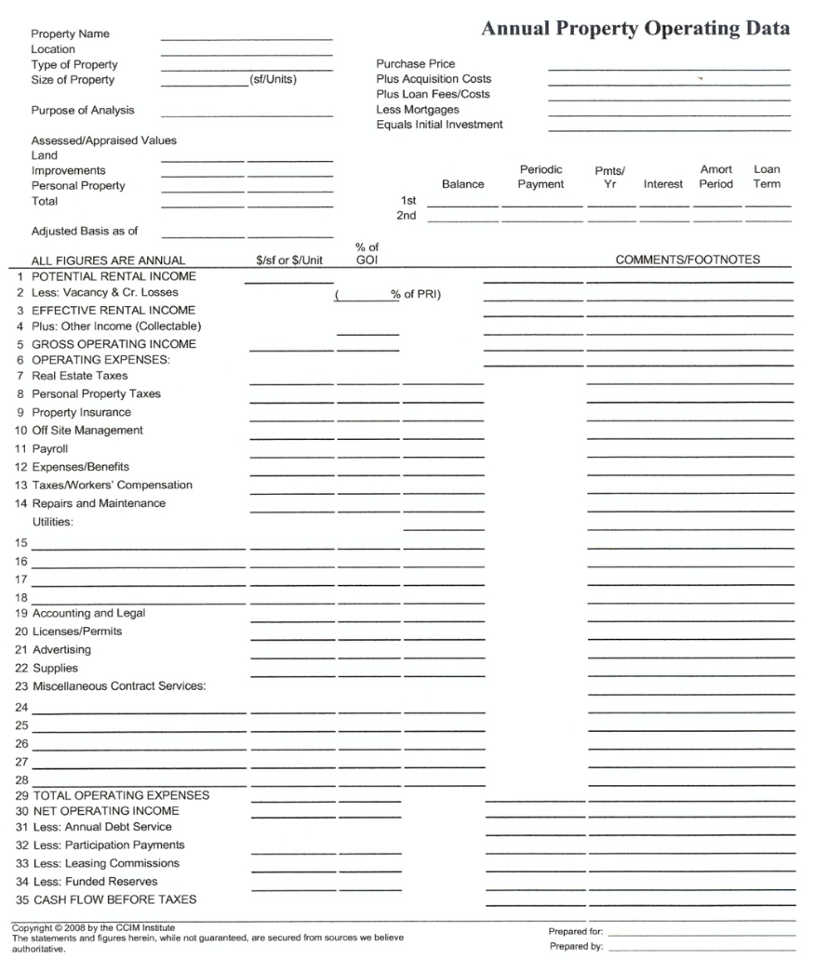

Estimating Net Operating Income
Net operating income (NOI) is a crucial figure throughout all phases of commercial property ownership. NOI is the amount of income left after paying operating expenses. It is the amount of funds left to make mortgage payments and capital improvements. At acquisition it is used to establish a purchase price for the property. It is also the figure that lenders will use when determining the size of the loan they will make available for the purchase a property. NOI must more than cover annual debt service (1 year’s total mortgage payments) for a lender to be comfortable with the size of the loan they give. NOI provides a return measure for the investment during the holding period. At disposition, NOI is important because it is used to calculate the selling price at the end of the investment holding period.

Income Levels
A commercial real estate property has four levels of income. They are potential rental income (PRI), effective rental income (ERI), gross operating income (GOI), and Net Operating Income (NOI).

Potential Rental Income
PRI is the total rental income a property could produce if it were 100 percent occupied at market rental rates. If there are current tenants in-place, PRI is the sum of the rent paid by those tenants plus market rent applied to the unoccupied space. In multi-tenant properties, PRI is almost always a combination of contract rent (the rent being paid by existing tenants), plus market rent for the vacant space.

Net Operating Income
A critical value in the cash flow model is net operating income (NOI). NOI is the annual income generated by an income-producing property after collecting all income from operations, such as rentals and other uses of the property by others, and deducting all expenses required to operate the property. The assumptions and judgments made in calculating NOI greatly affect the decision to invest in a given property and at what price. Lenders use NOI to determine loan amount, investors to determine what they will pay, and appraisers to determine market value.
The four basic components of NOI are:
- Potential rental income (PRI)
- Vacancy and credit losses
- Other income
- Operating expenses

NOI is calculated using the following model:
Net Operating Income
 | Potential Rental Income
− | Vacancy and credit losses
= | Effective Rental Income
+ | Other Income (collectible)
= | Gross Operating Income
− | Operating Expenses
= | Net Operating Income
NOI can be positive if gross operating income exceeds operating expenses or negative if operating expenses exceed gross operating income (GOI). NOI can be a historic value, determined by records of income and expenses from prior years, or it can be forecasted for the coming year and future years.
To obtain NOI data, use leases, financial records, market studies, and other available sources to forecast trends in the market, local economy, and overall economy as they impact the property’s NOI. To start this process, the most important source document is the lease.

Potential Rental Income
Potential rental income (PRI) is the total of all rents under the terms of each lease, assuming the property is 100 percent occupied. If a property is not yet leased, PRI is based on market rents as determined from comparable properties. This is the first value to input into the NOI formula.
Lease analysis is used to determine a property’s PRI. The lease identifies the main sources of a property’s income as well as who pays for which expense. Lease analysis begins with the recognition that there are almost as many different types of leases as there are properties. In general, leases can be viewed on a continuum, with an absolute gross lease at one end of the scale and an absolute net lease at the opposite end; various types of negotiated leases fall somewhere in the middle.
PRI data can be found in existing leases on the property or from competitive market rents in the area obtained from market assessment data from brokers, local financial institutions, appraisers, and other sources.
To calculate PRI, determine the rent under the terms of each lease and total all rents due under all leases. For some properties, this is the end of NOI calculations. If a property has one tenant with a long-term absolute net lease, PRI equals NOI. However, in most other situations, continue NOI calculations by forecasting vacancy and credit losses.

Vacancy and Credit Losses
Vacancy and credit losses are income lost due to vacancies and/or tenants defaulting on lease payments. Data on such losses can be found in existing leases, which specify when each lease expires, or from vacancy and credit losses of comparable properties when rented at market rents (which may be affected by market trends).
To calculate vacancy and credit losses:
- Determine competitive market rents in the area.
- Review the rent history of the property.
- Assess the availability of alternative space.
- Establish vacancy rates for the particular market.
- Review the length of existing leases and lease guarantees.
- Assess tenant quality, economic strength, and current lease satisfaction.
Forecasting vacancy and credit losses means analyzing how competitive rents are within the local market. The impacts of the supply of comparable space and the quantity of space in demand are important components in the vacancy factor. Leases also may include options to renew under different terms than the present lease.
Credit losses may be incurred when tenants are in arrears on their rent, when an apartment dweller doesn’t pay rent that is due, or when tenant eviction or bankruptcy proceedings are pending. Any of these circumstances may result in a loss of rental income and/or create extra collection and legal expenses.

Effective Rental Income
Effective rental income is PRI minus vacancy and credit losses. This is the rental income the owner anticipates collecting. Effective rental income is calculated as follows:

Effective Rental Income
 | Potential Rental Income
− | Vacancy and credit losses
= | Effective Rental Income
+ | Other Income (collectible)
= | Gross Operating Income

Other Income
A property may produce income other than rental income derived from the space the tenant occupies, such as billboard space on the side of a building facing an interstate highway, laundry income in apartment projects, telecom equipment rental on high-rise office buildings, parking, etc. This income is classified as other income. Other income is independent of rental income.
Other Income
 | Potential Rental Income
− | Vacancy and credit losses
= | Effective Rental Income
+ | Other Income (collectible)
= | Gross Operating Income
− | Operating Expenses
= | Net Operating Income

Data on other income can be found in the financial records from prior years or lease terms, which include provisions for security and damage deposits and pet fees. To calculate other income, total all sources of other income.

Gross Operating Income
Gross operating income (GOI) is the total of effective rental income plus other income from all sources. It is the total of all income from the annual operation of the property before operating expenses are deducted. GOI is calculated as follows:

Gross Operating Income
 | Potential Rental Income
− | Vacancy and Credit Losses
= | Effective Rental Income
+ | Other Income (collectible)
= | Gross Operating Income
− | Operating Expenses
= | Net Operating Income

Operating Expenses
Operating expenses are cash outlays made each year to maintain and operate the property, so it continues to produce market rents.

Operating Expenses
 | Potential Rental Income
− | Vacancy and credit losses
= | Effective Rental Income
+ | Other Income (collectible)
= | Gross Operating Income
− | Operating Expenses
= | Net Operating Income

Examples of operating expenses follow:
- Real estate and personal property taxes. Real estate taxes and personal property taxes are levied based on an assessed value, which may be reassessed on a periodic schedule or if the property is sold. An investor also may request an appeal of the assessed value if the value of the property declines and/or rents decrease dramatically.
- Property insurance. Insurance rates generally are based on the replacement cost of the property or improvement that is insured, the level of coverage chosen, and the specific hazards covered, such as fire, vandalism, and specified natural disasters (i.e., earthquakes and floods). Costs vary based on supply and demand within the insurance marketplace and the underwriter’s perception of risk. While insurance generally does not vary with occupancy changes, an empty building is considered a higher risk and is charged a higher premium than an occupied building.
- Management and personnel expenses (on- or off-site). Property management could include payroll, payroll taxes, and benefits if building management employees are on the premises. Management services, which normally include employee supervision, leasing, accounting, and negotiating service contracts, normally are based on a percentage of GOI.
- Repairs and maintenance. This includes painting of interior and exterior public areas, periodic repairs of building systems, elevator maintenance, and supplies (such as light bulbs, paper, and cleaning products).
- Utilities. Utility costs may include water, sewer, gas, solid waste removal, and electricity. These costs vary with occupancy levels, but not in direct proportion. Costs for common area electricity or landscape irrigation generally do not vary with occupancy. Costs for utilities in rental areas may vary with occupancy, depending on whether each space is metered separately.
- Other expenses (accounting, legal). Other expenses must be estimated on a case-by-case basis. For example, legal expenses may be higher for larger buildings. Data on operating expenses can be found from local, city, state, or federal taxing authorities; insurance agencies; maintenance records; utility companies or commissions; and property or building managers.

Items Excluded from Operating Expenses
Certain items typically are not classified as operating expenses when determining NOI. These excluded items are as follows:
- Interest and principal on debt encumbering the property. Financing costs or debt service does not impact a property’s NOI. This is an expense of ownership, not an expense of operating the property.
- Depreciation (cost recovery). Depreciation is an accounting entry, not actual cash outlay. This is an expense of ownership, not an expense of operating the property.
- Capital expenditures. Such expenses are written off for tax purposes over a period of years rather than during the year the cash outlay occurs, such as major repairs and replacements. These are rarely reoccurring expenses and not annual expenses required for the operation of the property.
- Income taxes. These are the obligation of the individual or entity that owns the property and are not an operating expense of the property.
- Reserves for replacement. These are funds set aside for future maintenance (such as to replace a roof, parking lot, or air-conditioning unit) and are not current operating expenses.
- Tenant improvements. This includes construction within a tenant’s useable space to make the space viable for the tenant’s specific use over the term of the lease.
- Real estate commissions. Commissions are fees paid to real estate agents involved in negotiating and facilitating the purchase or lease agreement.

Final Calculation for NOI
After calculating all of the previous components, NOI can be determined. NOI is GOI minus operating expenses. This is the end result of the NOI calculation:
Net Operating Income
 | Potential Rental Income
− | Vacancy and credit losses
= | Effective Rental Income
+ | Other Income (collectible)
= | Gross Operating Income
− | Operating Expenses
= | Net Operating Income

Lesson 3: Resources for Decision Making

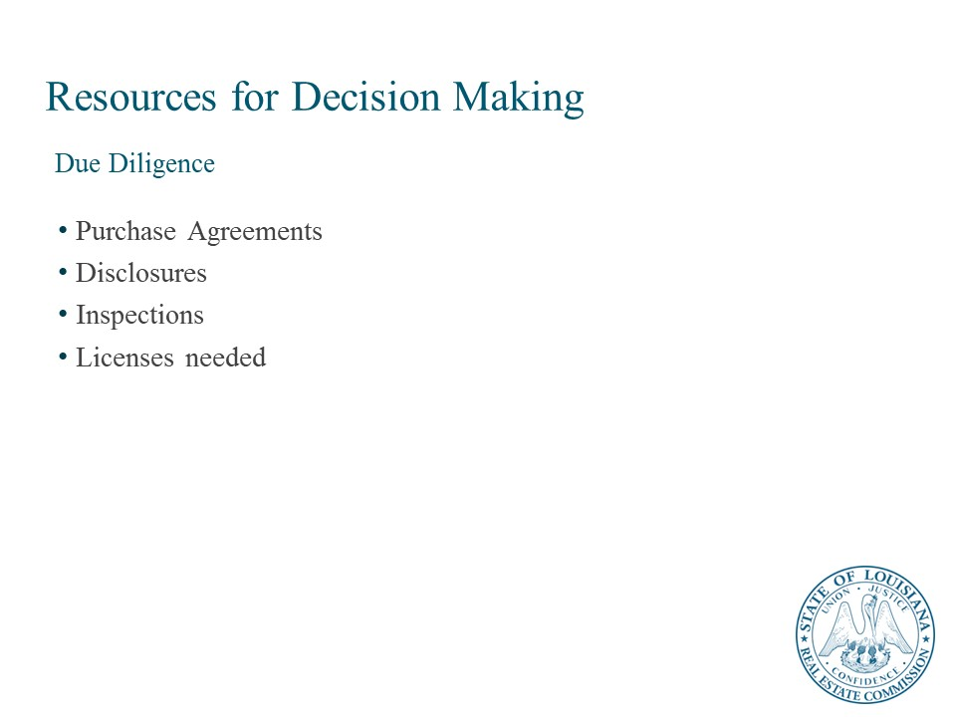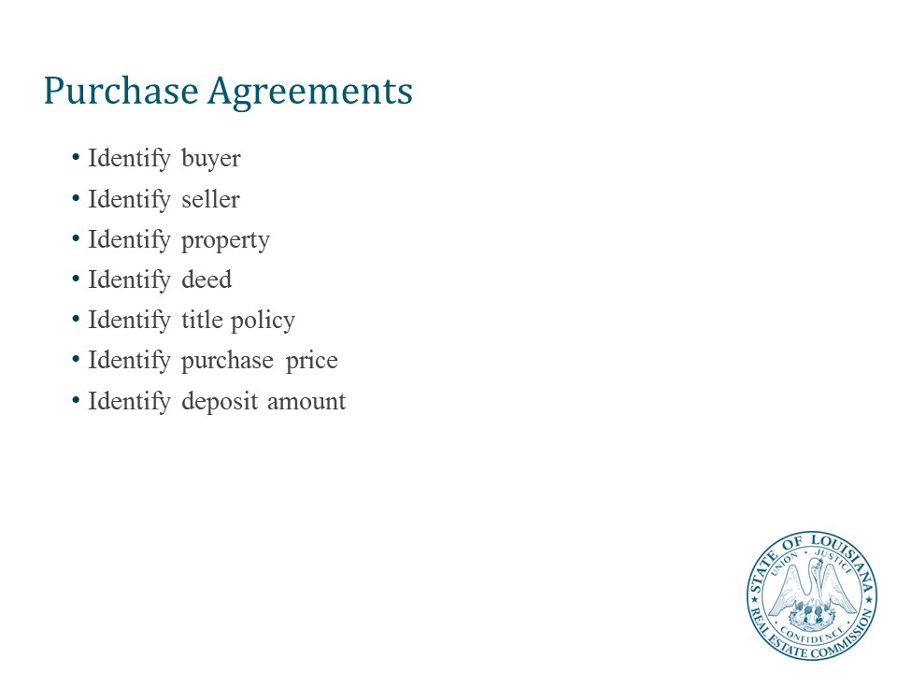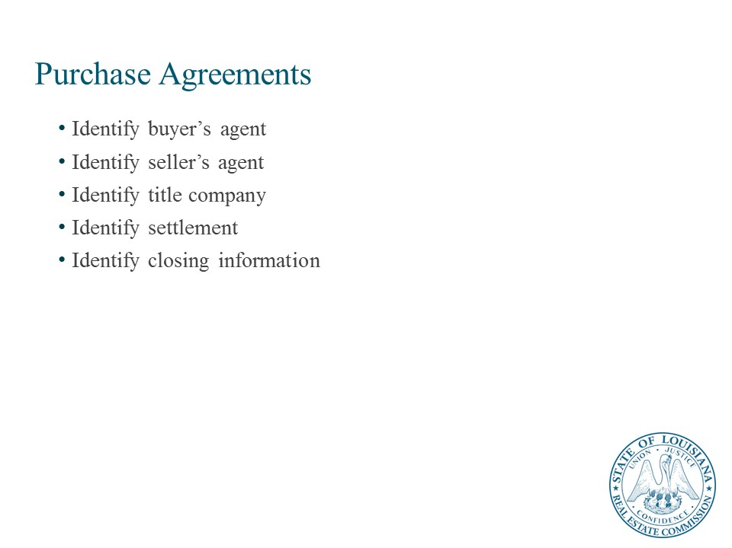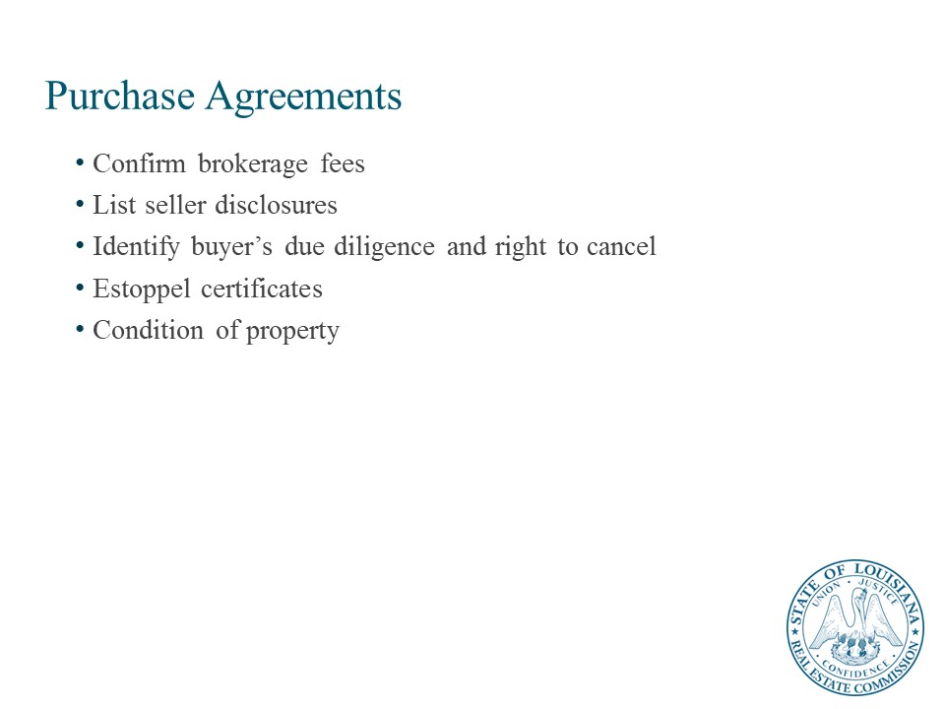

Purchase Agreements, Disclosures, Inspections, Licensing

Due Diligence Process
The due diligence process gives a buyer full access to the property for a deeper understanding of the commercial real estate asset. Typically, the buyer and seller of a property will agree to a timeline for the buyer to obtain all the information they feel is important prior to purchase. Due diligence takes place during the process of creating the Purchase and Sale Agreement (PSA). It is not uncommon to have a 60-day PSA that stipulates a 30-day due diligence period.
The buyer will typically be asked to deposit funds with the seller to confirm their intent to purchase the property. If the buyer uncovers any substantial new issues during the due diligence period, there’s a window of opportunity to discuss these items with the seller.

The following is a list of the key considerations when completing due diligence on a prospective purchase.
- Legal description of the property.
- The most recent title policy or title commitment on the property in the possession or control of seller together with all related documents.
- Zoning Compliance Certificate for the property and all zoning approvals (including variances and any pending applications).
- Declaration of covenants, conditions, restrictions, reservations and easements for the property.
- Seller’s third-party engineering, environmental reports (including but not limited to Phase I and Phase II reports, NFR letters, mold abatement reports and underground storage tank testing and closure reports), appraisals, soil tests, boring reports, foundation reports (logs of pilings), termite or radon studies.
- A true, correct and complete copy of each written lease and each guaranty (together with any amendments), and a certification that there are no oral leases or oral understandings, if any.
- An accounting of all rent and other income, common area maintenance, security deposits and real estate tax contributions paid by any tenant at the property, including, without limitation, a certified rent roll, showing current rent, previous rent if applicable, delinquencies, security deposits, years of occupancy, lease commencement date and lease termination date.
- All security deposits and any other amounts to which any tenant, vendor, or any other party may be entitled.
- A copy of the last three years’ real estate tax bills, including special assessments or incentives, copies of all tax protests, related correspondence and protest results for the property and copies of the prior two years’ utility bills for the property.
- A true, correct and complete copy of each written service contract (together with amendments thereto, if any) and a true, correct and complete written summary of each oral service contract, together with copies of any and all other contracts and agreements relating to the operation, maintenance and repair of the property.
- An accounting of all income and expenses related to the property, including collection reports and tax statements for the last three years.
- A list of all personal property, if any, owned by the seller, located at the property, and used or useful in connection with its operation and maintenance.
- A list of all permits, partial certificates of occupancy, certificates of occupancy, warranties, government notices, special assessments, code violations and unexpired guaranties and copies of same in seller’s possession or control.
- A copy of existing insurance policies and certificates and any pending claims against the property.
- A schedule of pending litigation, if any, affecting the property or seller’s ability to convey the property.
- Any and all other matters as purchaser may deem reasonably necessary to satisfy itself, in its sole discretion, concerning the property and the status of the property’s title.
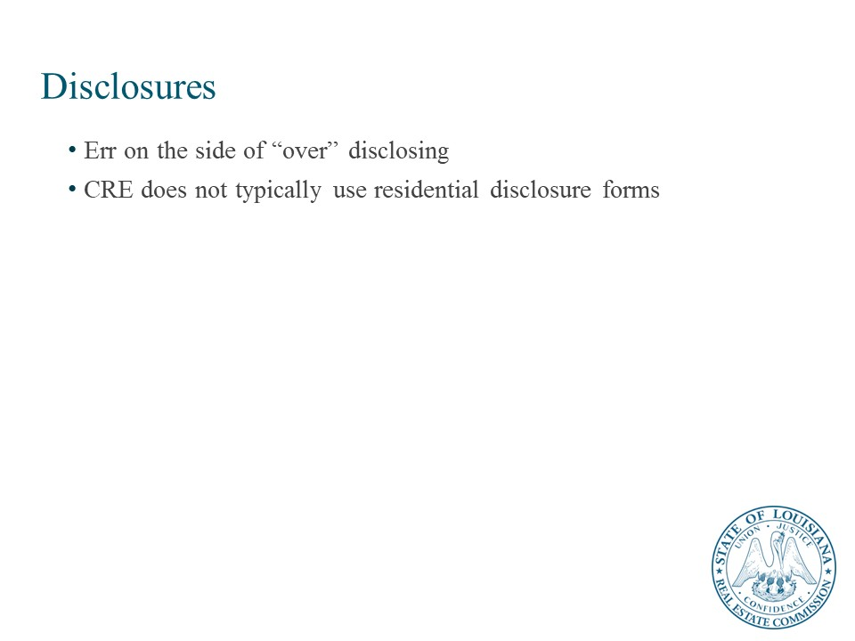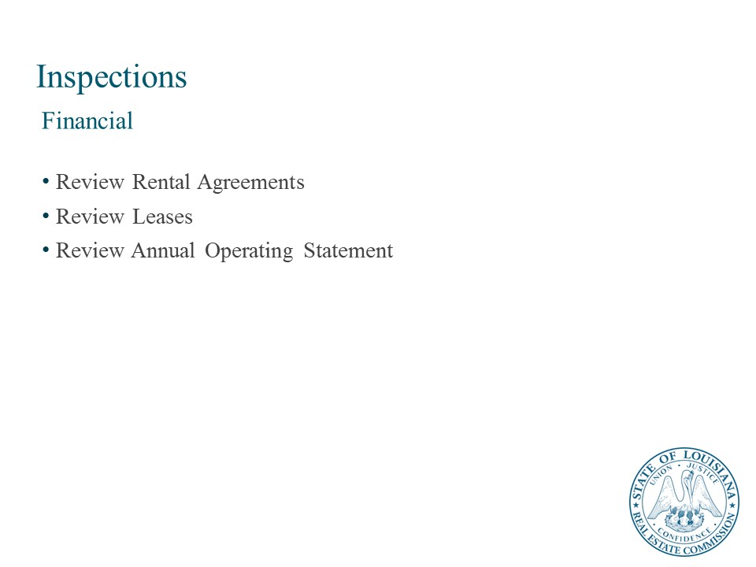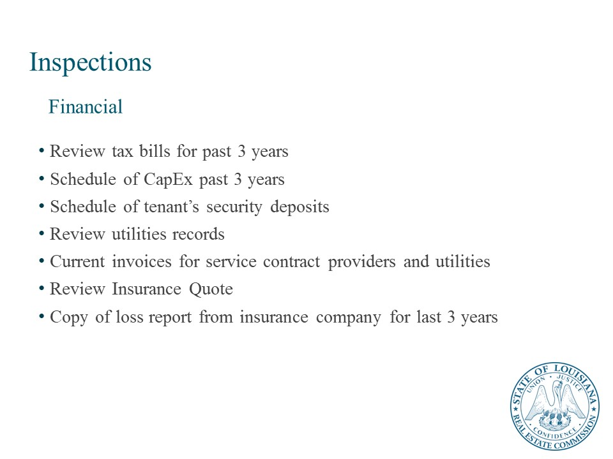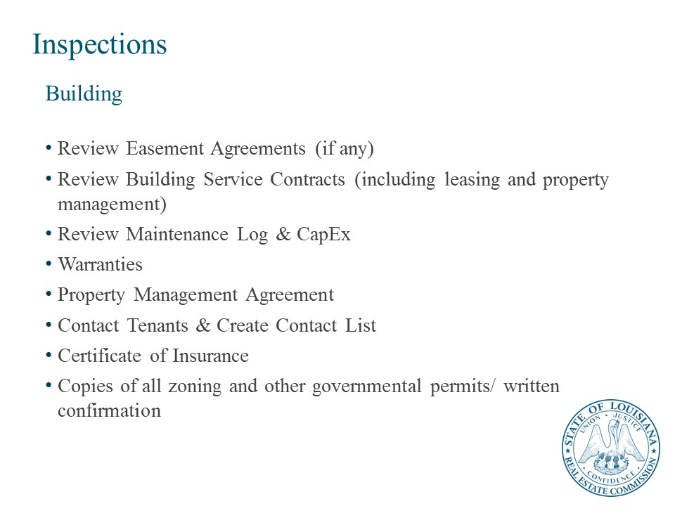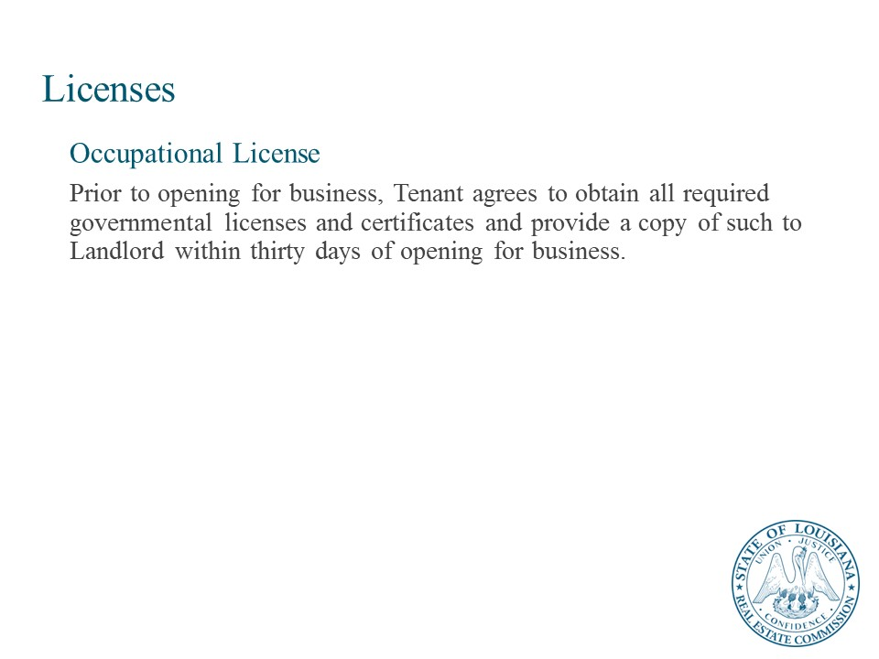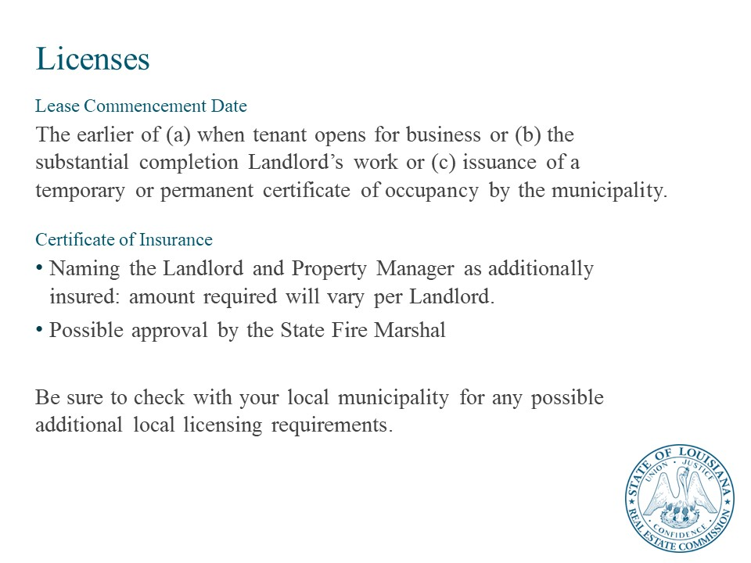

Disclosure
Be sure to work closely with an expert who can guide you in disclosures. For example, if a crime occurred on the premises, must you disclose that? Alternatively, what about if a feud with a neighbor resulted in property damage or an assault, like in the case of Rand Paul? Is that a disclosable issue?
Experts in real estate agree on one key point – err on the side of over-disclosing rather than omitting information that a litigious party may discover and later allege in a claim.
Commercial real estate sellers may mistakenly rely on “as is” provisions in a sales contract to limit their liability. This language is not foolproof, especially when the seller knows of the condition of the property prior to its sale.
An intentional failure to disclose can cause insurers to deny coverage based on the “intentional acts” exclusion.
Here are some of the legal theories used in cases involving a failure to disclose.
- Misrepresentation – Courts can affirm that a party “misrepresented” fact based on an affirmative statement made by the seller. For example, courts would probably consider this a misrepresentation: Stating, “This property has never suffered mold damage” when in fact a recent water loss involved professional mold remediation services.
- Nondisclosure – In contrast to misrepresentation, nondisclosure is just that – you fail to disclose when you should have disclosed. This is where insurance coverage can get sticky because insurers may construe that failure to disclose is an intentional act or decision by the property owner. Given those circumstances, it is well within the insurer’s rights under the insurance contract to assert a coverage declination.
- Potential damages – Plaintiffs usually seek damages for the cost to remediate any defects. In the example of a faulty roof structure, the cost to repair the roof would be part of the damages sought in the lawsuit. What if the plaintiff loses rental income due to the roof repair? Certainly, the plaintiff will assert a claim for this type of loss or any decrease in the value of the property.
Fiduciary relationship. By taking a listing, the broker undertakes a fiduciary relationship with the owner. Fiduciary obligations include good faith, fair dealing, the exercise of a high degree of skill and diligence, and the full disclosure of material facts. The broker cannot take any action that conflicts with the interest of the principal (the owner, in this case) without the principal's consent.
Risk control. Regardless of the type of listing, you can minimize legal problems by following a simple procedure:
- Make all agreements and disclosures in writing.
- Keep a written log of all contacts with buyers, sellers, and others.
- Use complete and correct information.
- Be ethical (adhere to the REALTORS Code of Ethics).
- Document all interaction with cooperating brokers.
Keep principals informed of activity in writing on a regular basis

Licensing
In order to list for sale or for lease real estate in any U.S. jurisdiction, the individual must hold a real estate license in the state or territory in which the sale/lease is taking place. Licenses are granted by state governments. Often, each state government will require a certain number of education hours to obtain and maintain a real estate license.

Client Licensing

Occupational License
Prior to opening for business, Tenant agrees to obtain all required governmental licenses and certificates and provide a copy of such to Landlord within thirty days of opening for business.

Lease Commencement Date
The earlier of (a) when tenant opens for business or (b) the substantial completion Landlord’s work or (c) issuance of a temporary or permanent certificate of occupancy by the municipality.

Certificate of Insurance
- Naming the Landlord and Property Manager as additionally insured: amount required will vary per Landlord.
- Possible approval by the State Fire Marshal
- Be sure to check with your local municipality for any possible additional local licensing requirements.

Lesson 4: Data for Decision Making
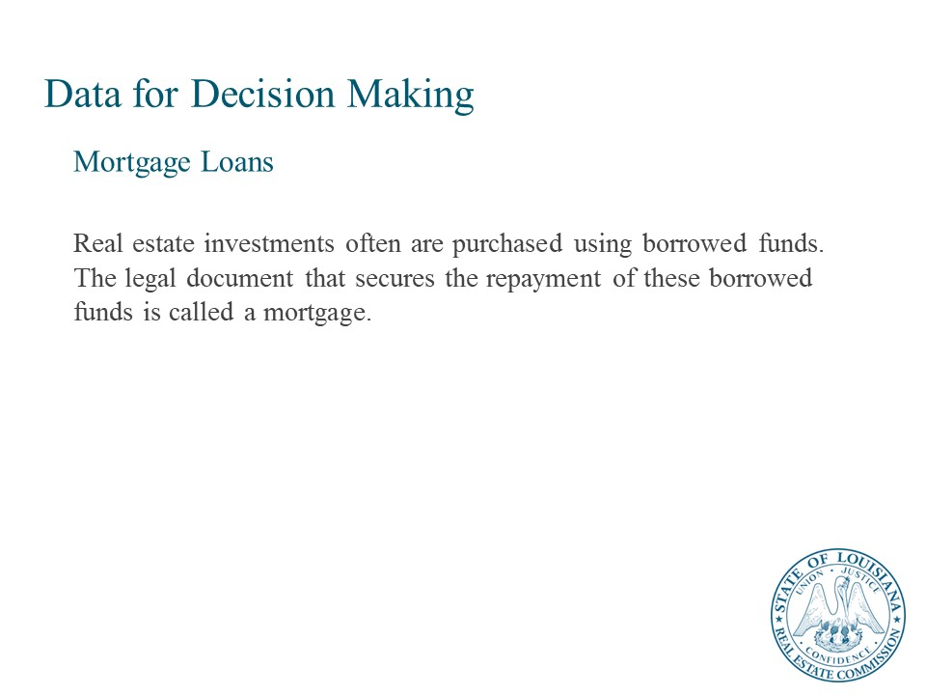
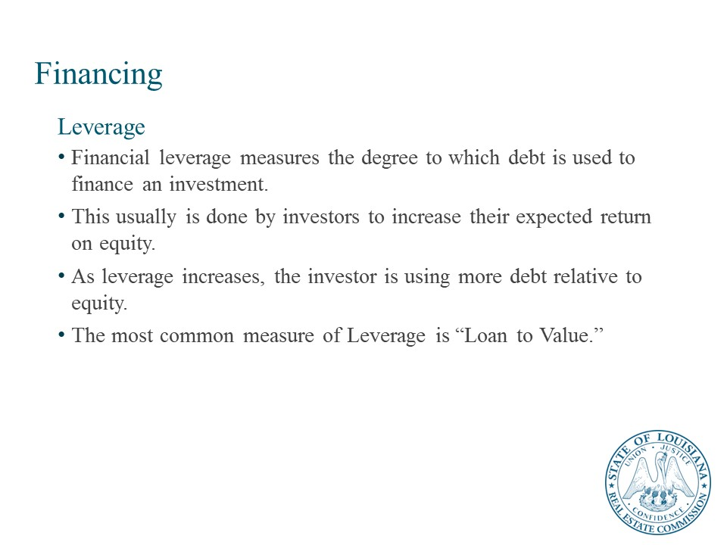
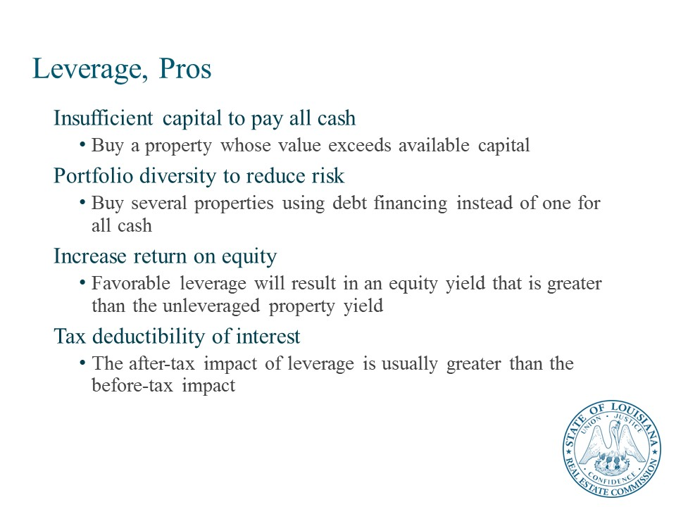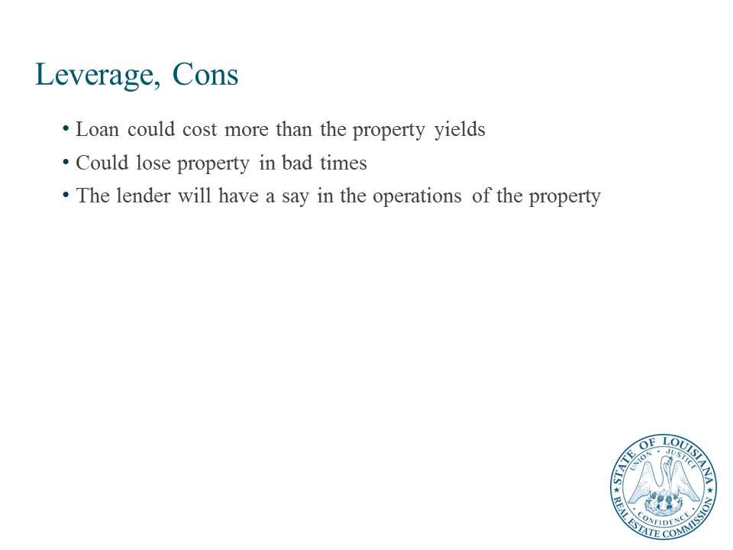

Mortgage Loans
Real estate investments often are purchased using borrowed funds. The legal document that secures the repayment of these borrowed funds is called a mortgage. The promise to repay the borrowed funds is the promissory note, which accompanies the mortgage. Several components are involved in obtaining a mortgage and there are additional associated costs, including legal fees, survey and appraisal fees, and other miscellaneous third-party costs. Points may also have to be paid—a point is 1 percent of the original loan amount. Mortgages also require a down payment, which is the amount the buyer invests to obtain a property. Mortgages are paid back over a certain period of time. Payments are usually monthly, but in commercial real estate other payment arrangements can be negotiated.

What is Financial Leverage?
Most commercial real estate investments are purchased with borrowed funds because of the benefits of financing and the long-term nature of the investments. Borrowing money to buy an investment also is called leveraging an investment.
Financial leverage measures the degree to which debt is used to finance an investment. This usually is done by investors in an attempt to increase their expected return on equity. As leverage increases, the investor is using more debt relative to equity.
An investor might buy a $1,000,000 building with $800,000 in debt financing and $200,000 of equity. In this case, she has an 80 percent loan-to-value (LTV) ratio.

Types of Leverage
Leverage can be favorable, neutral, or unfavorable. When leverage is favorable (positive), investors expect a higher return on equity than if they purchased the investment on an all-cash basis. When leverage is unfavorable (negative), investors expect to receive a lower return on equity than if they had paid all cash. Neutral leverage exists when the expected unleveraged internal rate of return (IRR) on the property (i.e., all cash) is equal to the cost of debt. Thus, the IRR on the equity equals the IRR on the property. In such a situation, the investor and lender both expect to receive the same rate of return.
Rational investors normally would expect leverage to be positive to compensate for the risk involved in borrowing money. Risk increases with leverage. As investors use more leverage, they expect a higher return because they are taking on more risk. However, the investor’s actual return may be less than projected, and leverage may be unfavorable, resulting in a lower return than if debt had not been used. This is the nature of the risk that investors take when they use debt financing.

Reasons for Borrowing Money to Buy Real Estate
Investors might decide to borrow money for many reasons:
- The most obvious case of debt financing is when investors simply don’t have enough cash available to pay for the investment in full, so they ask outside lenders to complement equity financing. Debt financing allows investors to make an investment that might not be possible otherwise.
- Debt financing can be part of investors’ broader investment strategies. Although they have enough equity to buy properties in full, they may deliberately choose to raise debt financing. The investor can be more diversified by using leverage to purchase more than one property.
- If the financial leverage is favorable (positive), the use of debt financing also increases the investor’s expected return on equity. When leverage is favorable, the investor’s return on equity invested exceeds the return that would be earned without the use of debt financing, although the risk also increases.
- Due to the tax deductibility of interest paid on debt, investors also might decide to borrow money to enhance the leverage of after-tax equity returns. The benefits of leverage often are magnified when evaluating the investment on an after-tax basis.

Methods of Disposition

Outright Sale
When an investor sells real property, the most common method is the outright sale, in which the investor receives all sale proceeds in one lump sum. The potentially large amount of taxes due on the sale of income property can be a significant deterrent to ordinary sales. Although taxes on gains cannot be eliminated, investors can use two methods—installments sales and like-kind exchanges—in certain situations to defer the payment of capital gains taxes. Additionally, gain can be deferred in the event of an involuntary conversion of the investor’s property.

Case Study Part 1: Investment Property
This work by Sightline Institute Modest Middle Homes Library is licensed under a Creative Commons Attribution 4.0 International License.

Case study scenario
Dee Breaux is the broker for Tiger Realty in Baton Rouge. Her newest clients, Joe and Lisa Burreaux, are in the market for an investment property near LSU campus. Dee finds them the perfect University Place four-plex near campus, and the Burreauxs love the property as a rental investment opportunity! Each of the four-plex units are 2-bedroom, 1.5 bath flats, which are leased on a monthly basis for the following rental payments:
- Apartment A – $500 / month
- Apartment B – $475 / month
- Apartment C – $550 / month
- Apartment D – $600 / month
Property expenses are as follows:
- Insurance – $1,800 / year
- Taxes – $1,500 / year
- Landscaping – $150 / month
- Association Fees – $200 / month
- Property Management – 10% / month
- All tenants are required to pay their own unit’s utility expenses.

Case study problem
What is the highest dollar amount the Burreauxs can pay for the University Place four-plex if they base the purchase price on a 10% capitalization rate?

- Enter your answer in the space below. Show the formula you used.

Income / Rate = Value
$15,450 / 10% = $154,500
The Burreauxs can pay $154,500 and get a 10% return on their investment.

Part 2: Property Management

Lesson 1: Overview of Property Management
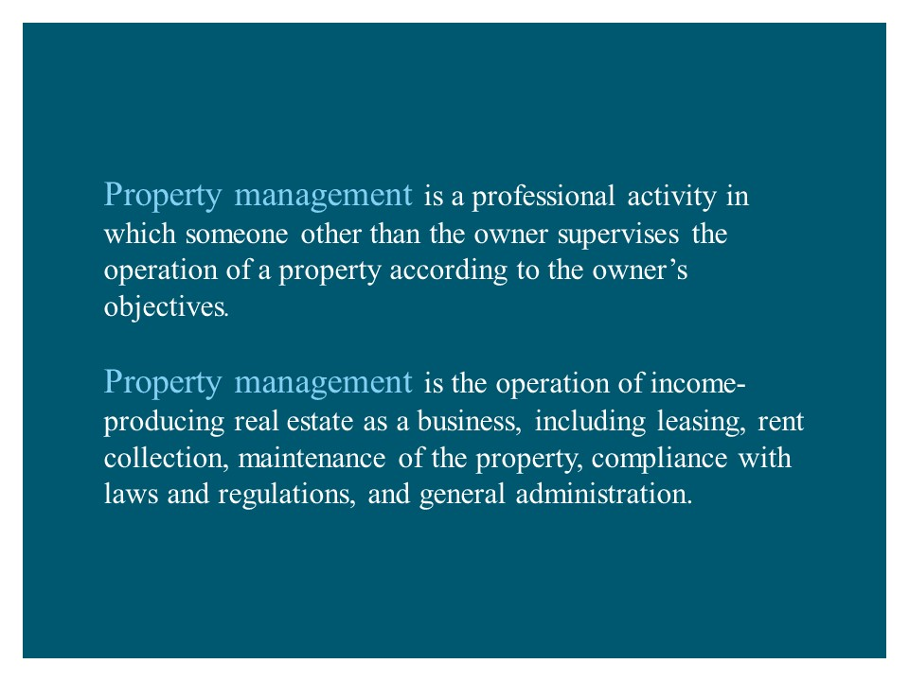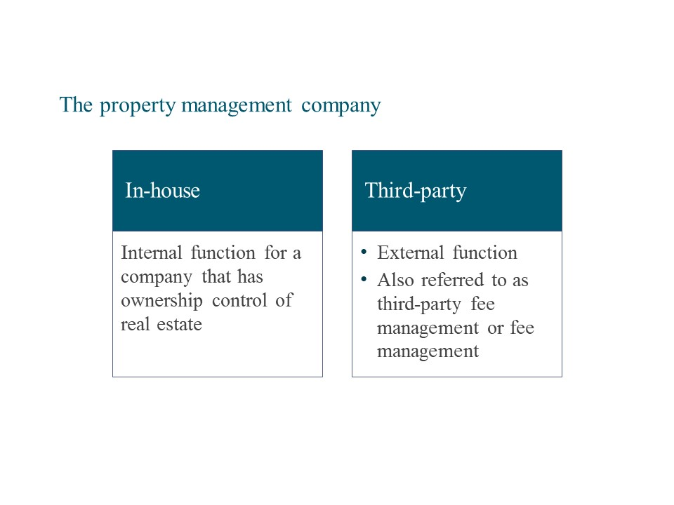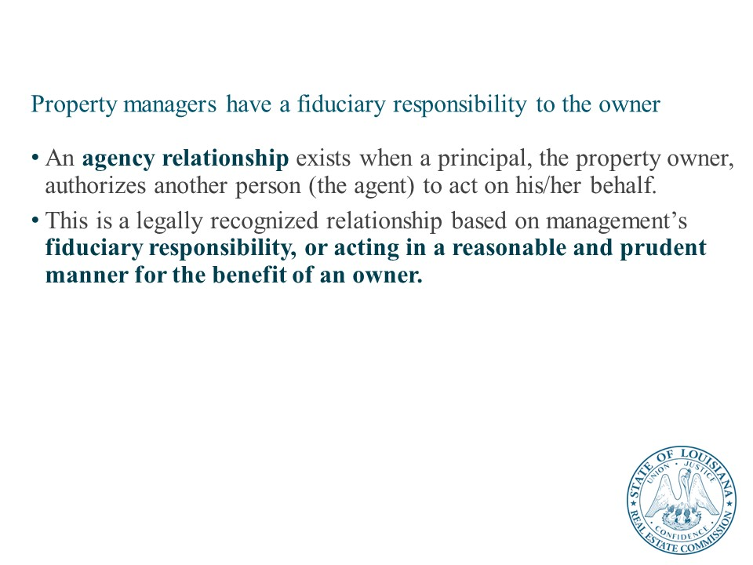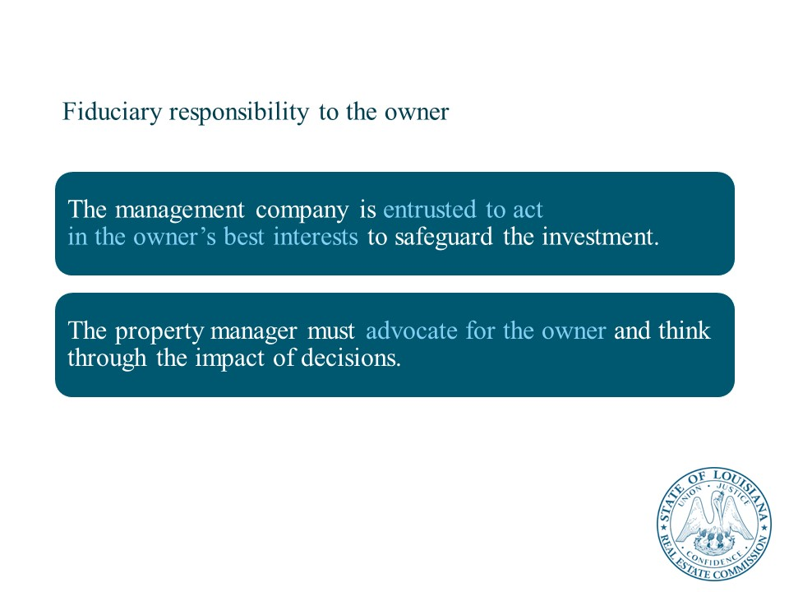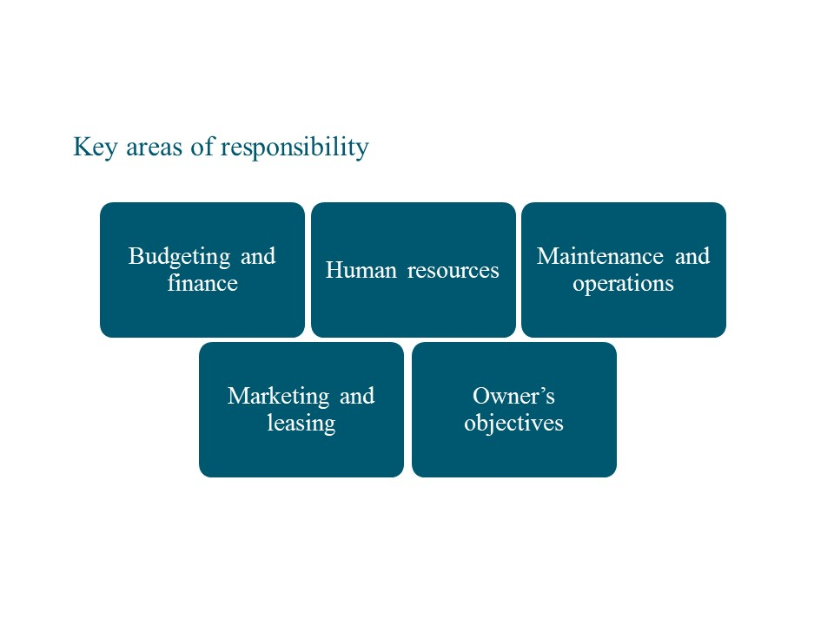
Property managers perform several functions in the management of properties. Key among these functions are:
- Budgeting and finance—all properties must have annual operating budgets, and property managers must constantly monitor income and expenses and impact on investment value.
- Human resources—the property manager’s team is critical to a well-managed property.
- Maintenance and operations—the property manager has responsibility for most aspects of property operations. This includes maintenance of the physical property and its systems; tenant relations; emergency planning; and many other functions.
- Marketing and leasing—effective marketing and leasing are required to optimize occupancy and rent levels.
- Owner’s objectives—property managers manage investment real estate according to the owner’s objectives for the real estate asset. The management plan and strategies will align with those objectives.
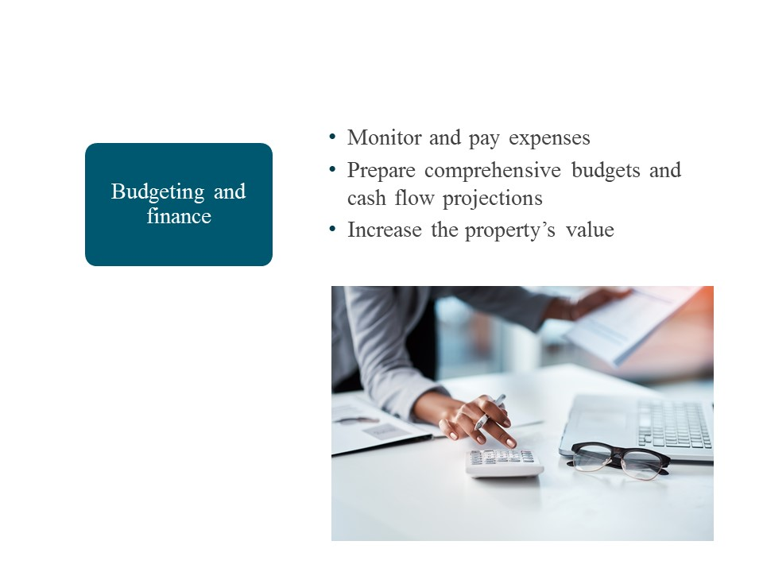
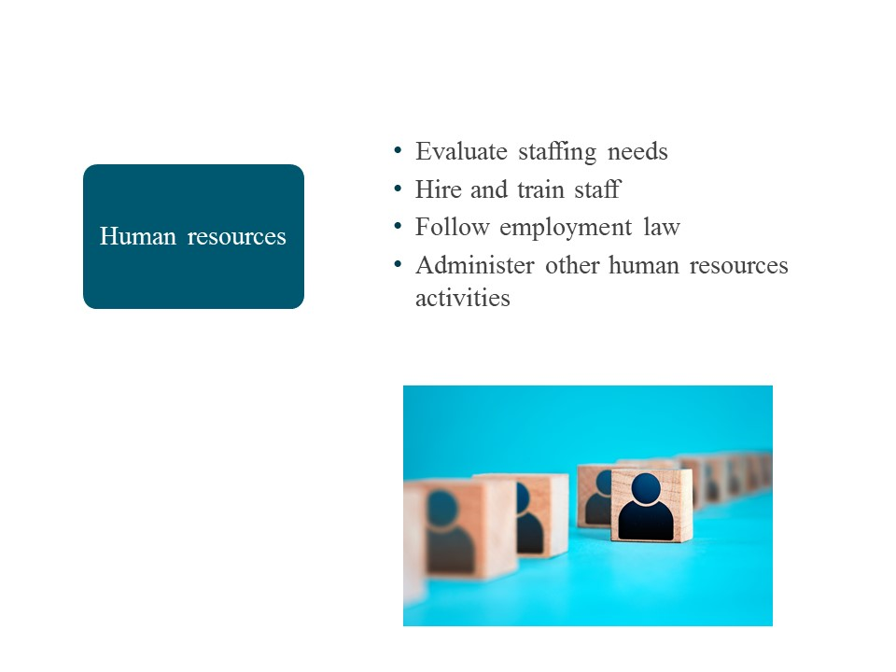

Key Human Resources Functions
Effective property management is not possible without high-functioning, diverse, and trained property teams. While many property managers have guidance and support from corporate human resources professionals, they must have the knowledge and skills to perform the following functions.
- Identify staffing requirements and functions
- Hire, manage, and evaluate employees
- Provide training and development opportunities for staff
- Follow employment law
- Employ leadership skills and techniques
- Recognize the benefits of diversity in the workplace
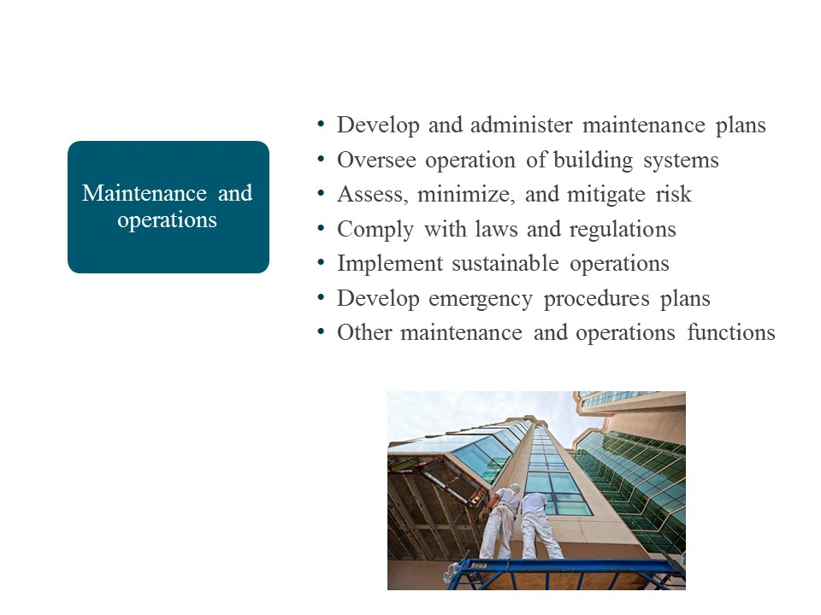
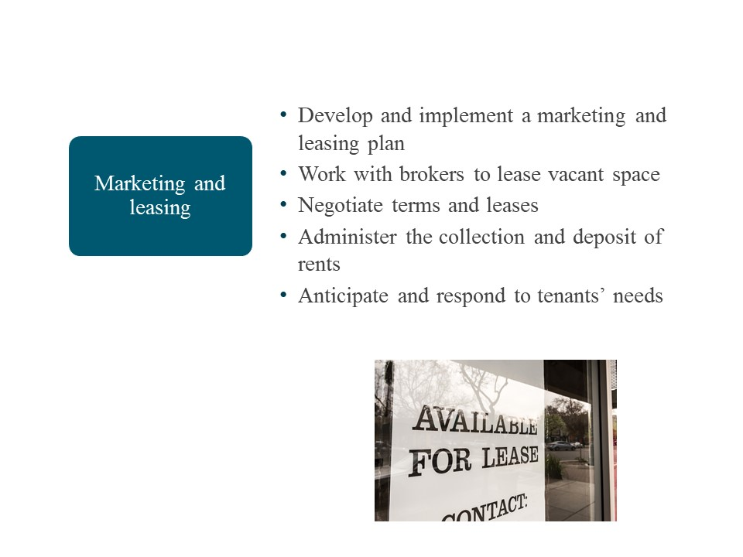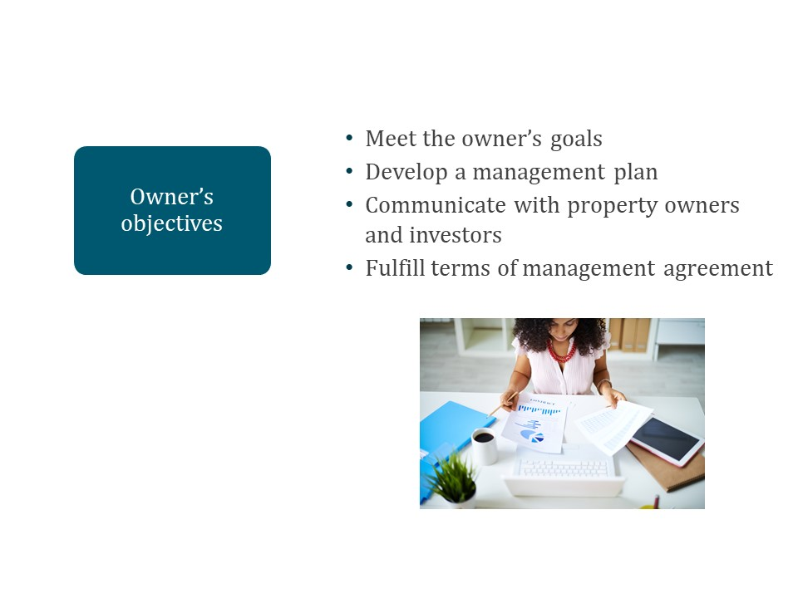

Why are the owner’s objectives so important?
Everything ties back to the owner’s objectives for the real estate investment. For example, consider an owner who plans to hold an apartment property long-term. Their objectives will tie directly to that investment hold period. Management goals and priorities, as outlined in a management plan for the property, will include strategies to achieve those objectives.
Property management strategies

Owner’s objectives

Instructor:
Facilitate a discussion on the importance of managing according to the owner’s objectives.
Emphasize:
- Property budgeting, maintenance, marketing and leasing, staffing, and everything else flow from the owner’s objectives for their investment (e.g., investment hold period will impact nature of any property improvements).
- The owner may have goals around maintenance of the property, equipment repair and replacement, sustainability, and other areas that require a clear understanding of their objectives.
- You need to be able to provide accurate, complete info on property performance to the owner.
- Surprises in cash flow and returns—including income beyond projections—could create undesirable positions for the owner (e.g., tax obligation)

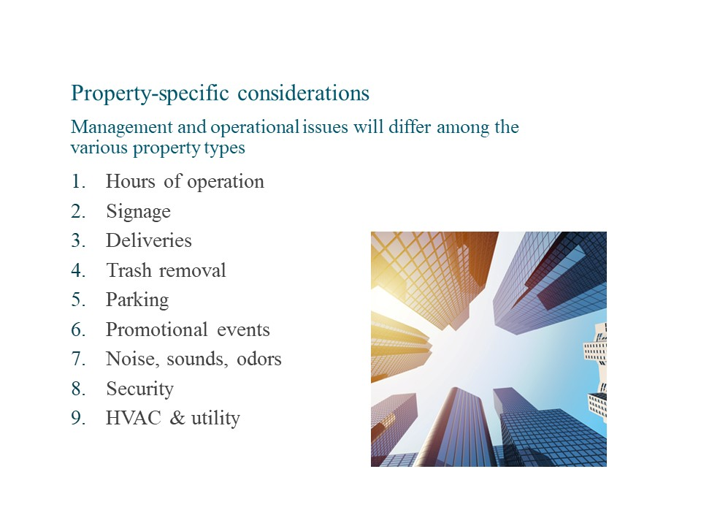

Examples of property-specific considerations
Examples of property-specific variations in management and operational issues include:
- Hours of operation—an office building typically has set operating hours, based on tenant operations. However, a residential property essentially runs 24 hours/day, 7 days/week.
- Signage—an industrial property will require much different, and probably far less, signage than a multifamily community.
- Deliveries—particularly with the rise in online shopping, multifamily communities must devote space and resources to managing package deliveries, storage, and other logistics. Retail properties will receive deliveries of inventory.
- Trash removal—office and multifamily properties typically have a centralized waste and recycling program, while each tenant usually procures these services at open-air shopping centers.
- Parking—parking may be a source of additional income for the property. Can you charge a parking fee? Are you able to rent out excess spaces? Is parking configured to maximize income?
- Promotional events—multifamily communities often have resident engagement events. Shopping malls often have large events that are open to the public and require significant planning.
- Noise, sounds, odors—cooking smells can be a source of conflicts at residential properties. All of these can present challenges at industrial properties, depending on tenant operations.
- Security—keeping occupants, staff, and guests safe is a priority of property management.
- HVAC and utility—regular maintenance on and efficient operation of building equipment, such as HVAC and lighting, can help manage operating expenses.

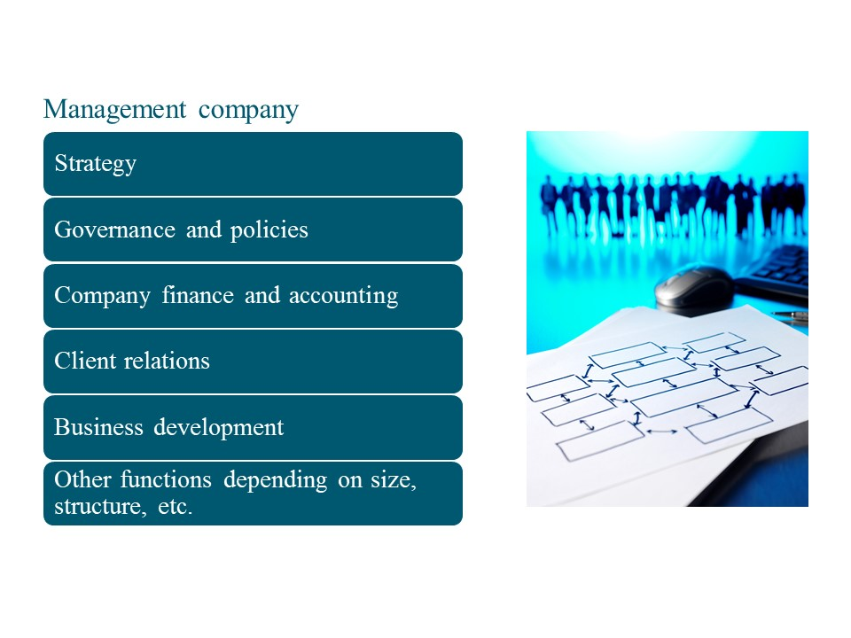

Management company structure
The following organizational chart shows a simplified example of how a small management company might be structured. Most companies have several different layers. How management companies are structured will vary by:
- Company size
- Company culture
- Types of owner(s)
- Market of operations
- Property type and portfolio
- Internal versus outsourced functions
- Additional services offered
- Other factors

Example management company structure
Simplified for instructional purposes

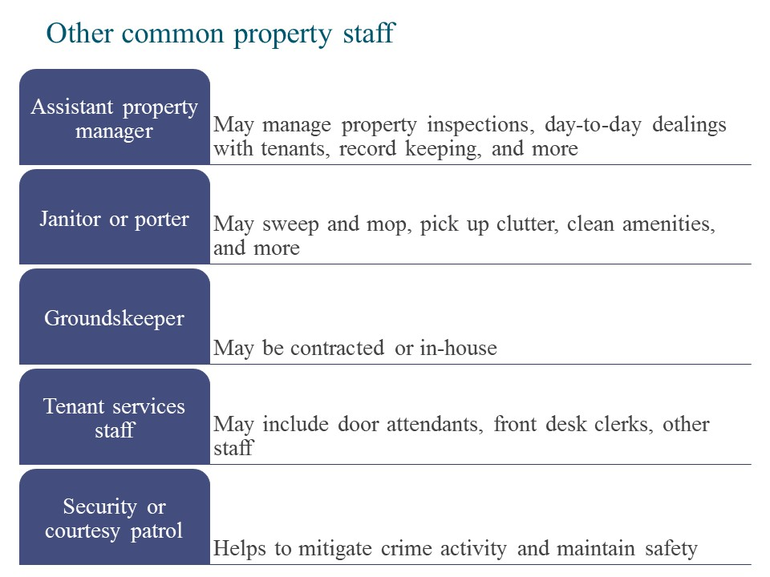
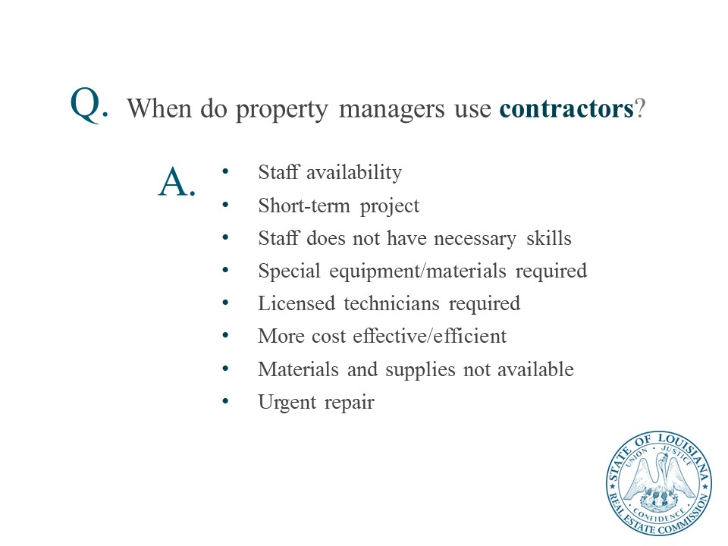

Contract best practices
Property management requires effective selection and management of contractors. Elements of a successful contracting practices include:
- Prepare a detailed scope of work and timeline
  - Use team members to help develop these details
  - Look at successful contracts for similar work in the past
- Obtain three (3) bids if possible
  - If the work is urgent, use a local, trusted contractor
  - Reach out to trusted colleagues for contractor recommendations
- Use logic and critical thinking to assess the submitted bids and the ability of the contractor to perform the work
- Check the internet for common industry costs
- Talk with trusted colleagues to assess the bid details and whether they are reasonable for the market and property type
- Use a per square foot approach where possible (or square yards for carpet)
- Compare bids using an “apples to apples” approach.
- Use a standard template for contracts if you have one available
- Always add the scope of work as a contract exhibit
- Add deadlines and timeframes in contracts (e.g., Phase 1, Phase 2)
- Inspect the contractor’s work regularly
- Obtain lien releases, insurance, and permits
- Ensure legal, code, and health and safety compliance
- Know how the work performed by the contractor will affect the property and its tenants.
- Issue any notices to tenants to inform them in advance of the work.
- Install signage where spaces are impacted by the contractor’s work (e.g., elevator out, fitness center closed).
- Approach any issues that arise during the contract in a solution-oriented manner
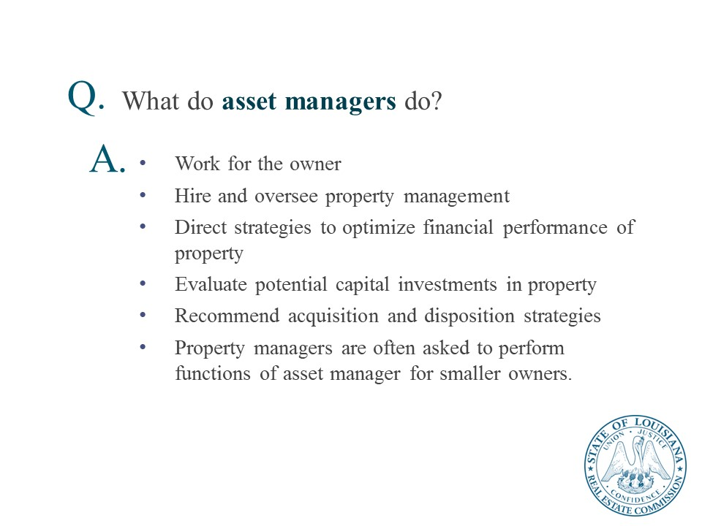

Knowledge Check

Property Management Roles and Responsibilities
- Which of the following activities is a property manager likely to engage in? (Select all that apply.)
- Design a building
- Supervise a renovation
- Meet with the property’s owner
- Change an air conditioner unit
- Prepare a budget
- Hire a leasing agent
- Install new carpeting
- Fill in the blank.
A property manager has a __fiduciary_ responsibility to the owner and is entrusted to act in the owner’s best interest.
- Which of the following are key duties of property managers under human resources? (Select all that apply.)
- Hire management company leadership
- Acquire new business
- Hire and train property staff
- Evaluate property staffing needs
- Hire management company accounting staff
- Follow employment law
- Obtain necessary business permits
- Which of the following are key duties of property managers under maintenance and operations? (Select all that apply.)
- Oversee operation of building systems
- Fix a leaky skylight
- Recommend property disposition strategies
- Adjust controls on a boiler
- Manage property design and construction
- Prepare and oversee a maintenance plan
- Implement an emergency procedures plan
- Which of the following are key duties of property managers under owner’s objectives? (Select all that apply.)
- File the owner’s business taxes
- Meet the owner’s goals
- Develop a corporate strategy
- Develop a management plan
- Manage property design and construction
- Hire management company leadership
- Fulfill terms of management agreement
- Fill in the blank.
Representing the owner, the _asset_ _manager_ hires and oversees property management.

Lesson 2: Property Management in Louisiana
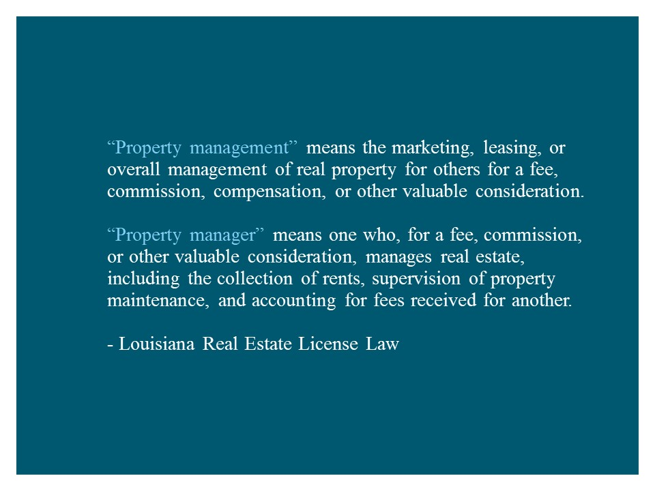
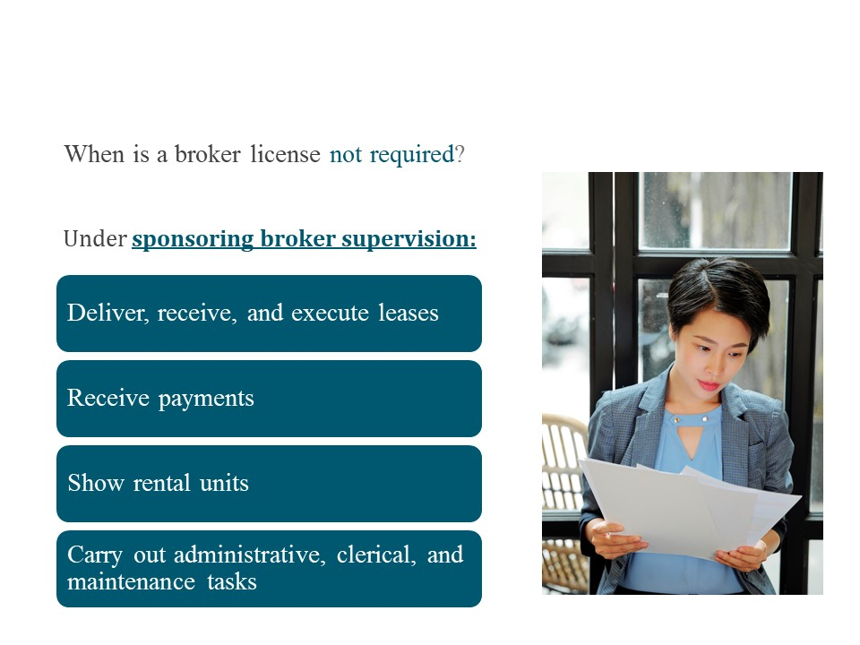

Other instances where a license is not required in Louisiana
- Property owners are not required to have a real estate broker license.
- Managers of HUD public housing
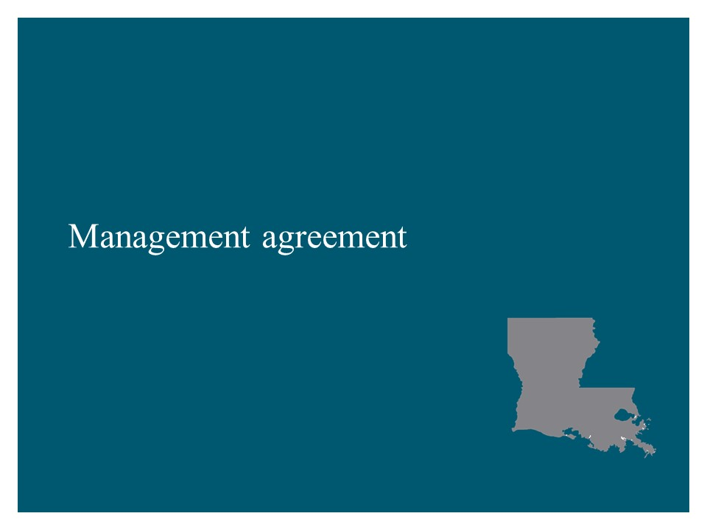
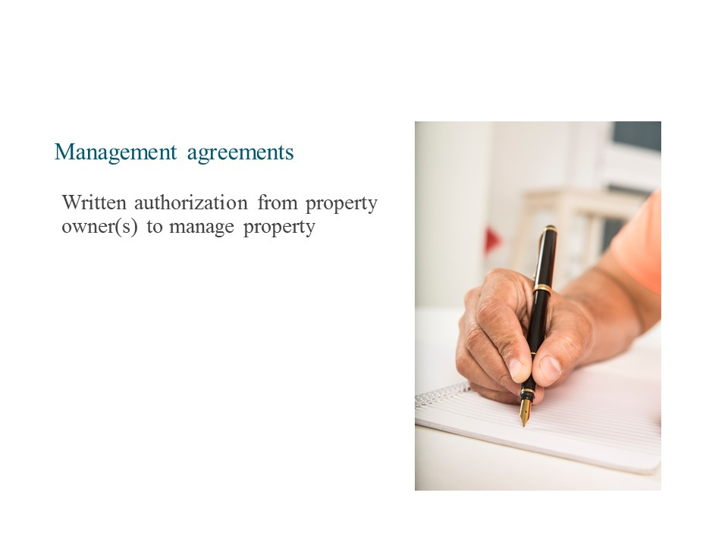
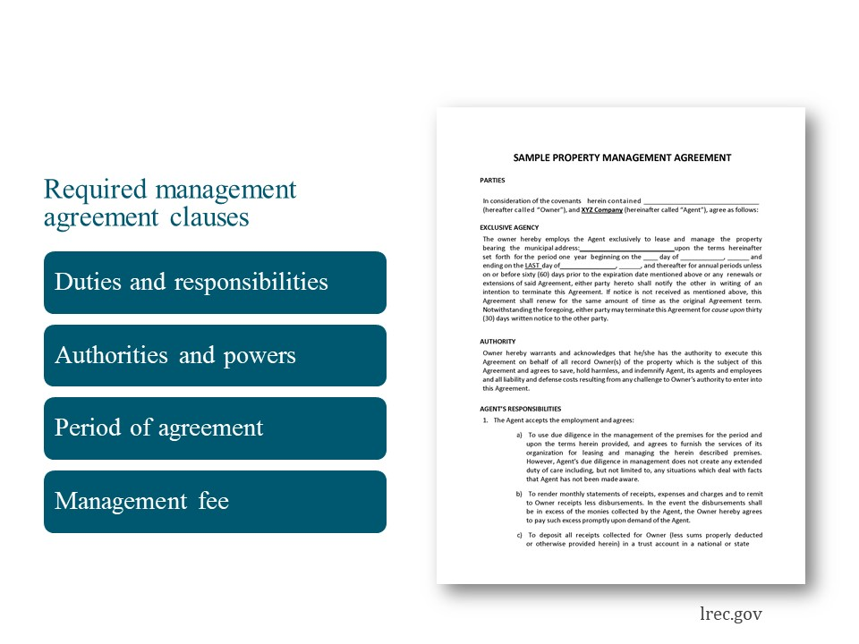
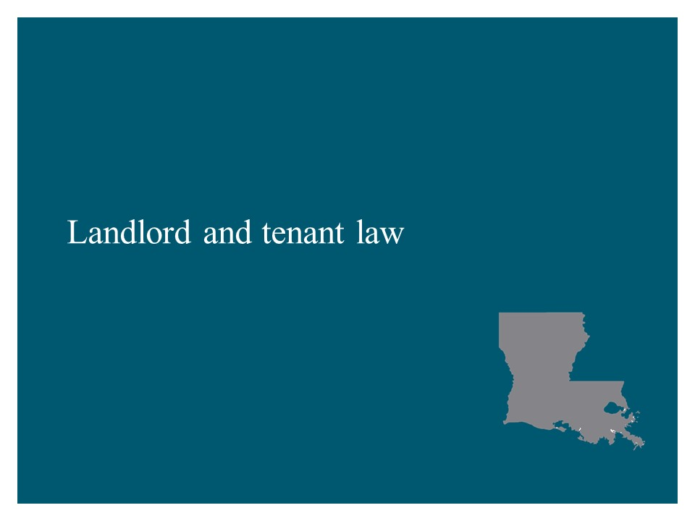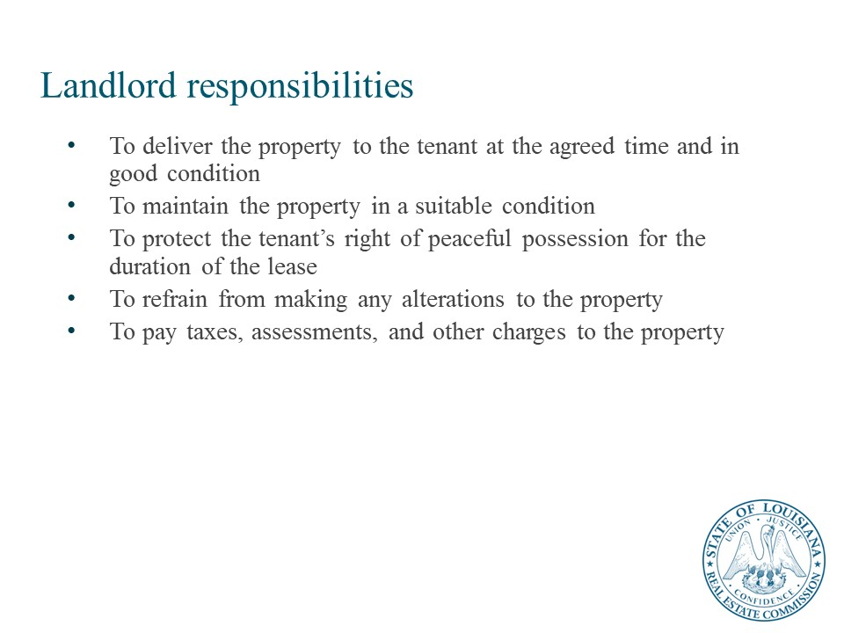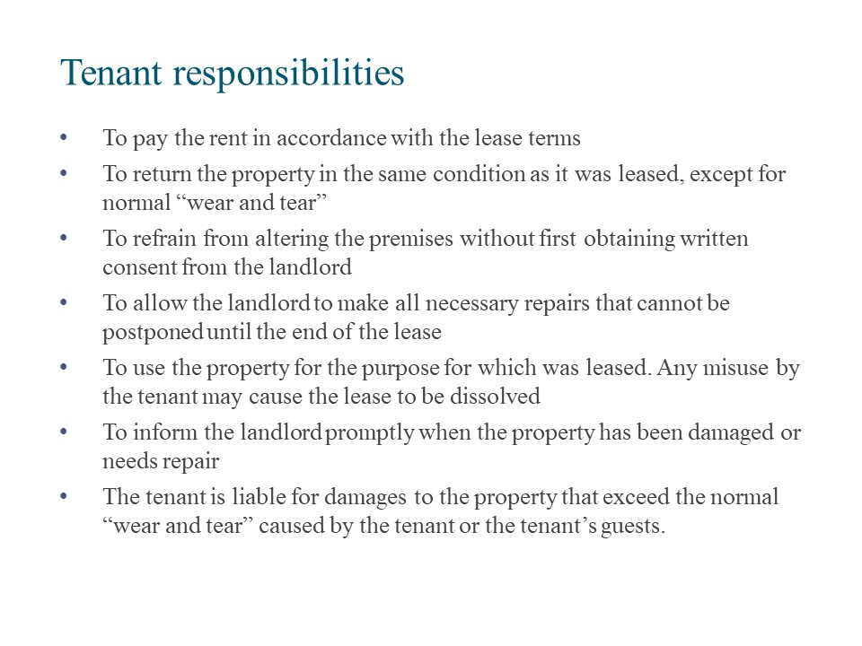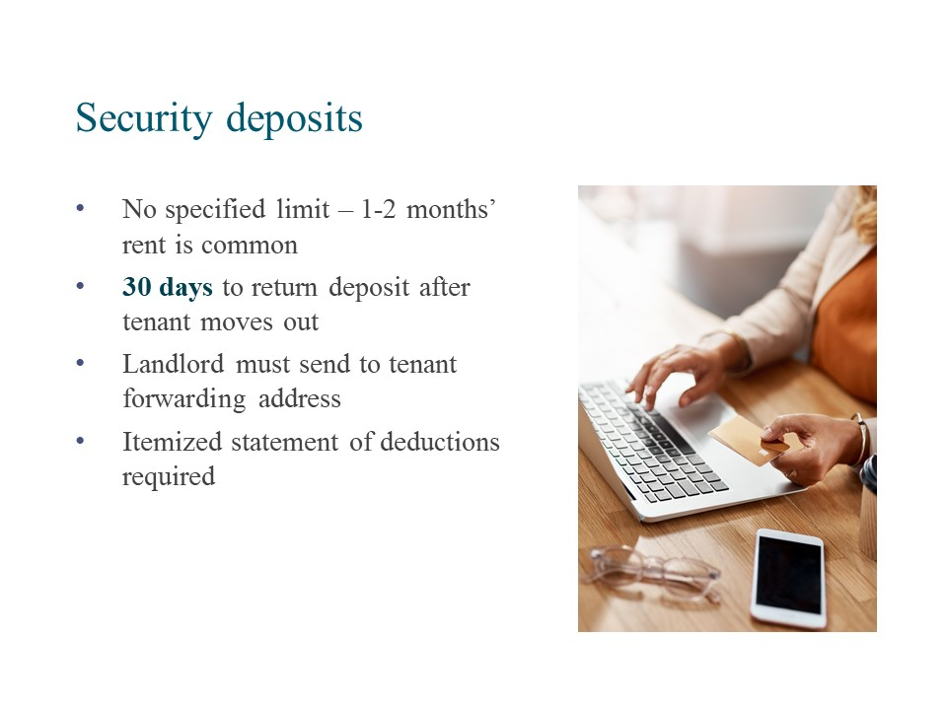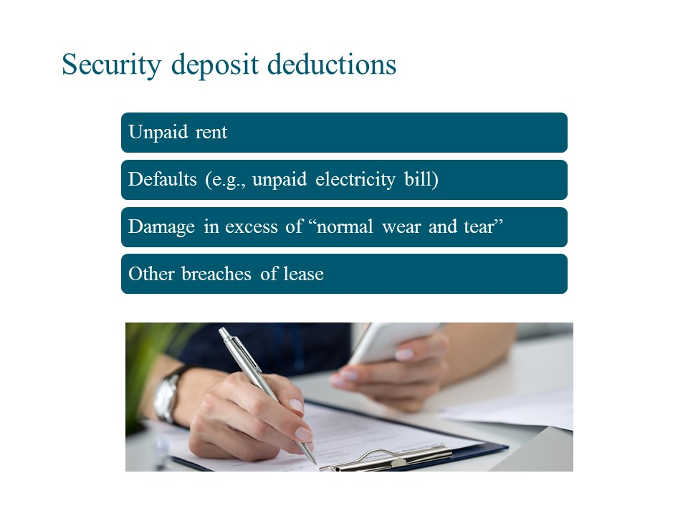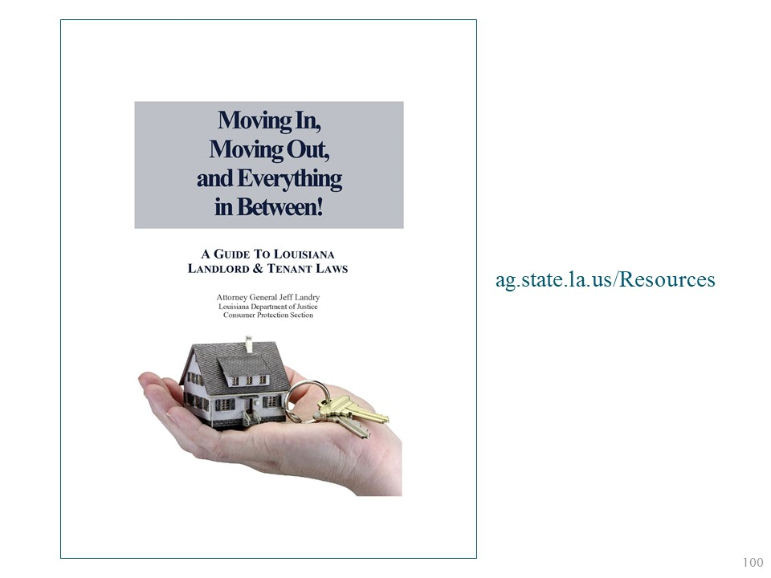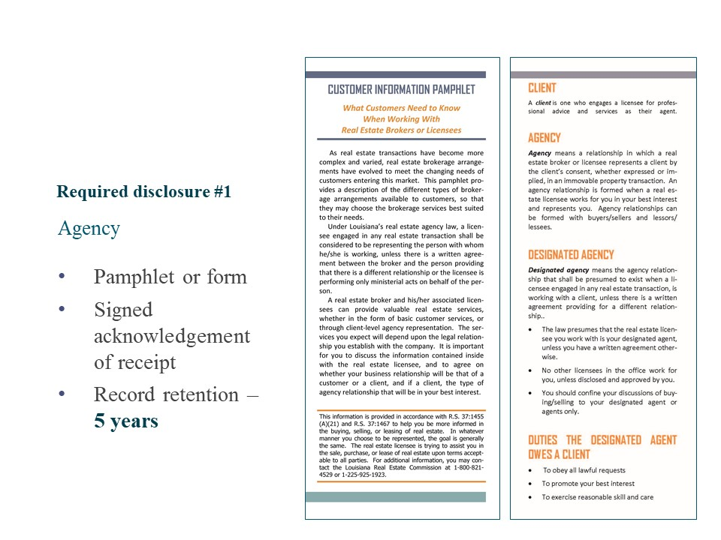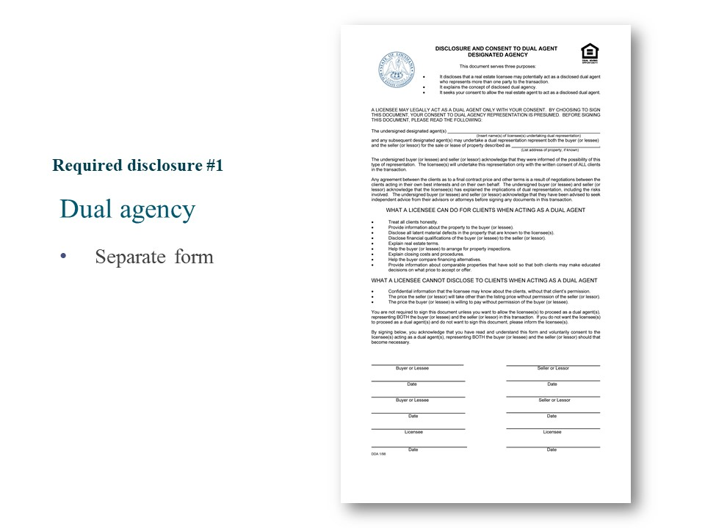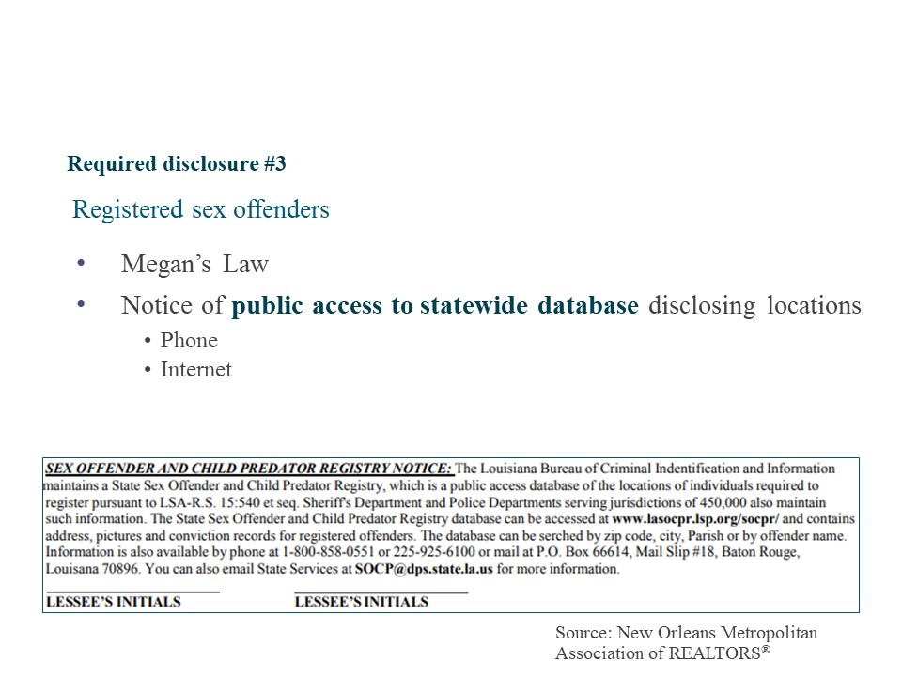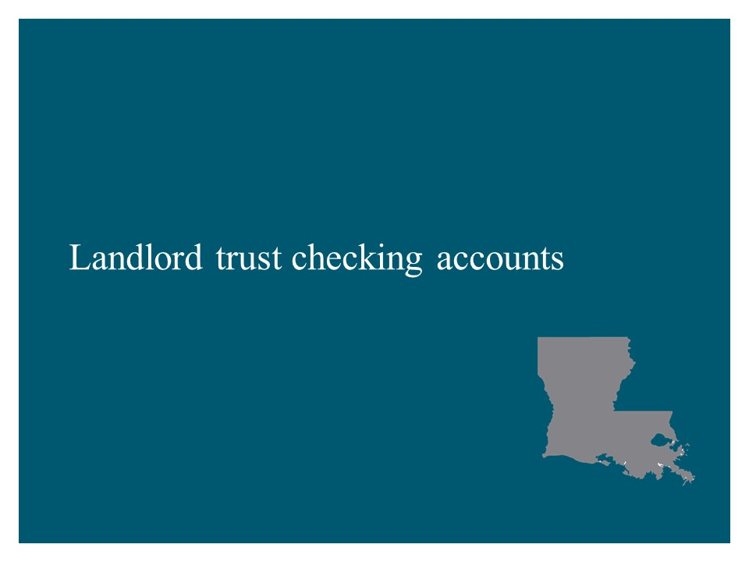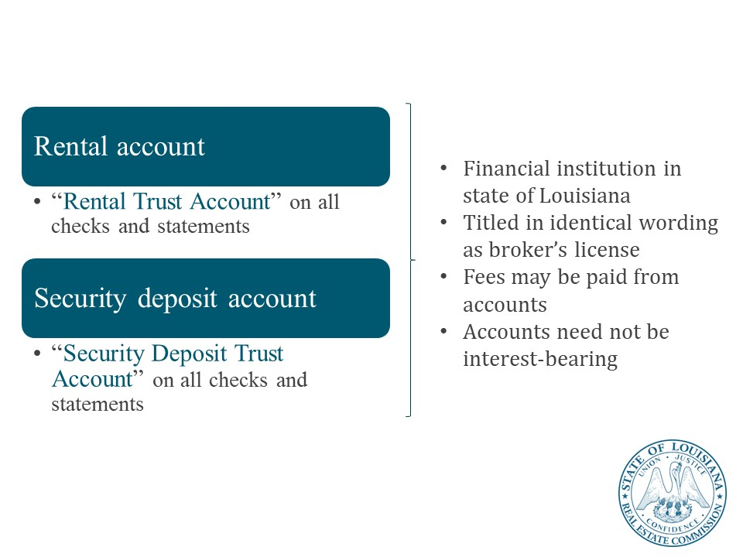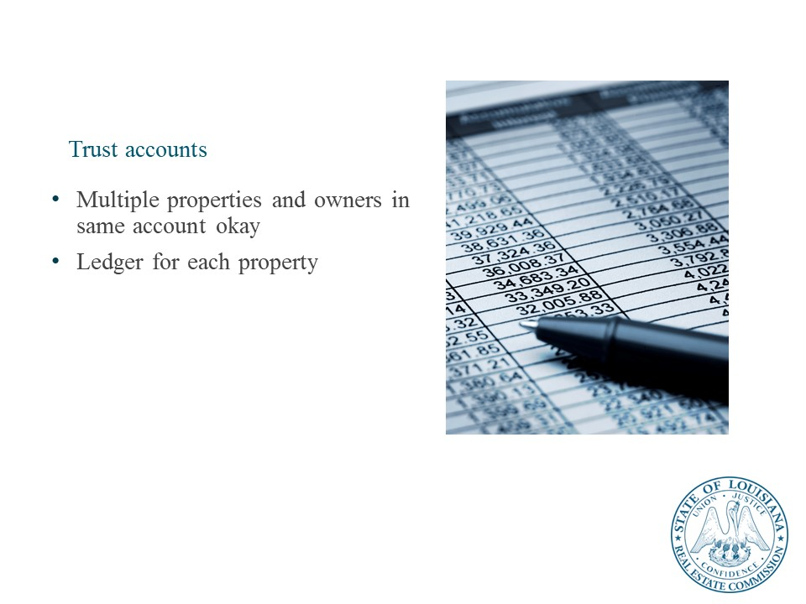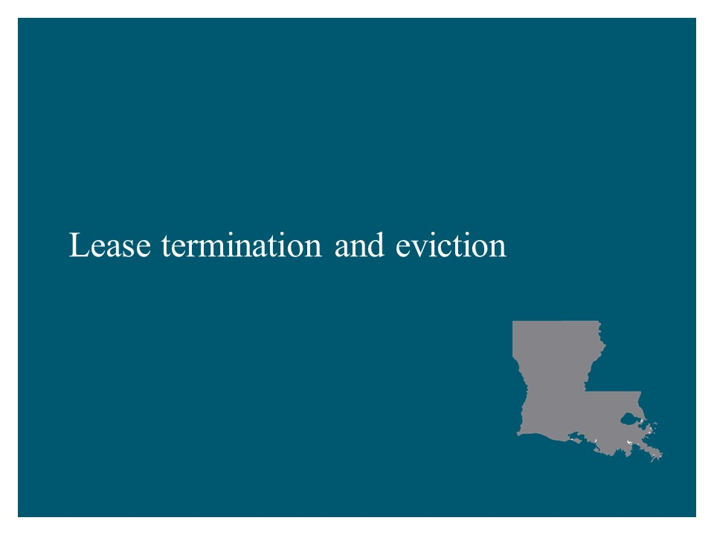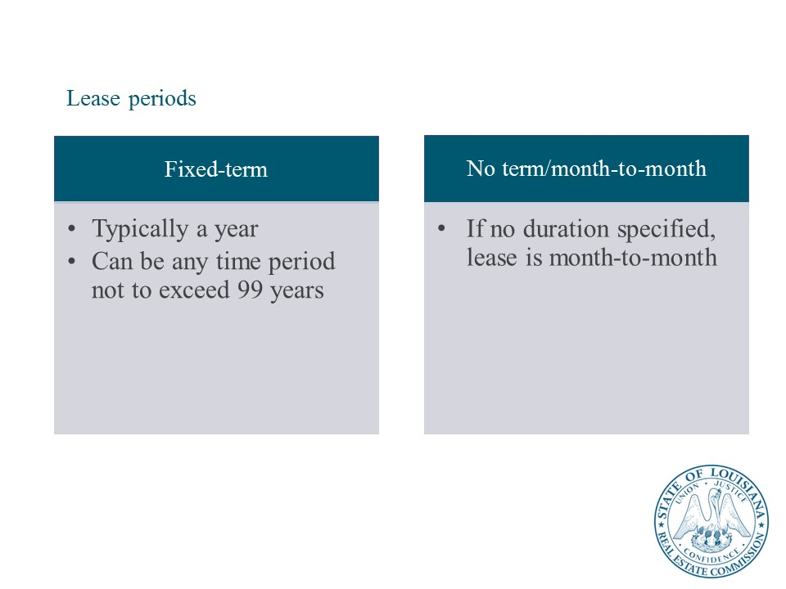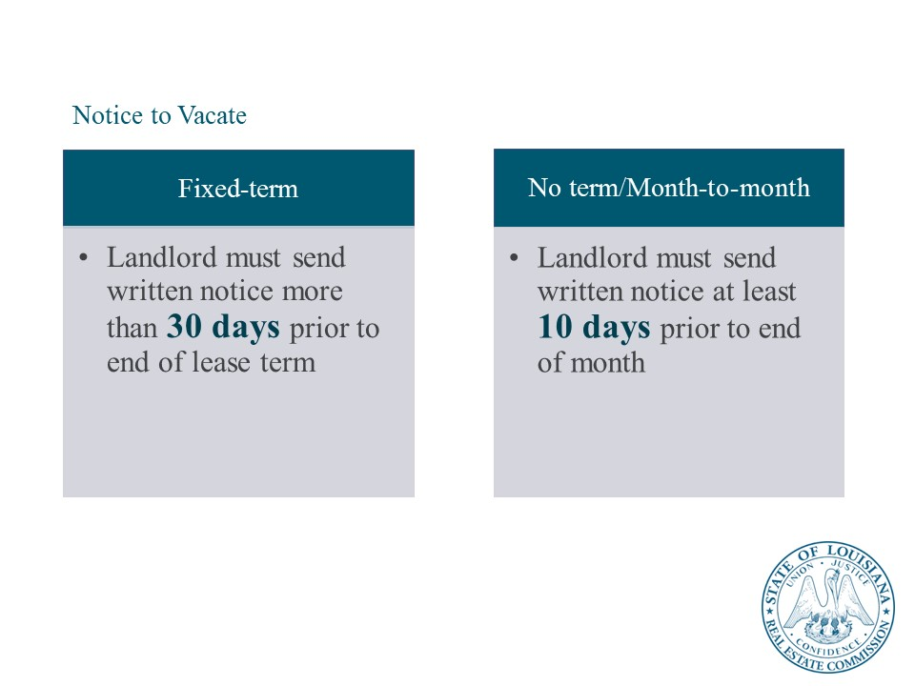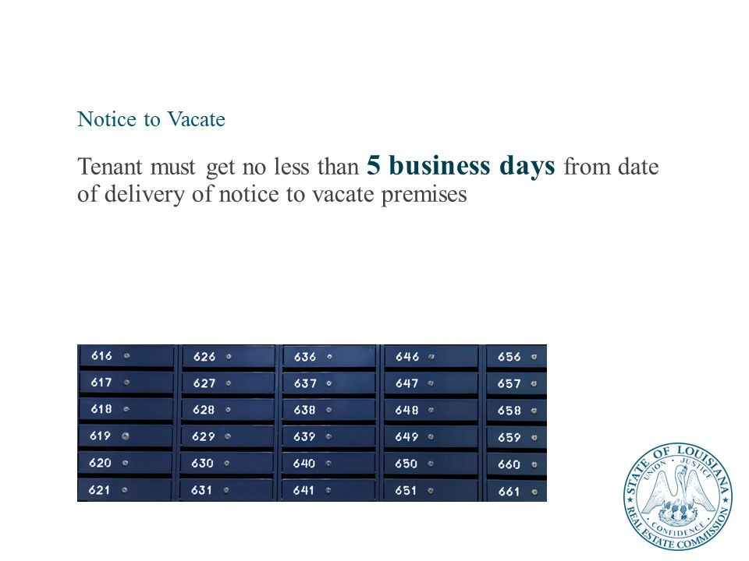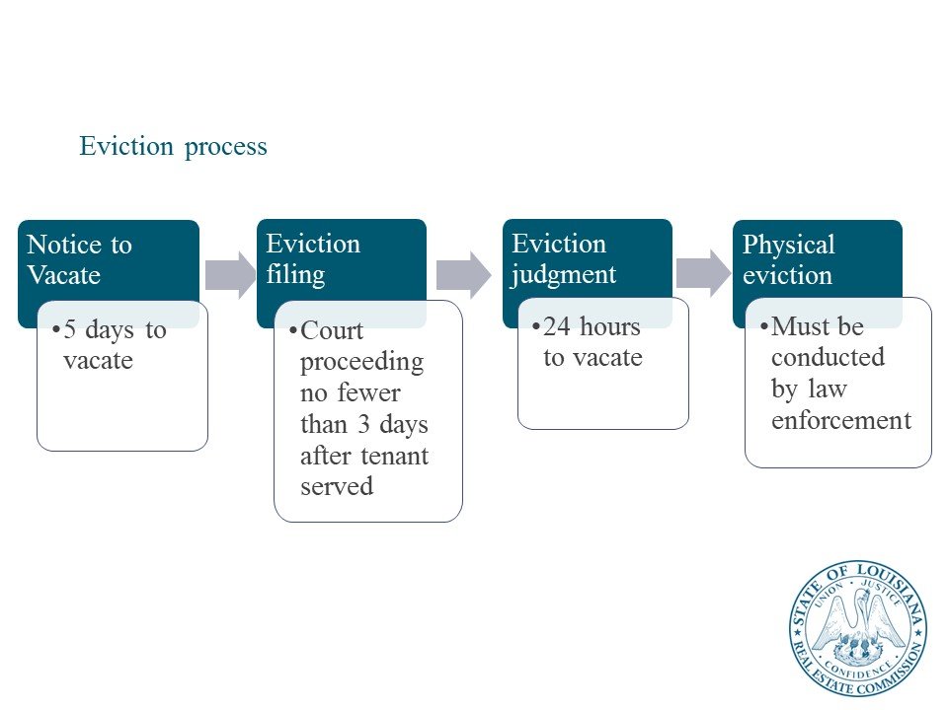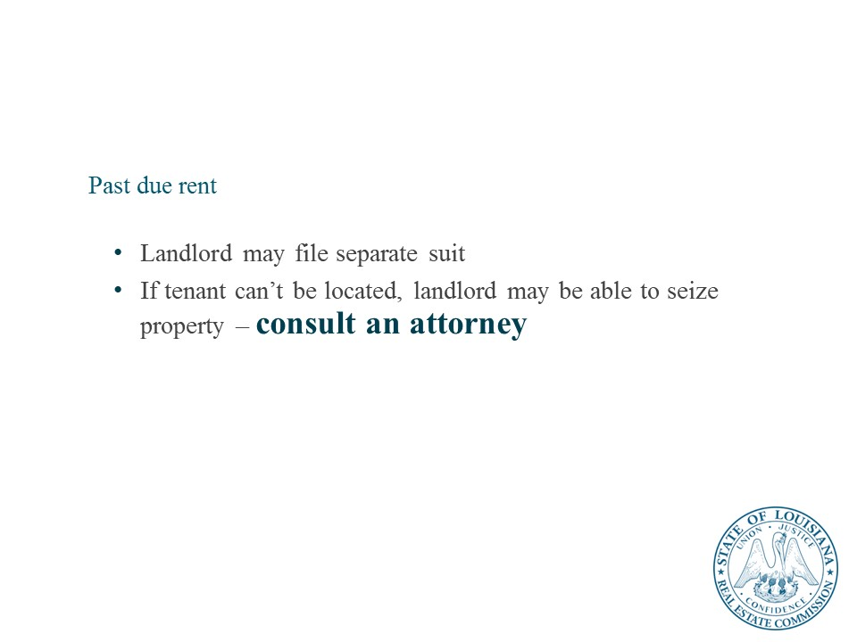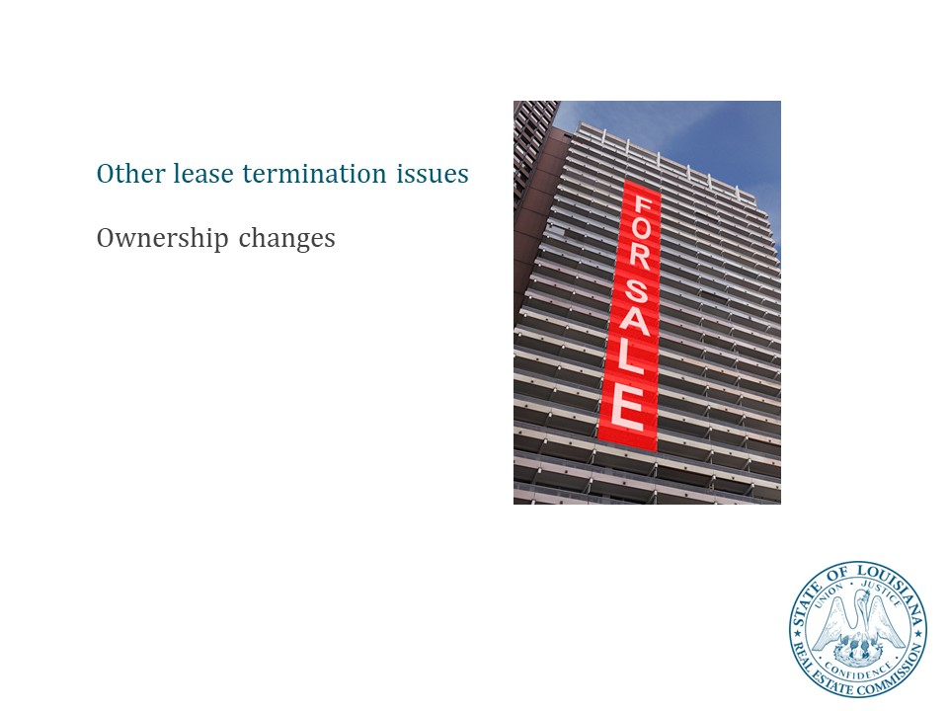

Lesson 3: Key Federal Laws
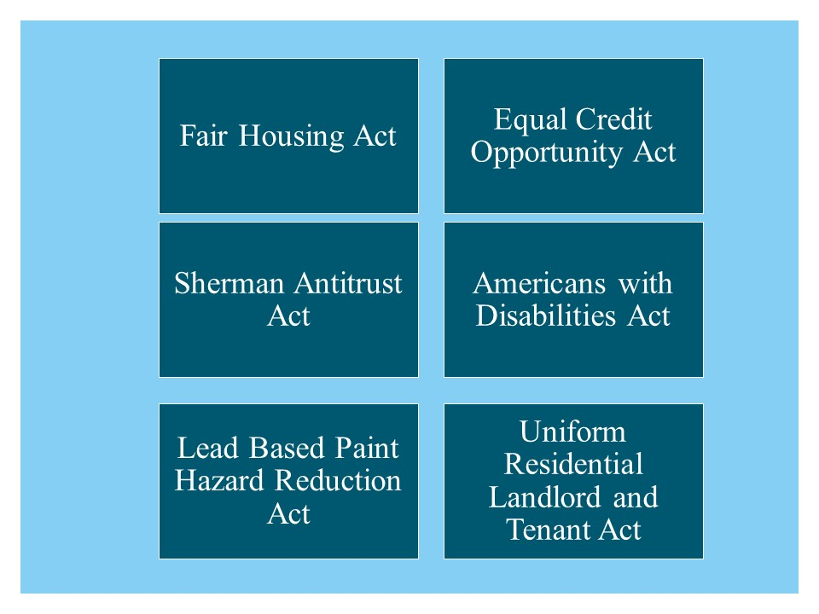

Fair Housing Act
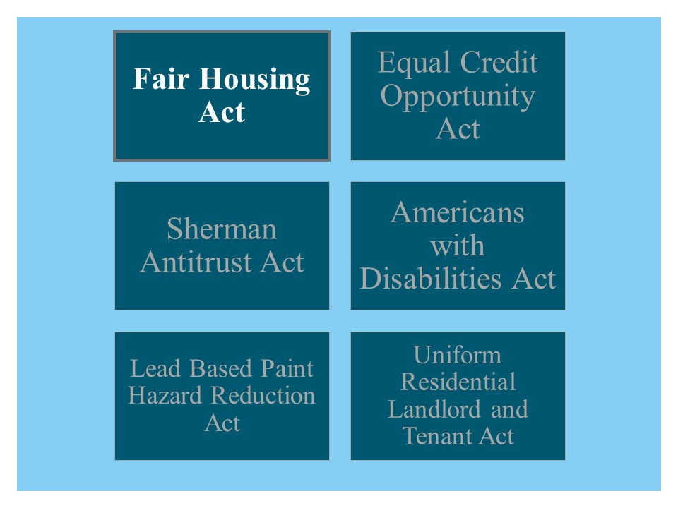
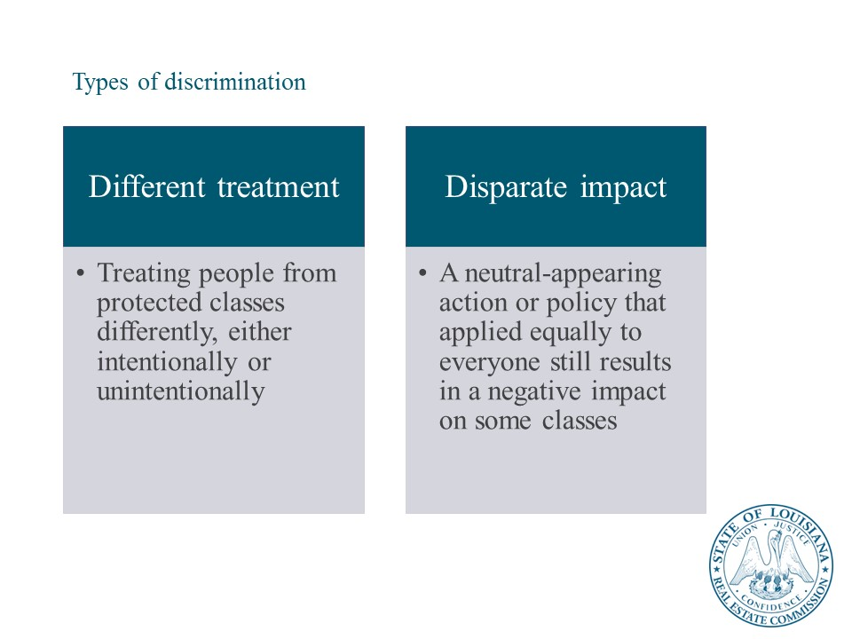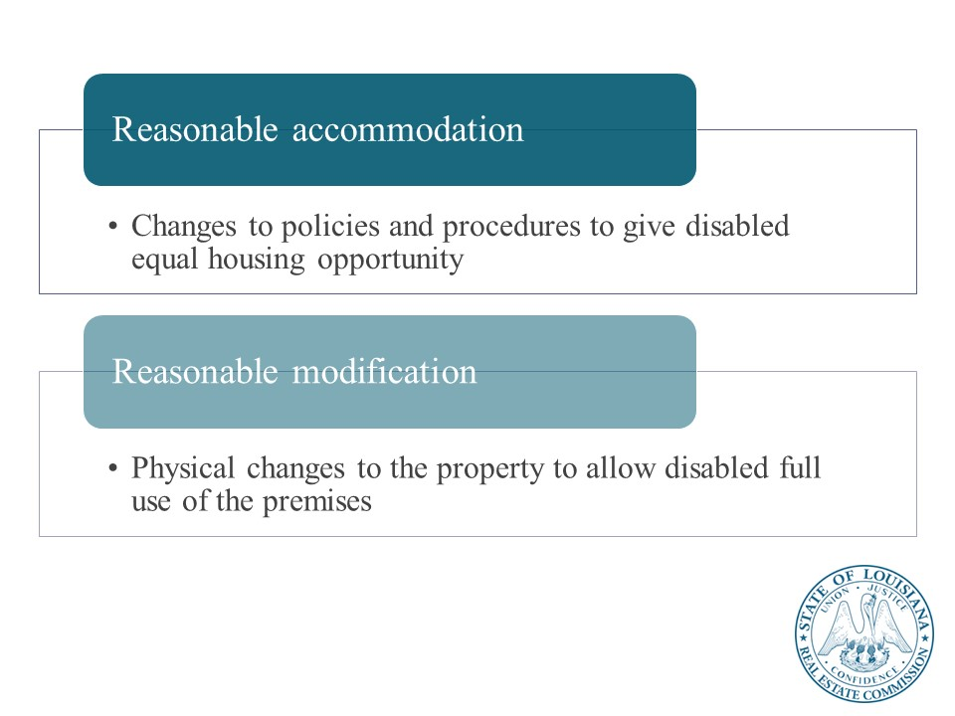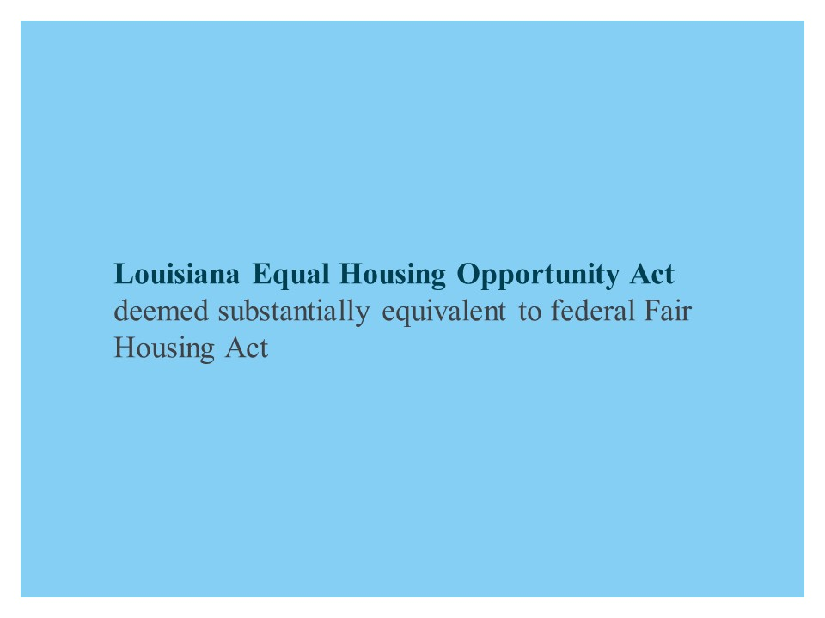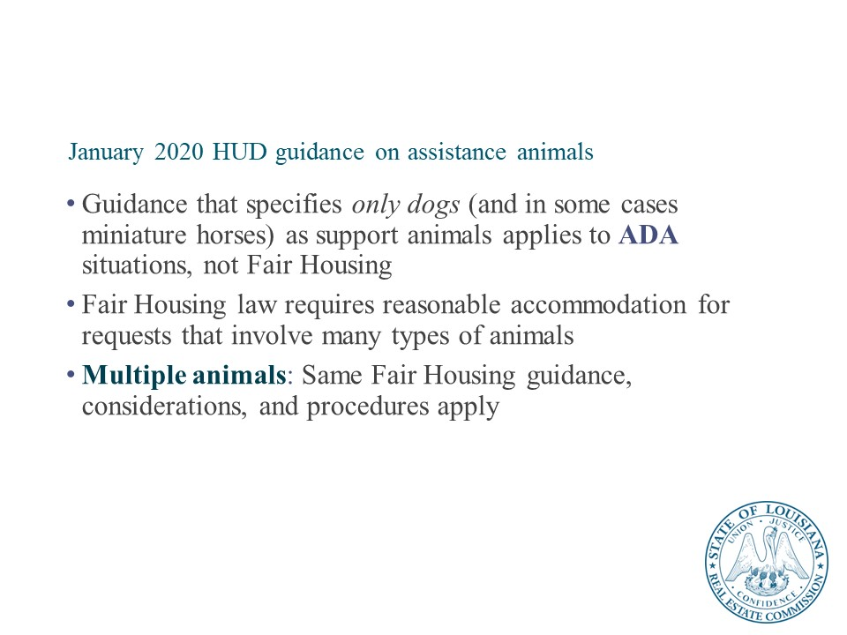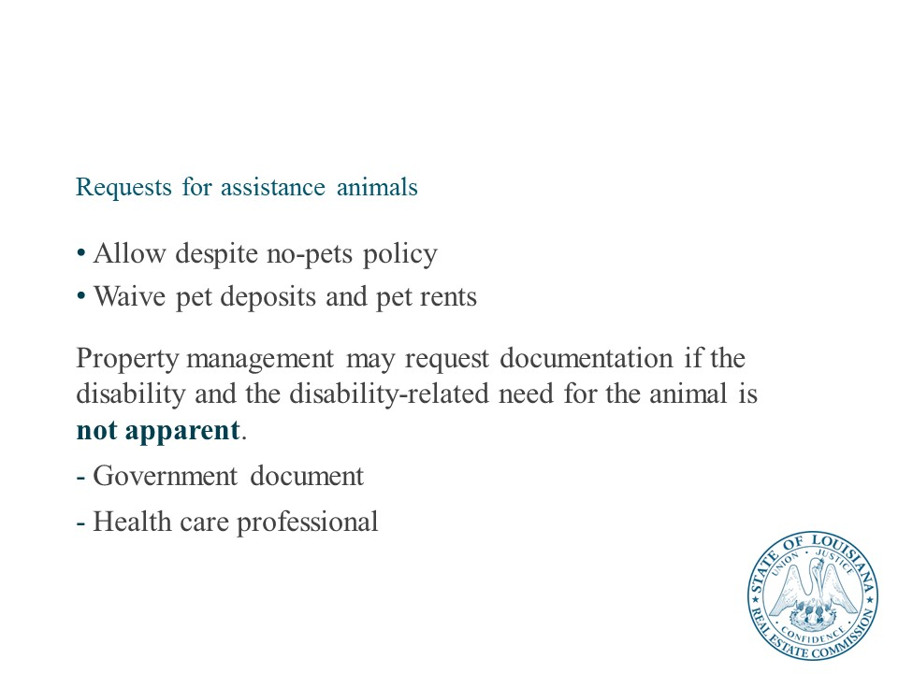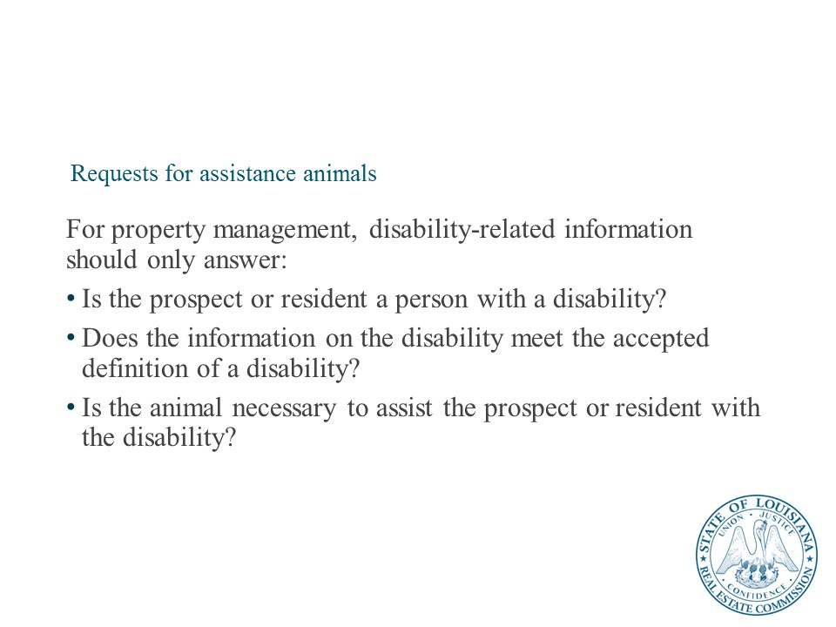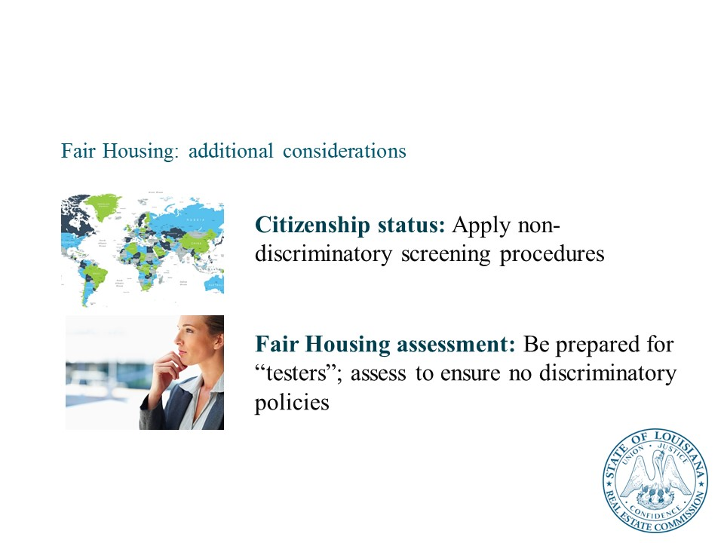

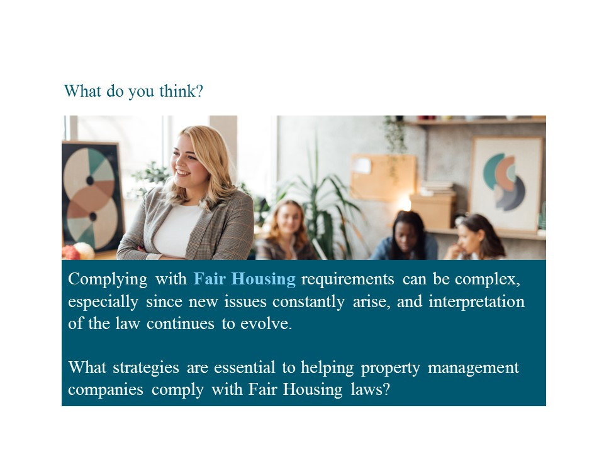
Instructor
Facilitate a discussion on what property management companies do to comply with Fair Housing laws.
Advance to the next slide to emphasize:
- Company policies and procedures
- Ongoing training for ALL site staff
- Qualified legal counsel
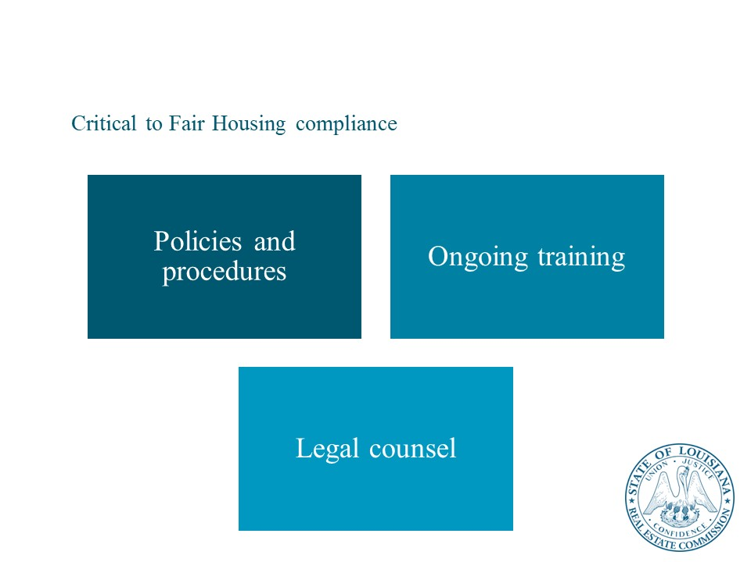

Sherman Antitrust Act
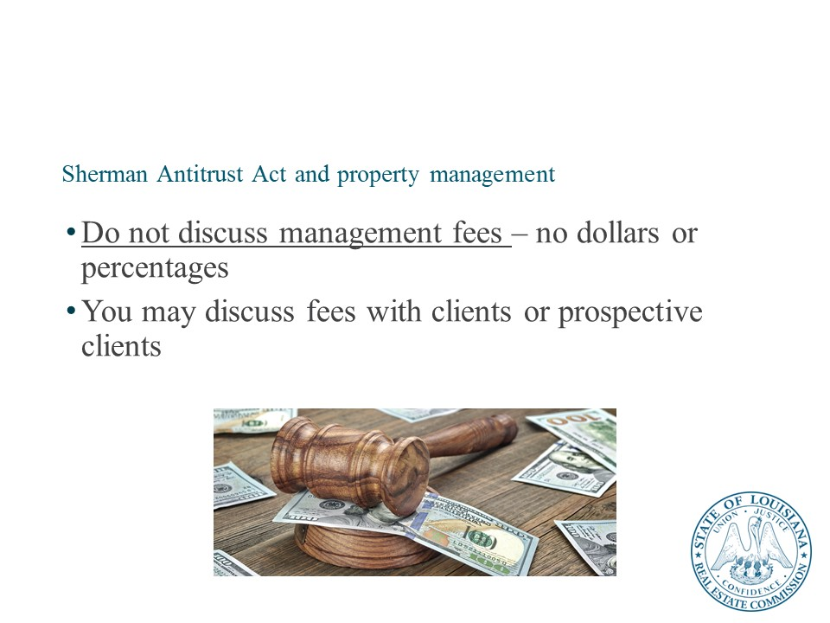

Lead Based Paint Hazard Reduction Act
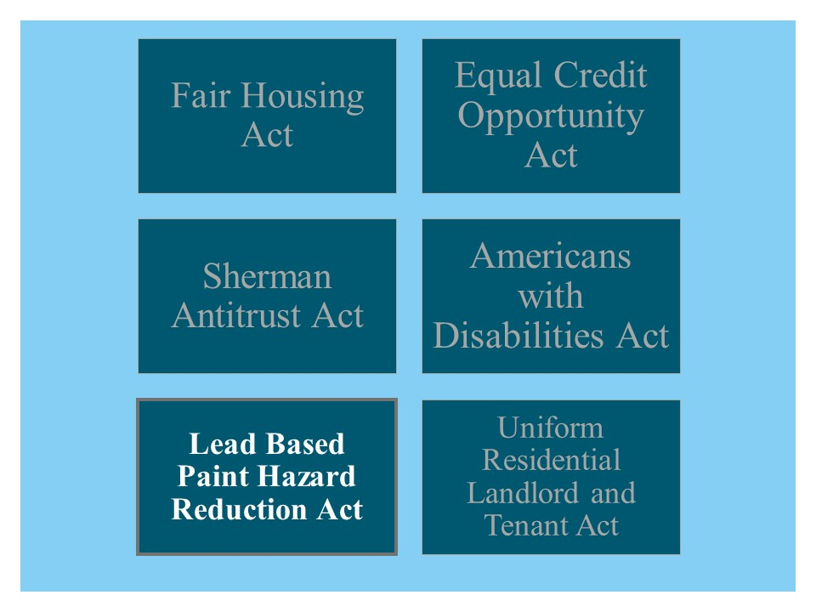
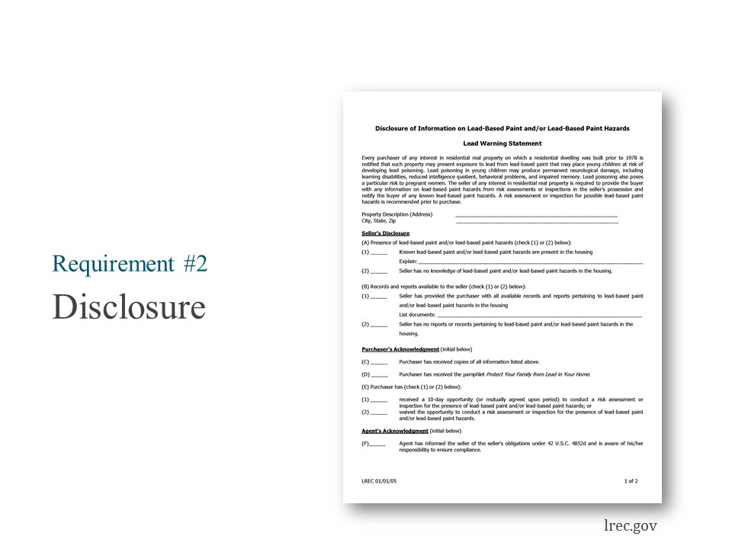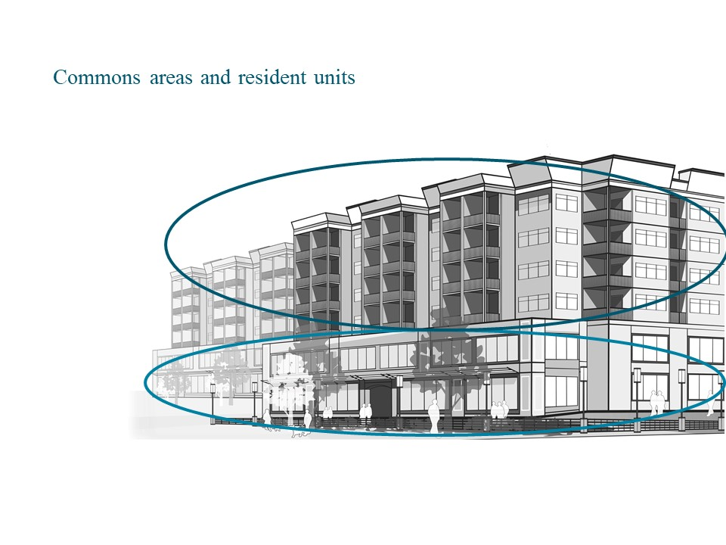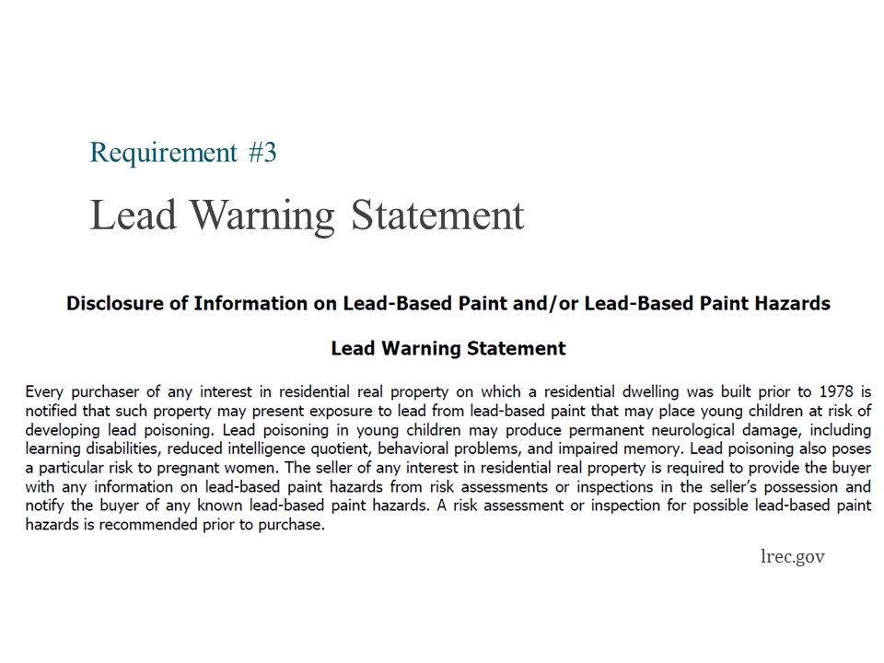

Equal Credit Opportunity Act
Instructor
Facilitate a discussion on what property management companies should do in this situation.
- Develop policies and procedures that apply rental application and approval consistently and uniformly.
- Discuss with the owner situations in which they would accept freelance and contract income, since people increasingly have 1099 income and such a policy could exclude qualified renters. Examples include:
Documentation proving consistent income for a minimum period of time
Co-signer

Americans with Disabilities Act
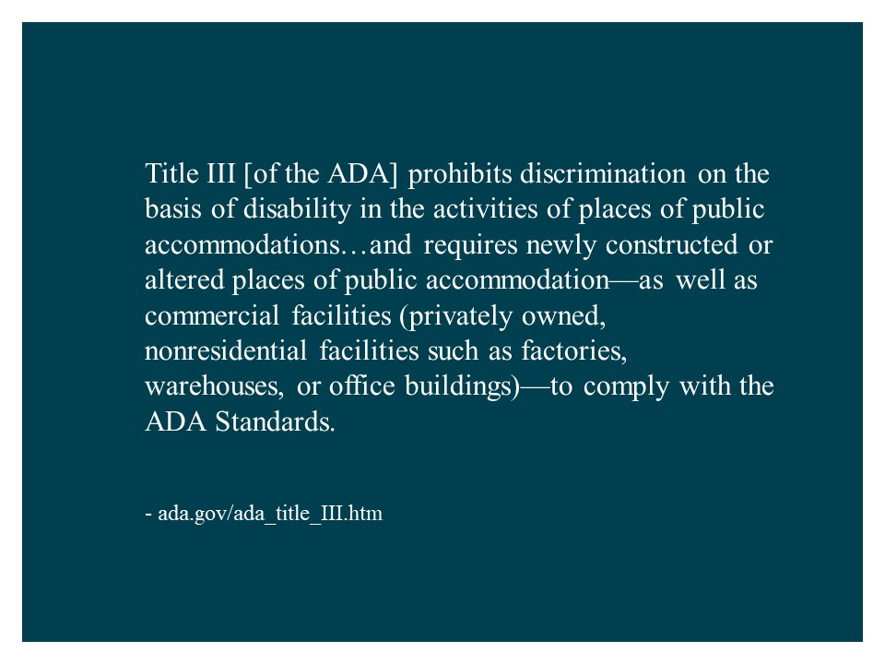
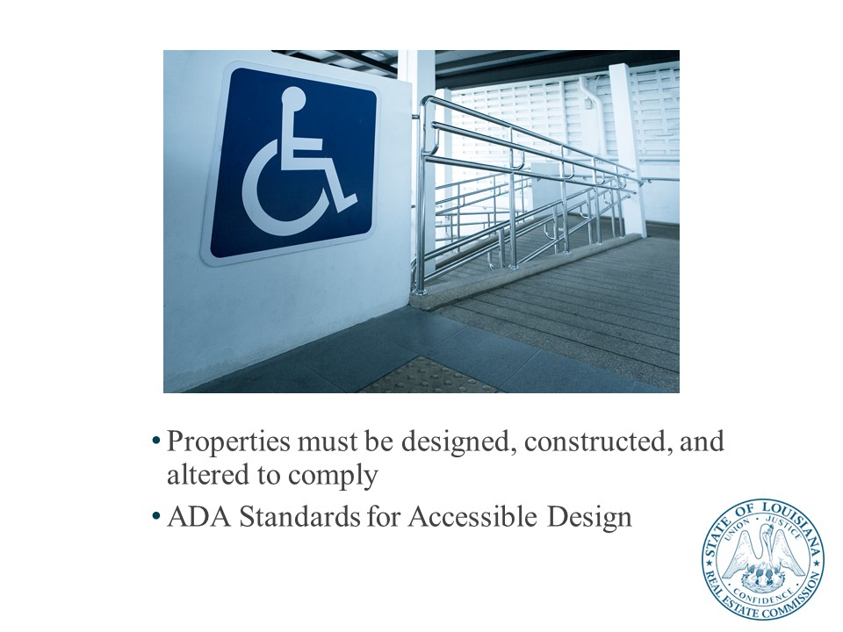

Uniform Residential Landlord and Tenant Act
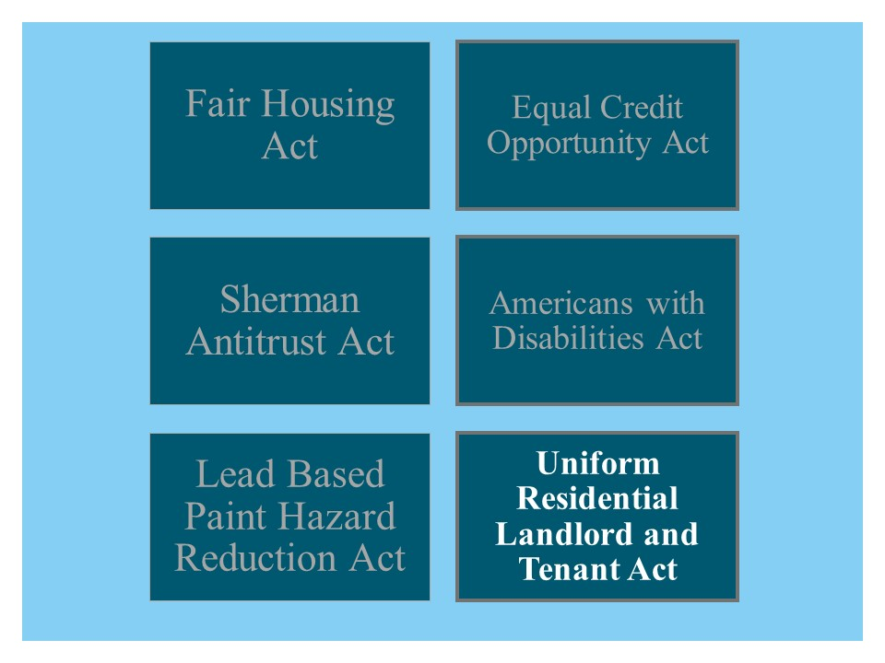
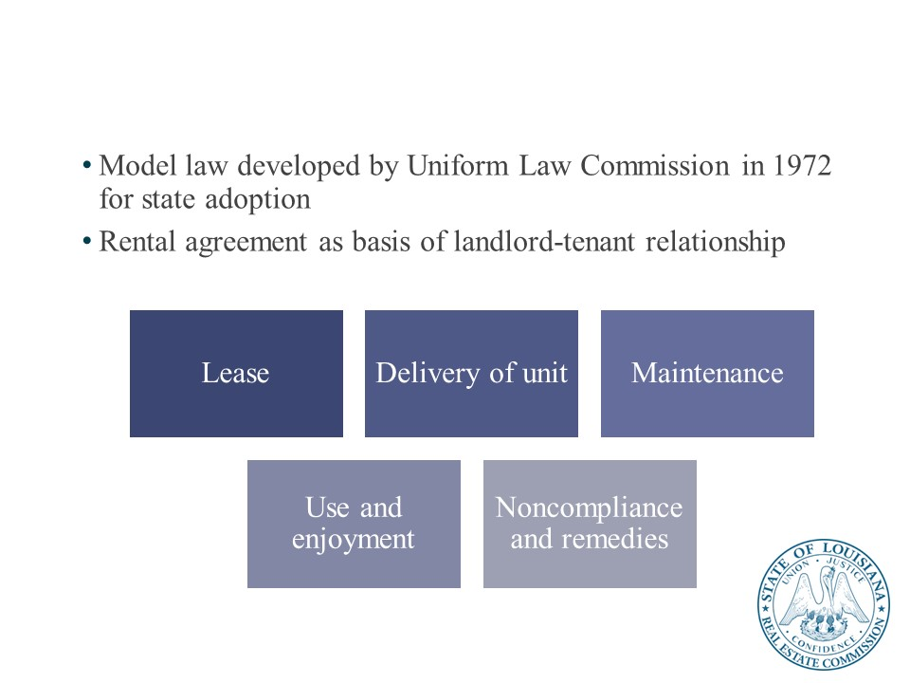

Knowledge Check

Key Federal Laws
Which federal law applies in the following scenarios?
- One property manager asks another how much they charge in management fees for properties in rural areas of the state.
___Sherman Antitrust Act___
- An applicant for an apartment requests a waiver of the no-pet policy for their iguana.
____Fair Housing Act________
- An owner asks property management why the eviction process is different in Louisiana compared to Mississippi, where they also have properties.
_Uniform Residential Landlord and Tenant Act_
- An owner acquires a new apartment building constructed in 1962 and asks what potential risks come with an older property.
__Lead Based Paint Hazard Reduction Act__
__Americans with Disabilities Act__
- An applicant for an apartment has several sources of income, including employment and child support.
__Equal Opportunity Credit Act__

Lesson 4: Property Management Best Practices

Successful Property Management
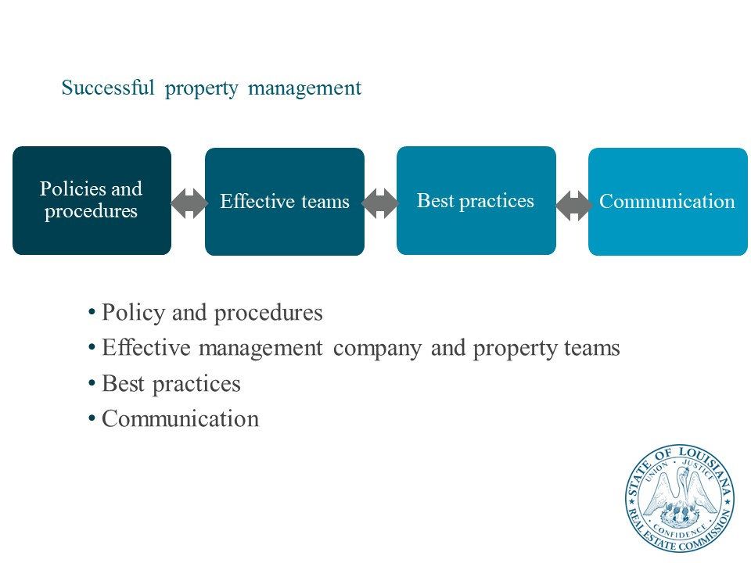
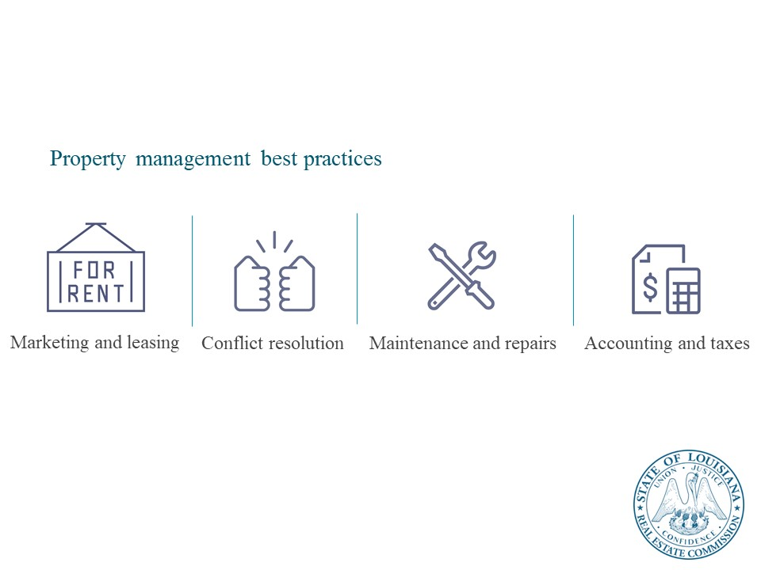

Marketing and Leasing Best Practices
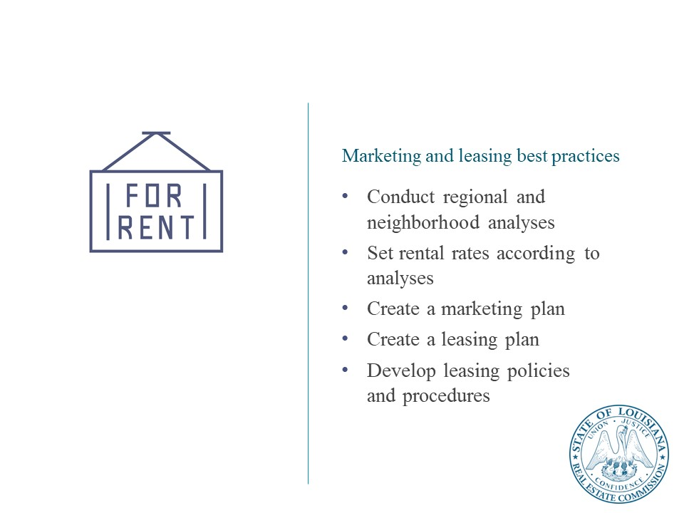

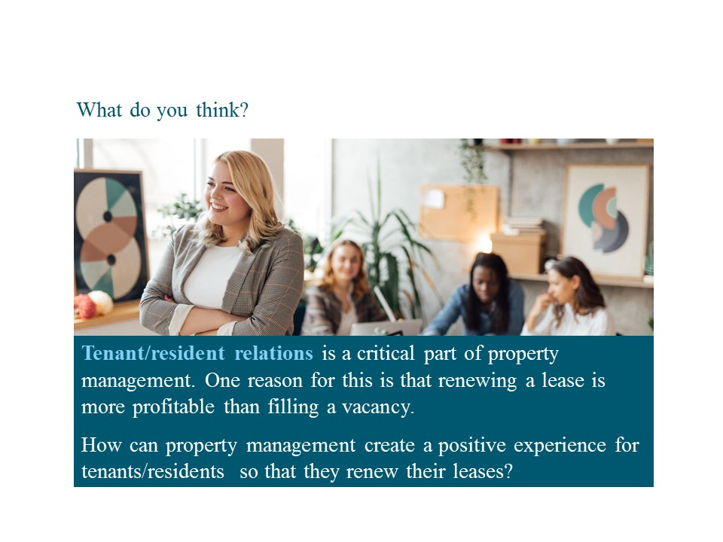
Instructor
Facilitate a discussion tenant/resident relations strategies.
Suggested answers:
- Customer service approach
- Well-functioning, responsive management and maintenance
- Engagement events (e.g., open houses, wellness and sustainability fairs, BBQs)
- Amenities and services
  - May also be a chance for ancillary income
- Consistent policies and procedures

Conflict resolution best practices
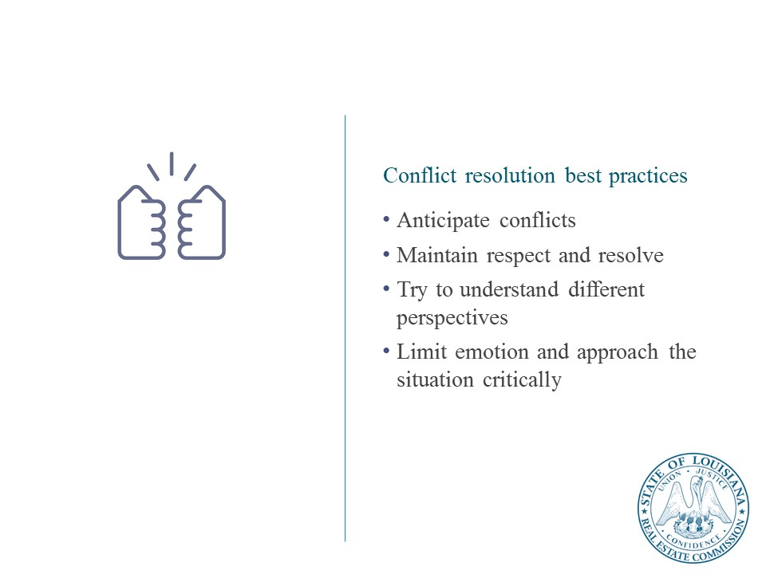
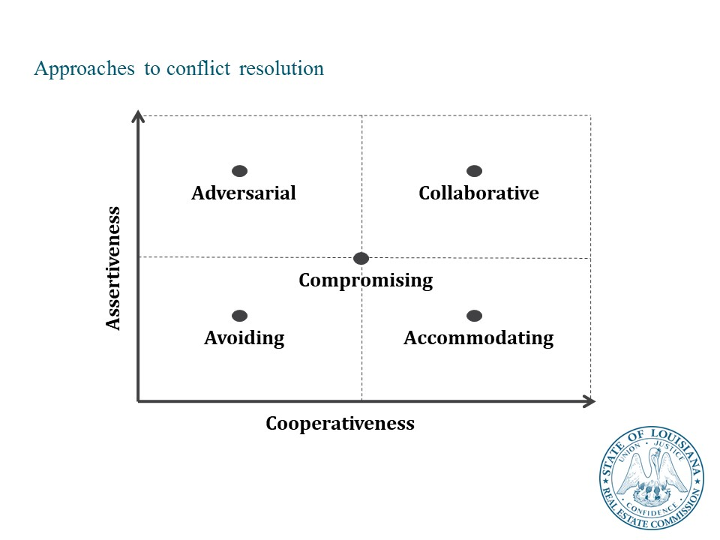
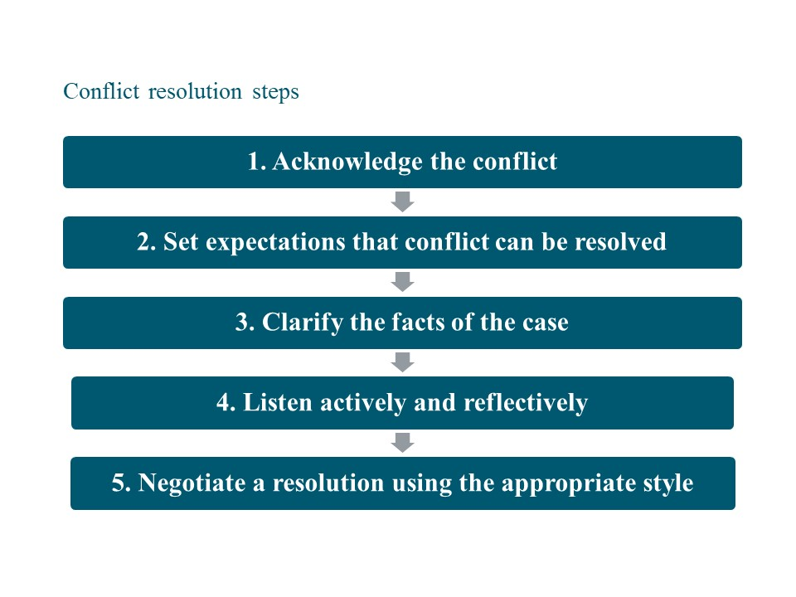

Maintenance and repairs best practices
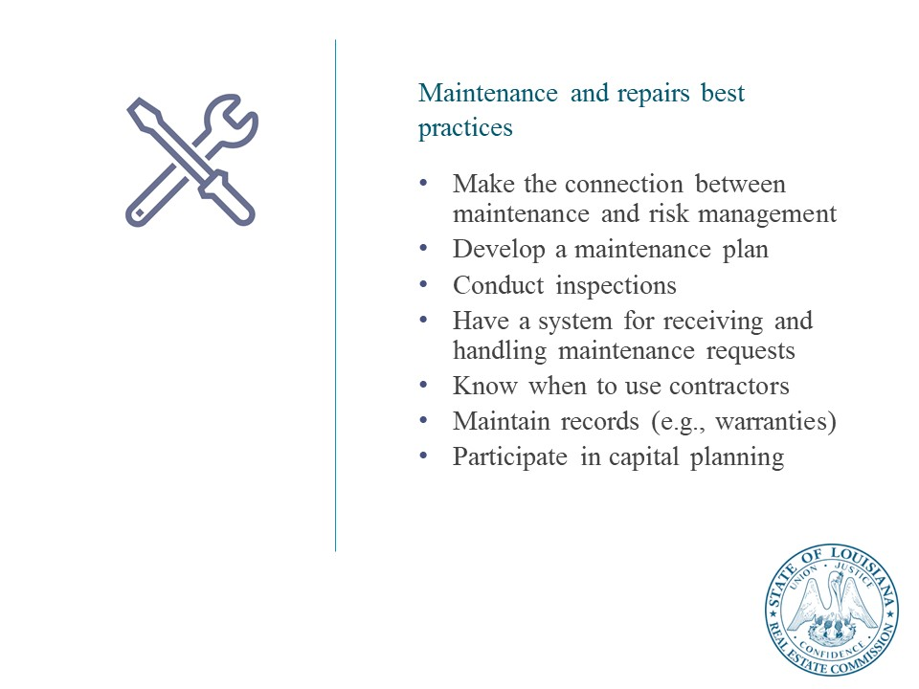
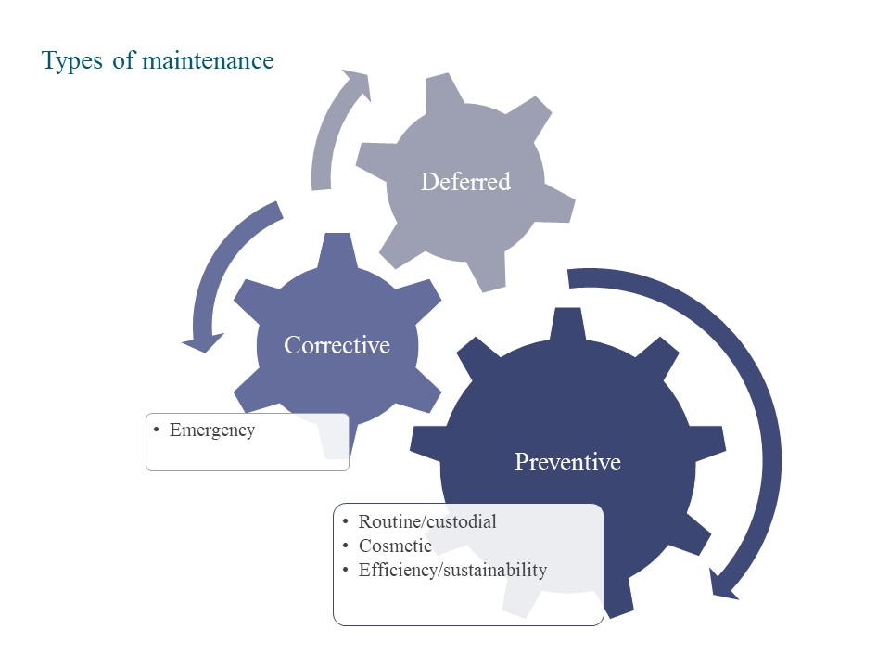

Accounting and taxes best practices
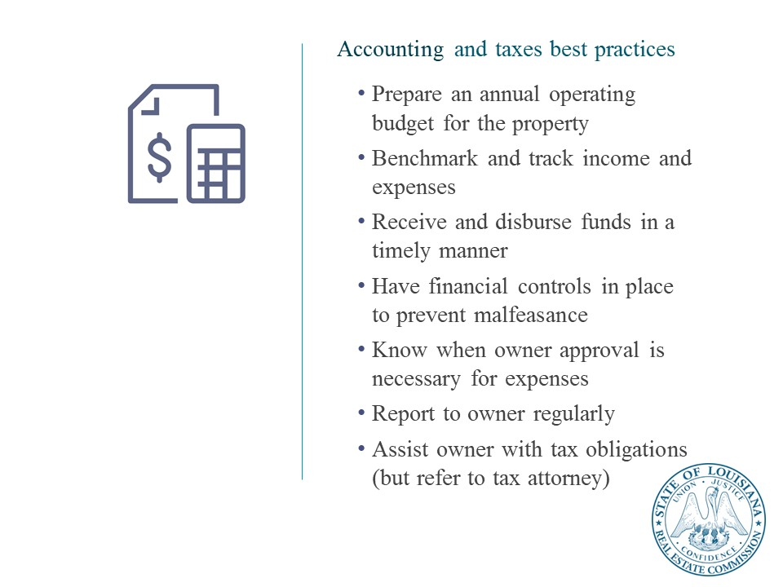

Case Study Part 2: Property Management
This work by Sightline Institute Modest Middle Homes Library is licensed under a Creative Commons Attribution 4.0 International License.

Case study scenario
In July 2020, Joe and Lisa Burreaux are transferred from Baton Rouge, LA, to Cincinnati, OH, after Joe is promoted by his employer. Their former broker, Dee Breaux, has decided to retire after years in the business. Luckily, Ted Larceny, a licensed real estate salesperson for Enterprise Realty, graciously offers to manage the Burreauxs’ four-plex at University Place (“Property”).
The Burreauxs inform their current tenants that Ted will be taking over the Property’s management. On July 31, 2020, Ted instructs the tenants to make all their future rental payments and security deposits directly payable to “Ted Larceny,” as property manager.
Ted never informs his sponsoring broker of his business with the Burreauxs. Payments are never made to Ted’s sponsoring broker or brokerage. Once Ted receives all rental payments each month, he deposits the rental payments into his personal checking account. Ted disburses the rental payments for Apartments A, B, and C to the Burreauxs on the 10th of each month while retaining 10% for management fees.
In September 2020, Ted warns the Burreauxs that one of their tenants, T’Claude Pirogue, stopped paying rent two months into his Apartment D lease!
The “always-enterprising” Ted reassures the Burreauxs that he has promptly lined up a second tenant for Apartment D – Coach Eaux! The Burreauxs are impressed and relieved their “hot-shot” property manager, Ted, has taken care of everything on their behalf.
Unfortunately, their “luck” truly stops before it even starts… Coach Eaux fails to take occupancy of or pay any rent for the Property! Ted – who was so quick to action in finding Coach Eaux – just can’t find a third tenant despite ALL of his constant, hard work on behalf of the Burreauxs. And, on top of it all, Ted loses the Lease Original he had signed with Coach Eaux…
From September 2020 through June 2021, the Burreauxs receive absolutely ZERO in rental payments for Apartment D, and they are terrified they will end up losing the entire Property, since it is not producing enough income to sustain the mortgage payments.
In July 2021, the Burreauxs receive a stunning phone call from none other than their first tenant, T’Claude Pirogue! He is contacting the Burreauxs directly to gauge their interest in selling the Property. T’Claude tells the Burreauxs all about how he and the love of his life, Earline Boudreaux, have become so attached to Apartment D, as they were married in the unit in Spring 2021! He even shares weddings pictures with the Burreauxs to convince them that he and his spouse are genuinely motivated buyers.
It turns out that T’Claude and Earline have been occupying Apartment D and paying rent directly to Ted on the Property since July 2020. Ted has been pocketing the Apartment D rent and keeping it all for himself!
The Burreauxs quickly file a complaint with LREC. The wise and just Commissioners determine Ted has violated:
- La. R.S. 37:1455(A)(4) – Failing to account for property management funds;
- La. R.S. 37:1455(A)(6) – Commingling client funds with personal funds;
- La. R.S. 37:1455(A)(17) – Failing to place the funds in the custody of his sponsoring broker.
Ted’s license is revoked, and he is ordered to pay fines and administrative costs totaling $2,600.00, unknown attorney fees, and full restitution of all lost payments to the Burreauxs.
DON’T BE LIKE TED!

Case study questions
Answer the questions that follow and be prepared to share your answers. Your instructor will facilitate a discussion.

- What should Ted have done to remain compliant with LREC Laws and Rules relating to property management?
- Ted should have placed all client funds in the custody of his sponsoring broker.
- The security deposits should have been deposited into the Enterprise Realty security deposit trust account.
- The rental payments should have been deposited into the Enterprise Realty rental trust account.
- The Enterprise Realty broker would pay certain, agreed-upon monies back to Ted.

- What property management best practices might have avoided this situation?
In this case, the problem seems to have been willful theft by a rogue employee. However, company-wide policies and procedures, as well as financial controls, may have drawn attention to this situation. This is especially true if Ted was using any of Enterprise Realty’s resources to manage the four-plex in the company’s name.
For example, policies and procedures around legal compliance, broker supervision, reports to ownership, and purchasing could have identified Ted’s irregular management activities.

Part 3: Louisiana Real Estate Commission Update

MyLREC Portal Overview
The MyLREC Portal gives licensees easy access to manage their license using an easy to navigate sidebar with selections tailored to their license type. The tailoring of the sidebar view allows for easier navigation and eliminates confusion about what a licensee needs to maintain good standing with the Commission.

Topics
- How to access the MyLREC Portal
- What are my log in credentials?
- Your user name is automatically generated by the LREC. You can choose your own password and reset it if necessary. If you cannot remember your user name and password, you can answer questions to retrieve/reset them.
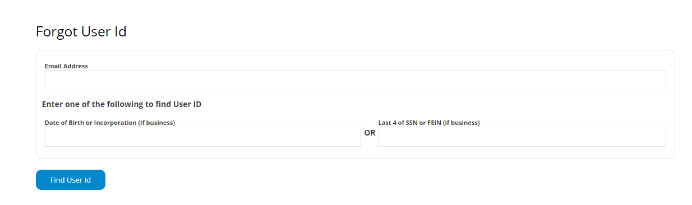

- Print License
- The MyLREC Portal gives licensees easy access to view/print their license. This has not been an available function to non-broker licensees in the past. Those licensees who are in good standing will be able to access their license by choosing “Print License” from the sidebar. Licensees with issues that prevent printing will be shown a list of the issues they need to address before their license will be made available for printing.

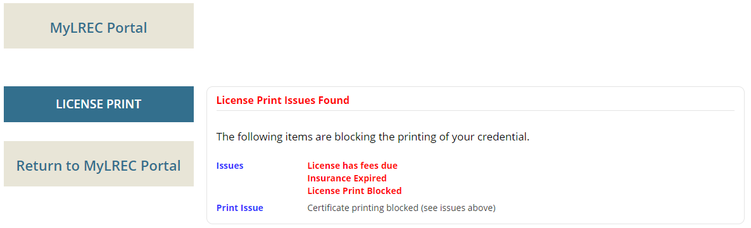

- Update Contact Information
- Licensees can easily and immediately update their contact information, including email address, phone number, mailing address, etc. inside of their portal. This is a very useful tool as the LREC Rules and Regulations require that licensees notify the Commission within ten days of an address change. In the past, this meant printing and mailing in a paper form. The portal allows for a quick, paperless updating option. This also allows for licensees to ensure that they receive all important updates from the Commission, which will be sent to the email address on file. Licensees can choose their primary email address within the portal to make sure that they receive all notices sent by the Commission.

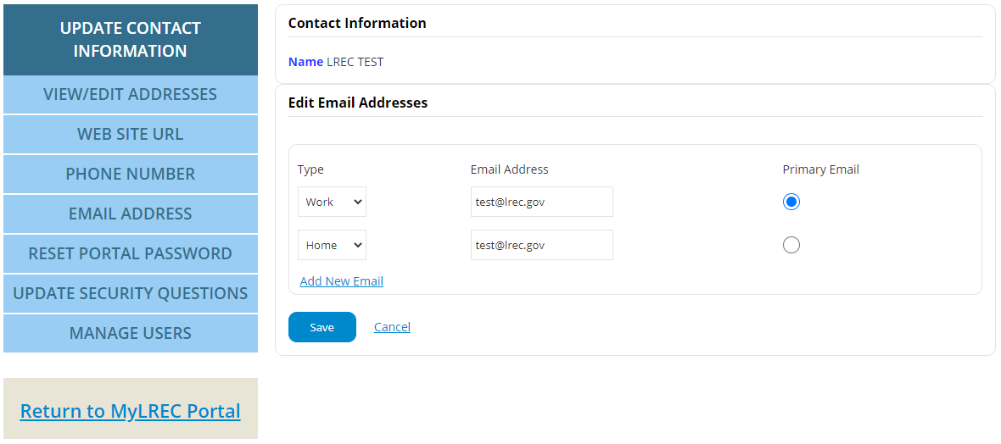

- View Education Transcript
- The MyLREC Portal gives licensees easy access to view their education transcript in order to ensure compliance with LREC requirements.
- Review Insurance Coverage
- Licensees can view the status of their Errors & Omissions insurance coverage to ensure that they are properly insured while practicing.
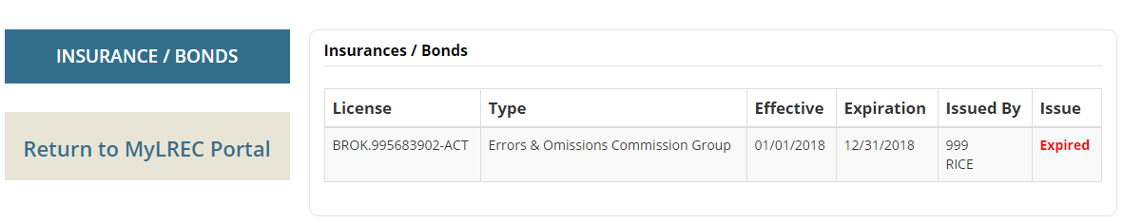
- Fee History
- Licensees can find a history of payments made to the LREC within their portal under “Fee History.” This is useful for individuals wishing to check their renewal status, E&O insurance coverage, etc. Fee history can be shown for the past 5 years, 10 years, or all time based upon the licensee’s input.

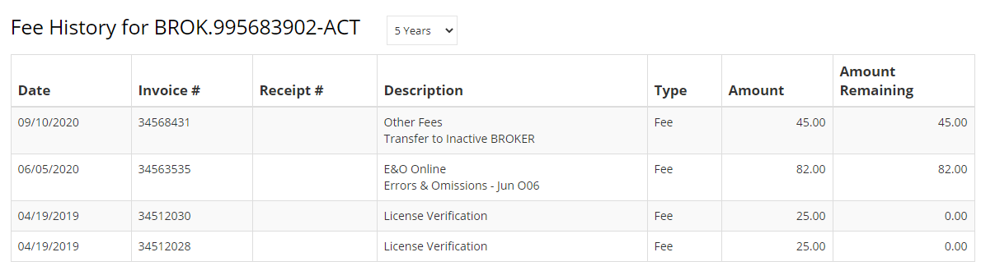

- Renew Online
- Licensees can renew their license(s) using the MyLREC Portal. Licensees will be given the option to renew online or print a paper renewal. The online renewal process is simple and secure, allowing a licensee to respond to required questions and pay their renewal fee via credit card or ACH payment quickly and without any paperwork and mail delays.

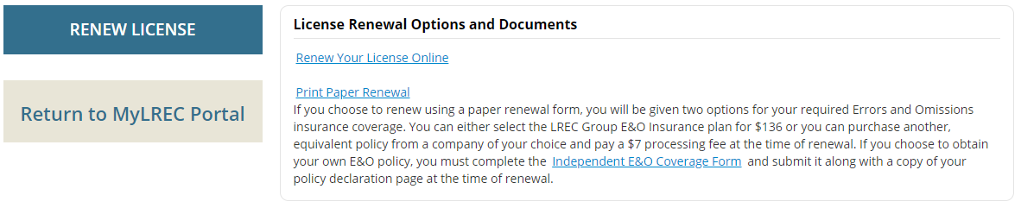

- Broker Features
- Brokers can now view a list of all of the licensees under their supervision in their portal. This listing includes the status of each licensee under the broker’s supervision, allowing the broker to monitor the status of the licensee’s education, renewal, etc.

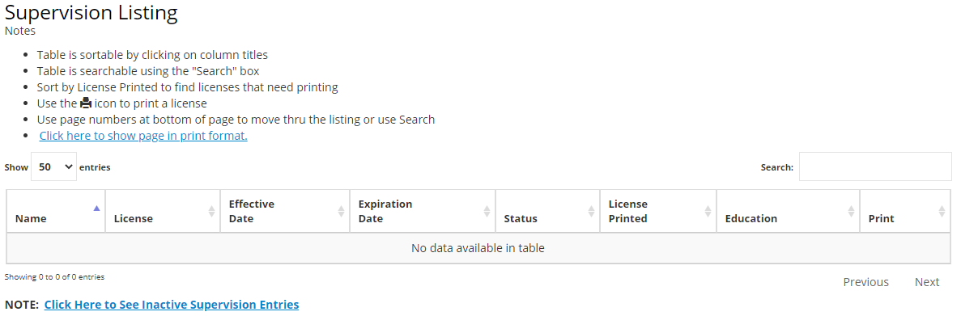

- Additional features are planned for the MyLREC Portal. Licensees should log in regularly to make sure that they do not miss out on upgrades!

