2019 Mandatory Course
LREC Updates & Addenda

Instructor Manual

Prepared By:
Burk Baker and Anna B. Trimble, Esq.

A Louisiana Real Estate Publication

TABLE OF CONTENTS

Course Syllabus
- Course Learning Objectives
- Timed Course Outline
- Introduction
- Section One: Updates to the Louisiana Residential Agreement to Buy or Sell
- Section Two: In-Depth Portions
  - Financing
  - Inspection Period
  - Curative Work and Merchantable Title

Section Three: Addenda
  - LREC Property Disclosures
  - Buyer Agency Agreement
  - Condominium Agreement
  - Contingency Agreement
  - Flood Insurance Purchase Requirement Addendum
  - New Construction Addendum
  - Notice of Ministerial Acts
  - One Time Listing with Representation
  - One Time Showing Without Representation
  - Right of First Refusal Addendum

Section Four: MyLREC Portal
  - Portal Features
  - How to access
  - User ID and password lookup
  - Auto forwarding your MyLREC Email

Case Studies
- Exhibits

- Course Syllabus

Instructor Qualifications and Background

Instructor: Burk Baker
BURK BAKER is a licensed Louisiana real estate Broker and instructor. He is the owner of the Burk Baker School of Real Estate and Appraising which has been in operation for 37 years, with classes held in Baton Rouge, Lafayette, Lake Charles, Metairie, Mandeville, and Monroe, as well as Natchez, Mississippi. He was licensed in 1977 and has been a Broker since 1979.
Mr. Baker attended Louisiana State University majoring in Business Law and has been an instructor of real estate for 38 years. He has also taught GRI courses sponsored by the Louisiana Realtors Association as well as Louisiana Real Estate Commission sponsored seminars throughout the state. Mr. Baker also teaches courses for local Boards of Realtors both in Louisiana and Mississippi. His personalized teaching methods, utilizing humor as a teaching tool, not only make class fun and interesting, but are also highly successful as an instructional method.
Mr. Baker is a member of the Greater Baton Rouge Association of Realtors, the Northeast Louisiana Association of Realtors, the Southwest Louisiana Association of Realtors, the Realtor Association of Acadiana, the New Orleans Metropolitan Association of Realtors, and the Livingston Board of Realtors. He holds the GRI, ITI, and CDEI designations. He is a member of Real Estate Educators Association. Mr. Baker is also a licensed Broker in Mississippi. Mr. Baker resides in Baton Rouge with his wife, Lisa.

Instructor: Anna B. Trimble
ANNA BAKER TRIMBLE is the daughter of Lisa and Burk Baker. Ms. Trimble graduated from Washington & Lee University majoring in English and received her law degree from The University of Texas School of Law in Austin. Ms. Trimble currently practices Real Estate and Corporate law and resides in Baton Rouge with her husband David and their three children Margaret, George, and Anne.

Course Material
All materials needed for this course are included in this manual. The materials include:
- Course Syllabus
- Timed Course Outline
- Learning Objectives
- Course Content Material (Instructor and Student Manuals)
- PowerPoint Presentation
- Digital versions of all course materials can be found on the LREC website under Current Licensees Vendor Mandatory Course Materials or by visiting this link:
https://lrec.gov/current-licensees/vendor/mandatory-course-materials/

Course Completion Requirements
Students must be present for the full four (4) hours if a live presentation. Students taking Internet based presentations must complete all quizzes and exams with a score of at least 70%. An identity affidavit attesting to the fact that the student has personally completed the course without assistance must be submitted before a certificate of completion is granted.

Vendor Policies and Regulations:
Prerequisites: There are no educational prerequisites for this course.
Registration: Any attempt to take this course under an assumed identity will forfeit your right to receive a certificate of completion and may result in sanctions by the Louisiana Real Estate Commission.
Attendance: Students attending a live presentation must sign in before the course and sign out after the course; this course is a four (4) hour presentation, and 100% attendance is required to receive credit for completion. Credit shall not be granted for partial attendance. No exceptions!
Tardiness/Absences: Credit shall not be granted for late arrivals, excessive absences, and/or early departures. Students are not allowed to make up missed portions of a course.

Course Participation: Instructors may not, in any venue, answer questions of a personal or legal nature, and students should not interpret any information received from instructors or course content as being legal advice.
Classroom Rules of Conduct: To provide an atmosphere conducive to learning, students must turn off all electronic devices prior to the start of class. Newspapers, books, magazines, or any other reading materials are not permitted during class presentation. Violations may result in loss of continuing education credit.
ADA Compliance: Upon request, reasonable accommodations will be provided to individuals with a documented disability to assure that an equal opportunity to participate in this course is provided. For further information, contact our office at (555) 555-5555.
Vendor Contact Information: (insert your contact information here) Phone: (555) 555·5555, weekdays between 8:30 a.m. and 5 p.m. central time. E-mail: anyschool@yourschool.com
Address: any town USA

Disclaimer
These materials are to be used for informational purposes and should not be construed as specific legal advice, nor are they designed to cover every aspect of a legal situation or every factual circumstance that may arise regarding the subject matter included.
This publication is for reference purposes only and readers are responsible for contacting their own attorneys or other professional advisors for legal or contract advice. The comments provided herein solely represent the opinions of the authors and are not a guarantee of interpretation of the law or contracts by any court or by the Louisiana Real Estate Commission.

Notes to Instructor
- Students must remain in the classroom for the entire class time.
- Students may not use cell phones during class.
- Students arriving late or leaving early will not receive a certificate of completion.

- Instructors will be provided with a Power Point Presentation that accompanies the course.
- There are no other hand-outs other than the student manual.
- One academic hour is 50 minutes. You may take a 10-minute break every hour for a total of 40 minutes for a 4-hour course, to be taken at the instructor’s discretion.

2019 Mandatory: LREC Updates & Addenda Learning Objectives

Purchase Agreement:
- Updates: Upon completion of the Updates Subsection in the “Purchase Agreement” portion of the course, the student will be able to:
- Describe the improvements made to the LREC state form purchase agreement and identify the rules of law pertaining to the preparation of purchase and sale agreements.

- In-depth Portions: Upon completion of the In-depth Portions Subsection in the “Purchase Agreement” portion of the course, with regard to each of the items below, the student will be able to:

- Financing – Describe the required deliverables from Buyer to Seller in conjunction with a loan application and understand the costs and timeline associated with obtaining financing as well as the ramifications of failure to timely obtain financing.

- Inspections – Explain the benefit of the change to allow for extension of inspection period and understand the timeline inherent with the inspection and repair process.

- Curative – Understand the obligations and ramifications of Seller’s curative work upon receipt of title objections.

- Property Disclosures & Addenda: Upon completion of “Property Disclosures and
Addenda” portion of the course, with regard to each of the items below, the student will be able to:
- LREC Property Disclosures – Summarize and explain the recent changes made to the LREC Property Disclosure form and discuss Louisiana Supreme Court Cases that may have bearing on these changes.

- Buyer Agency Agreement – Compare and contrast major issues with Buyer agency agreements to listing agreements.

- Condominium Agreement – Understand the purpose and substance of the Condominium Addendum and be able to accurately populate the form.

- Contingency Agreement –Describe the difference between a contingent and non-contingent contract and accurately summarize the contingency clause.

- Flood Insurance Purchase Requirement Addendum (Obtain and Maintain) – Understand the obligations of Seller and Buyer related to notice and future awards of disaster relief.

- New Construction Addendum – New Home Warranty Act – Discuss changes made to laws pertaining to the New Home Warranty Act and understand the elections required on the form.

- Notice of Ministerial Acts – Define “Ministerial Acts” and understand the relationship formed or not formed between the Licensee and customer based on Ministerial Acts.

- One Time Listing with Representation – Describe the limitations on a Licensee in drafting a listing agreement with representation.

- One Time Showing Without Representation - Describe the limitations on a Licensee in drafting a listing agreement without representation.

- Right of First Refusal Addendum - Describe the rules and laws pertaining to the preparation of rights of first refusal addendum and identify information needed for a right of first refusal addendum.

MyLREC Portal: Upon completion of the “MyLREC Portal” section of the course, the student will be able to discuss how to access email and describe the features of the MyLREC Portal.

III. 2019 Mandatory: LREC Mandatory Updates & Addenda Timed Outline

I. Purchase Agreements Minutes

Introduction and Common violations 30

Updates to Louisiana Residential Agreement to Buy or Sell 30

In-Depth Portions of Purchase Agreement

Financing 20

Curative 20

Inspection 20

LREC Property Disclosures 15

Addenda

Buyer Agency Agreement 10

Condominium Agreement 10

Contingency Agreement 10

Flood Insurance Purchase Requirement Addendum 10

New Construction Addendum 10

Notice of Ministerial Acts 10

One Time Listing with Representation 10

One Time Showing without Representation 10

Right of First Refusal Addendum 10

MyLREC Portal 15

2019 Mandatory:
LREC Updates & Addenda

Introduction

Introduction:
Welcome to the 2019 Mandatory: LREC Updates and Addenda. While the material contained in this course may at first seem elementary, much of the material is not being practiced correctly by the average Licensee on a continuing basis.
I’m sure some closing attorneys have seen contracts written by practicing agents that were at the very least alarming, and even our professional educators are presented with documents from agents asking “what do they do?” We often get calls about deals that are in jeopardy and documents pertaining to transactions that are rife with violations of the license law, rules and regulations, and contract law.

Some of the common violations include:
- No annotation on counter offers
- Agents assuming that because a Buyer signed the customer information pamphlet they are now their client
- Not getting offers signed and communicated to the offeror before the time stipulated in the offer
- Buyer’s Licensee not delivering the Deposit after acceptance
- Not keeping rejected offers for five years
- Not returning rejected offers to the other agent
This course is designed for the average Louisiana Licensee and cannot be simple enough.
The Louisiana Residential Agreement to Buy or Sell is an agreement between the Buyer and the Seller to sell and buy. While there are many rules in the Louisiana

Civil Code specific to purchase and sale, the general rules of Louisiana contract law also apply.

The Louisiana Civil Code defines the Agreement to Purchase and Sell as:
“an agreement whereby one party promises to sell and the other promises to buy a thing at a later time, or upon the happening of a condition, or upon performance of some obligation by either party” La. C.C. art. 2623.
The Agreement to Purchase and Sell is a bilateral promise. A “bilateral promise” is a reciprocal promise meaning each party promises to perform an act in exchange for the other party’s act. According to Article 2623 of the Code, “such an agreement gives either party the right to demand specific performance” under the contract.
Under Louisiana law, a contract to sell must include, at a minimum, the following:
- the thing to be sold;
- the price,
- and meet the formal requirements of the sale it contemplates.

The Louisiana Real Estate Commission (“LREC”) has taken this edict one step further and created a form purchase agreement. Title 46 of the Louisiana Administrative Code governs the professional and occupational standards of Real Estate professionals. Chapter 39 requires any Licensee representing either the Buyer or Seller of residential real property to use the Residential Agreement to Buy or Sell form promulgated by the LREC when initiating an offer to purchase or to sell residential property. The official source of the Residential Agreement to Buy or Sell is the LREC website.
In this course we will refer to the Residential Agreement to Buy or Sell as the “Purchase Agreement” when the context refers to the form itself or how to fill it out. When context requires that we refer to an executed Purchase Agreement that has been filled out, signed and is now “in play,” we will use the word “Contract.”

Chapter 39 of the Louisiana Administrative Code requires that a Licensee use the Purchase Agreement when the transaction involves “residential real property.” Residential real property means real property consisting of one or not more than four residential dwelling units which are buildings or structures each of which are occupied or intended for occupancy as a single-family residence.
The Licensee may not alter the prescribed form; however, a Licensee may add addenda or amendments to the form. What is more, counter offers may be made on an alternate form. Any modifications to the printed form should be made by adding an attached addendum which references the lines that are to be changed and the changes that you are making to them.
Put simply, a Licensee must use the form prescribed by the Louisiana Real Estate Commission and found on their web site. No strike-outs or modifications of any kind may be made to the form.
In this course, we will discuss the updates made to the Purchase Agreement. We will examine the updates made in 2017 as well as 2018, all of which are incorporated into the current Purchase Agreement, which is included in your manual and may also be found here: https://lrec.gov/forms/mandatory-forms/
We will also examine in-depth the sections on Financing, Curative work, and Inspections. We will explore what is customary, what is required, and what actions may incur liability on the part of the Licensee. In conjunction with the examination of the Purchase Agreement, we will refer to and analyze the addenda, both mandatory and suggested, that may be used when filling out a Purchase Agreement. As a general rule, these addenda will be attached to the Purchase Agreement anytime the proposed transaction extends beyond the set parameters of the Purchase Agreement. For example, we will discuss matters that are not a part of the printed form and that should be articulated in the section entitled “Additional Terms and Conditions” found at lines 301-307 of the Purchase Agreement. A Licensee should strive to err on the side of overinclusion when filling out the Purchase Agreement.
Finally, we will examine the new features associated with the updated MyLREC portal.

For ease of comprehension, we will capitalize the words “Buyer,” “Seller,” “Property,” “Licensee,” and “Deposit.” References to gender are interchangeable.

Section One: Updates to the Purchase Agreement
Update - Box 1: In 2017, the Purchase Agreement was updated to require inclusion of the Licensee’s license number as well as the name of the brokerage firm, the Broker, and the Broker's license number.
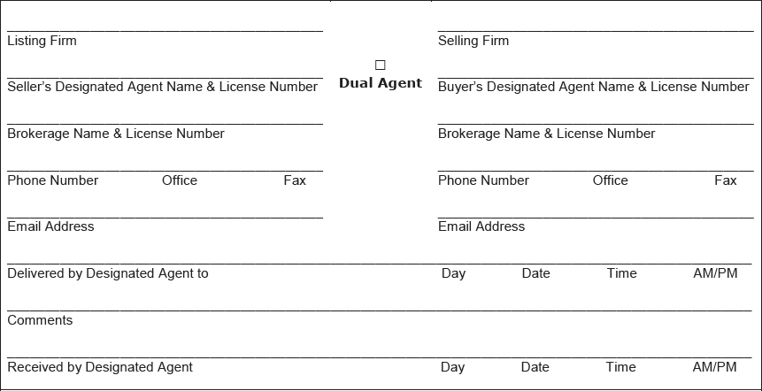

In 2018, this line was revised to refer to “Brokerage Name” instead of Firm or Broker’s name. This change was made to better articulate the concept that the Licensee should insert the name of the entity for which they are doing business as registered with the LREC. Licensee should input the name of their Brokerage firm and their individual license number in Box 1.
Most Brokerage firms now have the ability to purchase auto-populated software that is keyed to fill in the blanks automatically based on the name of the Brokerage firm inserted into the blank. The hope is that this software will alleviate many instances of human error.

Update -Lines 46 – 50: Contingent Sales
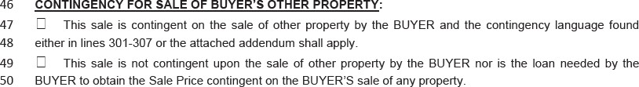

As this course will explore in more detail below, a sale that is contingent upon a condition may be terminated by the Buyer or Seller if the Buyer is unable to accomplish the stated condition. Lines 46-50 relate to a sale that is contingent upon the Buyer’s ability to sell another property that is owned (at least in part) by Buyer.
These lines have been updated to reference the “Additional Terms and Conditions” in lines 301-307 and the Contingency Addendum. The Contingency Addendum should be attached if the Buyer checks the box in line 47. A Licensee should also reference the contingency condition in lines 301-307. In those lines, a Licensee should describe the Property that Buyer must sell and provide an allowed timeline for Buyer to complete the sale.

Update - Financing Contingency:
In 2018, the form was updated to include language requiring a Buyer that utilizes a financing contingency to check all boxes that describe the desired loan product. The Conventional Mortgage check box was added in 2018. Hence, multiple boxes in the below section will likely be checked.

Update - Buyer’s timely application for financing:
As we will explore in more detail in the In-Depth portion of the course, Lines 72- 85 have been revised to ensure that a Buyer timely applies for the specified loan, and that Buyer gives notice to Seller that Buyer has done so. A Seller who agrees to a financing contingency has agreed to take the Property off the market for a specific period of time to allow a potential Buyer the time and opportunity to complete the desired transaction. This change gives the Seller confidence that the transaction is going forward.
In 2017, the form was revised to require the Seller to provide utilities and access during the appraisal. This is line 98 in the Purchase Agreement. At the same time, the Purchase Agreement was revised to require the Seller to provide utilities and access during the inspection period. This is line 176 in the Purchase Agreement. The inspection period will be extended for each day that either utilities or access is not provided.

Update – Deposit Lines 114-119
In 2018, the form was updated to specify that the Deposit must be delivered by Buyer within seventy-two (72) hours of "notice of acceptance of the offer." Acceptance of the offer is defined as execution combined with communication of the acceptance. La. C.C. art. 1934. The right to deliver the Deposit via a promissory note has been replaced by a requirement for actual funds such as Certified Funds, Electronic Transfer, etc. See lines 111-112 below.
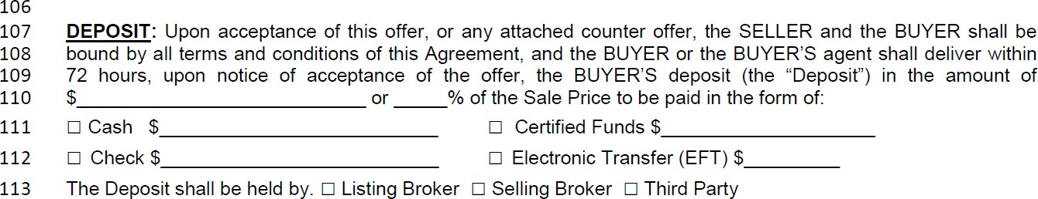
These changes re-enforce the trend toward underscoring that Buyer is a legitimate Buyer and that the transaction will close.

Discussion Topic:
It is important to note that Louisiana law does not require a Buyer to provide a Deposit in order for a Contract to be valid. However, it is common practice because it is a traditional show of good faith and sends the message to the Buyer that it is a serious offer. Unless the parties agree otherwise, the default rule in Louisiana is that a Deposit will be credited for the Buyer toward the Sale Price at the Act of Sale.
Doing away with Deposits on Purchase Agreements would also do away with Deposit disputes. Of course, you would still need a Deposit on an earnest money contract, but most residential contracts in Louisiana are specific performance.

Update - Deposit Held by Third Party
The Deposit always goes into the listing Broker’s escrow account unless all parties agree otherwise in writing. This brings us to the addition of the box pictured below. There is a current trend toward allowing the title company to hold the Deposit. Hence, the Purchase Agreement has been updated on line 113 to allow a Third Party to hold the Deposit.

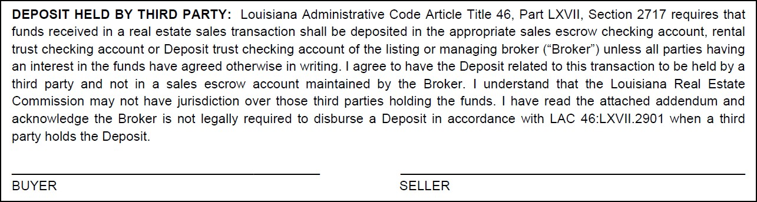
While, Section 2717 of the Louisiana Administrative Code requires that the listing Broker hold the Deposit, the Buyer and the Seller may agree to let a Third Party hold the Deposit. The Box pictured above states the relevant law and should be

signed by the Buyer and the Seller if the listing Broker will not be holding the Deposit.
Brokers who anticipate that they will accept a Deposit, or any other money in conjunction with a sale, must open and maintain a “Sales Escrow Account.” LREC
§2701. A Sales Escrow Account is non-interest bearing, which is why most Deposits made in conjunction with the Purchase Agreement are stated to be “non- interest bearing.”
NOTE: If you are a broker and do not anticipate taking deposits, you do not have to have an escrow account. You may place funds in an interest bearing account if all parties agree in writing, however only one Deposit can be in the interest bearing account at one time.

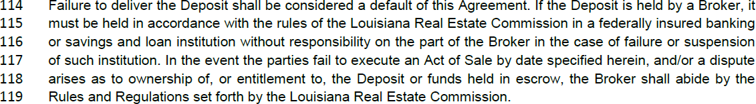
In addition to signing the box pictured above, it is good practice to use a Deposit addendum that spells out the terms of the release of the Deposit. There is no promulgated form for the deposit addendum. A sophisticated Third Party, such as a title company, will often use an escrow agreement that spells out the terms of the conditions that must be met for release of the money. In fact, the definition of “escrow” is when a third party holds something (usually money) for a stated time or until a stated condition has been met. We have attached a sample addendum and a sample third party escrow agreement to this course as Exhibits A and B.

In real estate transactions, the Deposit is usually held until the terms of the Purchase Agreement are satisfied and the transaction closes or, in the alternative, until it is clear that the transaction will not close. If the transaction closes, as stated above, the Deposit is usually credited toward the Sale Price. If the transaction does not close, and there has been a breach of the Purchase Agreement, the Deposit is usually returned to the non-breaching party.

Update - Return of Deposit Lines 121 – 146
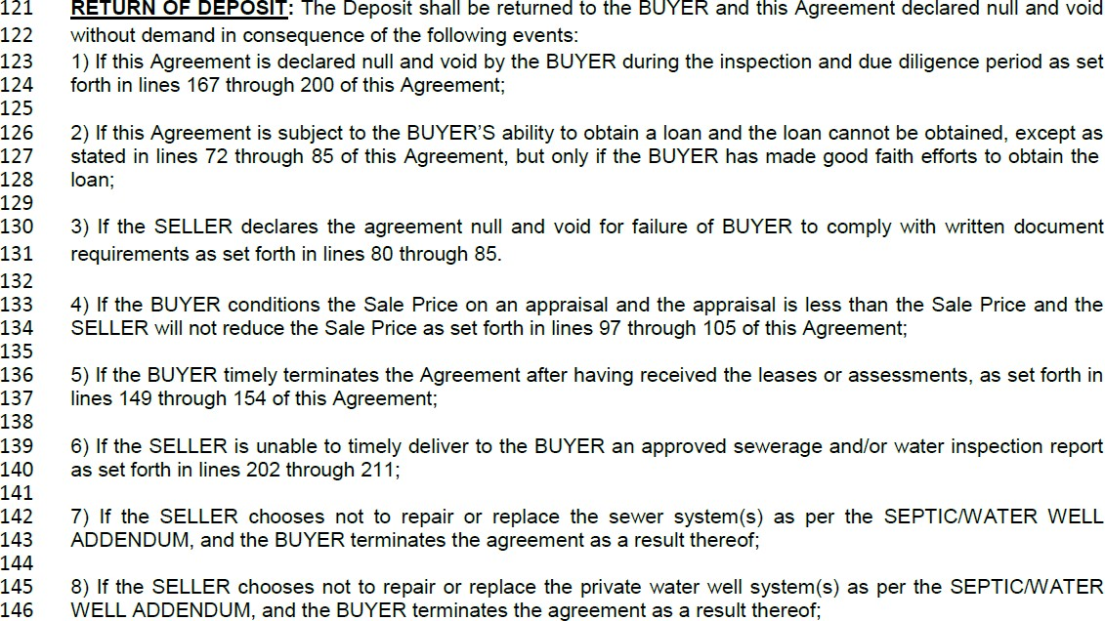

The form has been updated to allow for the Deposit to be returned to Buyer if Seller terminates for Buyer’s failure to push loan through. See lines 130-131.
When a dispute exists in a real estate transaction regarding the ownership or entitlement to funds held in a sales escrow checking account, the Broker holding the funds shall send written notice to all parties and Licensees involved in the transaction within sixty (60) days of (i) the scheduled closing date or (ii) Broker’s knowledge that a dispute exists, whichever occurs first. In such a case, the Broker shall do one of the following:
- Disburse the funds upon the written and mutual consent of all of the parties involved;
- Disburse the funds upon a reasonable interpretation of the Contract that authorizes the Broker to hold the funds.
- Place the funds into the registry of any court of competent jurisdiction and proper venue through a concursus proceeding;

- Disburse the funds upon the order of a court of competent jurisdiction.
Disbursement should occur within ten (10) days after the Broker has sent written notice to all parties and licensees;

Update – Flood Hazard Information Lines 290 - 292
The Flood Hazard Information was added after the floods of 2016 in south Louisiana. See lines 290-292. The addition of this language has necessitated the potential need for the Flood Insurance Addendum that is discussed in more detail Section Three: Addenda below.
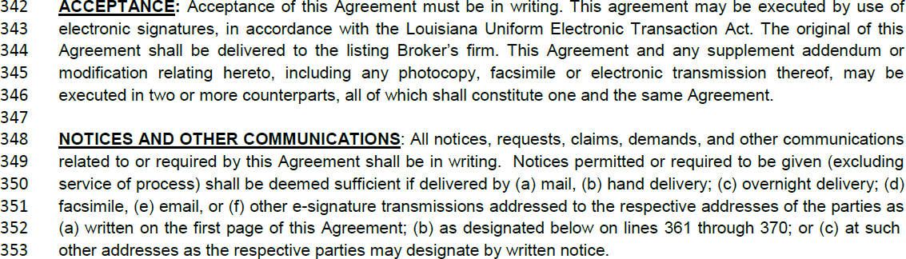

Finally, the Purchase Agreement was updated in 2017 to allow Acceptance and Notice by electronic signature, but makes clear in lines 371-372 that this does not mean that the Buyer’s agent can communicate directly with Seller or that the Seller’s agent can communicate directly with the Buyer.

Conclusion:
The updates to the Purchase Agreement work cohesively to promote uniformity among transactions, eliminate fraudulent or flimsy transactions, and increase disclosure, knowledge and awareness among Buyers and Sellers.

However, while Licensees are required to use the Purchase Agreement as stated in Section 3900 of the LREC Rules & Regulations:
§3900. Purchase Agreement Forms
  - The purchase agreement form used by licensees representing the buyer or seller in a residential real estate transaction shall be the Residential Agreement to Buy or Sell, or any successor thereof, prescribed by the Louisiana Real Estate Commission.
This requirement does not supersede the requirement to present all offers immediately as stated in the LREC Rules & Regulations Section 3901. Section 3901 states:
§3901. Timely Presentation of Offers and Counter Offers
A. All written offers and counter offers for the purchase of real estate shall be presented to all buyers and/or sellers for their consideration and decision immediately, without delay.
Example: A selling agent presented an offer to the listing agent on an outdated purchase agreement. The listing agent instructed him to take it back and put the offer on the current purchase agreement, which he did, informing the Buyer why he must sign a new purchase agreement. The next day when presented with the new form, the listing agent said he would take it as a
back-up offer as the seller had meanwhile accepted another offer.
The Buyer filed a complaint on the basis that his agent had been negligent in his duties causing the Buyer to lose the house.
The listing agent’s license was suspended for 30 days for failing to present the offer. The Buyer’s agent was required to take continuing education.

Section Two: In Depth Portions

Financing
Very few potential Buyers will have enough cash in the bank to buy a home without a loan. Therefore, most prospective Buyers will seek to finance their purchase by borrowing money. Usually, this is done by engaging a financial institution such as a bank or other institutional lender. A loan is defined as a relationship between a lender and borrower. The lender is sometimes referred to as a creditor and the borrower is sometimes called a debtor. In this course, when we refer to a “mortgage,” we refer to a type of loan that is secured with real estate or personal property.
In some instances, a Buyer may be able to are able to obtain Seller financing. This is also called “bond-for-deed” or “owner financing.” The Buyer will make a down payment, and then make installment payments over a specified period (usually, a number of years). Buyer will pay interest to the Seller and the Seller will retain title to the Property until the mortgage is paid in full. In rare cases, a Buyer may be able to assume the Seller’s existing mortgage. In such a case, the Buyer will pay the difference between what is owed on the mortgage and the Sale Price and the Buyer will take over the Seller's payments to the lender on the mortgage.

Note: Mortgages may only be assumed if the provisions in the mortgage state specifically that it is assumable. Most mortgages written today include a due-on-sale clause that prohibits assumption of a mortgage. Seller should be alerted to the fact that he or she will remain liable on the mortgage obligations unless the Seller's lender specifically and in writing releases Seller.

Selecting a Financing Contingency: Lines 52-61
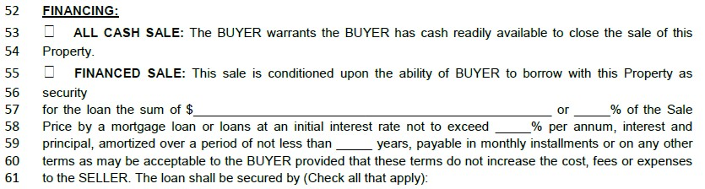

The above paragraph constitutes a financing contingency. When the “Financed Sale” box in line 55 is checked, the Purchase Agreement is said to contain a financing contingency. A financing contingency is a clause in a purchase and sale agreement that expresses that the Buyer’s offer is contingent upon Buyer’s being able to secure financing for that particular Property.

If the sale is not contingent upon the sale of some other Property and the Buyer does not need to borrow money to purchase the Property, then the box in line 49 should be checked. However, it is rare that a Buyer will not need to borrow money to for the transaction.
Typically, a Buyer uses this clause to establish a set period of time to apply for, and receive approval for, a mortgage for which the subject Property is security. Within this clause the Buyer will also normally list the type of mortgage they intend to obtain, the term of the loan, and the interest rate.
The purpose of the financing contingency is to protect the Buyer in the event they are unable to get approved for a loan. A financing contingency can be very specific about stipulations and conditions, but the main goal is to make sure the Buyer is not punished for being unable to get financing to complete the transaction. Hence, if the Buyer is unable to obtain the particular type and amount of financing specified in the Contract, Buyer may terminate the Contract. Most Buyer-initiated financing contingencies will stipulate that the Buyer gets their Deposit back if the Buyer is unable to get approved for the loan.
This paragraph also provides a blank for a maximum interest rate per annum if the Buyer wishes to include this as a term of sale. Further, a blank is provided for

amortization of the loan. For example, the Buyer may say that he must obtain a mortgage loan for 80% of the Sales Price at an initial interest not to exceed 9% per annum, interest and principal amortized over a period of not less than 30 years. Buyer may agree to other loan terms not stated in the financing terms in the lines above, so long as these different financial terms do not increase the costs, fees or expenses to the Seller. This provision protects the Buyer from having to accept a loan with terms that are extremely unfavorable or not financially viable.

Case: Maryland’s highest court has considered whether Buyers could fulfill a purchase contract’s financing contingency by submitting only one loan application which was then rejected by the lender.

The purchase contract was contingent upon the Buyers obtaining financing. The Buyers did apply for a loan but were denied because the appraisal overstated the value. The Buyers did not apply for another loan even though they received offers to help them arrange alternative financing, and they canceled the purchase contract pursuant to the Financing Contingency.
The Sellers later sold their residence for a price lower than the Buyers had agreed to pay for the property. The Sellers sued the Buyers for breach of contract, and the Buyers counterclaimed for their Deposit. The trial court ruled in favor of the Buyers, but denied them recovery of their attorney’s fees. On appeal, the court ruled that the Buyers were entitled to recover reasonable attorney’s fees and so the case was sent back to the trial court for further proceedings on the amount of attorney’s fees the Buyers could recover.
See full case in “Case Studies.”

In most cases, a Buyer will not want to apply for financing until the home inspection is completed and satisfactory. This timing should be allowed for when filling out the Purchase Agreement. A typical financing window is 30 – 60 days.

Example: The Buyer checked “Cash Sale” on the Purchase Agreement. A few
days before the closing the Buyer said he would not be able to close yet because the appraisal had not been completed. The Listing Agent said there was no need for an appraisal because he checked “Cash Sale” on the Purchase Agreement, and the Sellers are not willing to wait.
The Buyer arranged to borrow the money from a relative and the sale closed as scheduled.
A Buyer should check the “Financed Sale” box if a portion of the Sale Price is to be financed on behalf of the Buyer AND that securing that financing is a condition to closing. Note that a Buyer may finance a portion of the Sale Price and not check any of these boxes. In a strong real estate market, a Seller is likely to pick the offer that has the highest dollar amount and the fewest contingencies and stipulations.

Discussion Point: A buyer signs an agreement to purchase a house and
receives approval for the loan. One week before the closing the Buyer buys a
new car and now does not have sufficient funds to cover closing costs. Is the
Buyer in breach of the contract?

When a Buyer makes an offer on a house, there may be multiple contingencies. Some people choose to waive their right to ask the Seller for a financing or appraisal contingency in order to beat out their competition. However, without a financing contingency, if a Buyer does not have the cash to complete the transaction AND cannot obtain a loan, the Buyer may forfeit the Deposit or be subject to a lawsuit for ten percent (10%) of the Sale Price as liquidated damages unless the contract was negotiated to say otherwise. Because this type of clause favors the Buyer, some real estate agents suggest that the Buyer obtain "pre- approval" from a lender, which gives the Seller some confidence that the Buyer will not use the clause to void the contract unless some extraordinary circumstance arises.

Type of Financing (Choose ALL that apply): Lines 62 - 66

Today, a wide variety of financing products exist to finance a purchase. Some Buyers may qualify for federally insured loans that permit smaller-than-normal down payments and lower interest rates than prevailing market rates.

Lines 68 - 70

Points are the lender's charge to the Buyer to obtain the loan. The Buyer may have paid some of this fee in advance to secure the loan. One (1) point equals one (1) percent of the loan amount. The Seller is usually responsible for paying the commission on the sale and must pay any taxes owed on the property, any money due his or her lender, and any liens that may be outstanding on the property. Usually, the Buyer is required to pay the cost of a title insurance policy and abstract of title that insures the Buyer against any defects in the title to the property.
The Buyer will also be responsible for closing costs which average at three percent (3%) of the Sale Price. The Louisiana License Law states in §1455, number 25 as one of the 36 ways to lose your license that:
(25) Failure of a Licensee to inform the Buyer and Seller at the time an offer is presented that either party may be expected to pay certain costs such as discount points, etc. and the approximate amount of said costs.

Lines 72 - 85
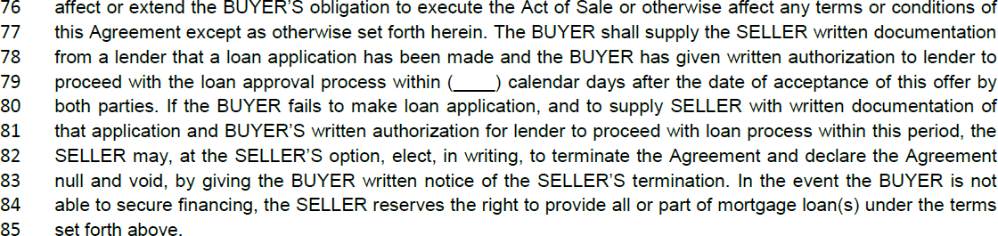

“The BUYER acknowledges and warrants that the BUYER has available the funds which may be required to complete the sale of the Property including, but not limited to, the Deposit, the down payment, closing costs, pre-paid items, and other expenses. If this sale is a Financed Sale, BUYER acknowledges that any terms and conditions imposed by BUYER’S lender(s) or by Consumer Financial Protection Bureau Requirements shall not affect or extend the BUYER’S obligation to execute the Act of Sale or otherwise affect any terms or conditions of this Agreement except as otherwise set forth herein. The BUYER shall supply the SELLER written documentation from a lender that a loan application has been made and the BUYER has given written authorization to lender to proceed with the loan approval process within () calendar days after the date of acceptance of this offer by both parties. If the BUYER fails to make loan application, and to supply SELLER with written documentation of that application and BUYER’S written authorization for lender to proceed with loan process within this period, the SELLER may, at the SELLER ’S option, elect, in writing, to terminate the Agreement and declare the Agreement null and void, by giving the BUYER written notice of the SELLER ’S termination.”
In Lines 72-85, the Buyer acknowledges and warrants that he has available funds which may be required to complete the sale of the Property. This is commonly referred to as providing “Proof of Funds.” This includes the Deposit, the down payment, the closing costs, prepaid items and other expenses. This section is also intended to give notice to the Buyer that there may be costs that the Buyer will need to pay above the amount of the mortgage loan.

As discussed in the Section on Updates, this section has been revised to require Buyer to show evidence that the loan has been approved and is going forward and to give Seller more comfort that the failure to obtain financing will not contribute to the failure of the transaction.
Buyer must agree to make a good faith financing application with the lender. This includes ordering and paying for an appraisal and credit report if required for loan approval by the lender. A blank is provided for the number of calendar days after acceptance of this offer or any counteroffer that written proof from the lender of the loan application should be supplied by the Buyer to the Seller.
This means that the Buyer must make his application for financing within a certain number of calendar days from acceptance of the offer or counteroffer and then provide proof that the application has been made to the Seller. This time period for compliance is best practice when a contract contains any sort of contingency. In this case, it protects the Seller. Without it, Seller’s property could be off the market for months, with no assurance that the sale will go through.
The loan application proof could be supplied to either the Seller or the Seller’s Licensee. The commitment by the lender to make loans without contingencies (except subject to title approval and other contingencies normally imposed by the lender), excluding ordering appraisal and credit report shall constitute final loan approval. This standard is considered final loan approval for purposes of the Purchase Agreement.

Lines 83-85
“In the event the BUYER is not able to secure financing, the SELLER reserves the right to provide all or part of mortgage loan(s) under the terms set forth above.”
Very seldom, and only in certain circumstances, would you want to force the Buyer to buy a Property. Most Sellers are not in a position to undertake owner financing because they have allocated the money from the sale to buy a new home. However, this sentence could provide powerful leverage for a builder who has let the Buyer pick out colors, special fixtures, or upgrades, only to have the Buyer change his or her mind.
In the industry, a sham rejection letter is referred to as a flimsy rejection letter. A Buyer wanting to get out of a contract could furnish a flimsy rejection letter obtained from a

friendly lender, or because they refused to pay off a small debt in order to qualify, or purposely purchased and charged a big-ticket item such as a car or boat with the intention of not qualifying for the loan. Any of these events could enable a Buyer to get out of the contract without being in breach of the financing contingency. In this case the builder would have the option of offering to do the financing at the same or better terms.

Inspection Period.
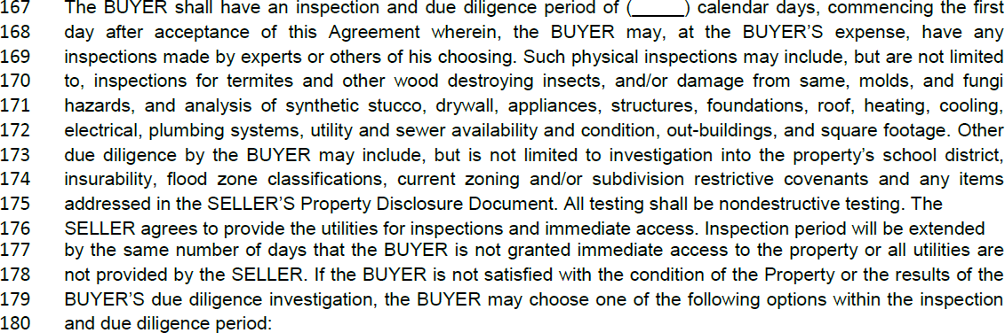
Lines 167 – 175

“The BUYER shall have an inspection and due diligence period of () calendar days, commencing the first day after acceptance of this Agreement wherein, the BUYER may, at the BUYER’S expense, have any inspections made by experts or others of his choosing. Such physical inspections may include, but are not limited to, inspections for termites and other wood destroying insects, and/or damage from same, molds, and fungi hazards, and analysis of synthetic stucco, drywall, appliances, structures, foundations, roof, heating, cooling, electrical, plumbing systems, utility and sewer availability and condition, out-buildings, and square footage. Other due diligence by the BUYER may include, but is not limited to, investigation into the property’s school district, insurability, flood zone classifications, current zoning and/or subdivision restrictive covenants and any items addressed in the SELLER’S Property Disclosure Document.”

Standard real estate contracts in nearly all fifty states provide the Buyer with a stated period of time during which the Buyer can inspect and assess the property and decide whether or not he or she wishes to proceed with the purchase thereof. These time periods are sometimes referred to interchangeably as feasibility periods, inspection periods, or study periods. The inspection period is meant to be an unfettered termination right for Buyer.
Some Sellers interpret this period as a termination right only in the event that the inspection reveals some material adverse fact. However, the concept of what constitutes a “material adverse fact” is subjective and therefore could be difficult and time consuming to prove. Therefore, the best practice is to allow the Buyer the unrestricted right to terminate during time period allotted for inspection for any reason or for no reason at all.
A good way to think of this period is a chance for a prospective Buyer to “kick the tires,” so to speak.
Most offers now include waiver of redhibition, so the Seller would not be liable for defects found after closing that existed before the sale but were not discovered or known by the Seller.

Confusion over Component Parts:
During the inspection period, a Licensee should make very clear to a prospective Buyer which items will convey with the Property and which items will be removed. Any items that are to remain, but are not component parts, should be specifically and clearly listed in the Purchase Agreement. An appropriate place to do this is in “Additional Terms and Conditions.” For example, items such as an outdoor swing, sugar kettles, and satellite dishes may be expected to convey and should be itemized.
Things permanently attached to an immovable object are its “component parts.” This area of law has been unclear at times. In the 2005, the Louisiana Supreme Court handed down the Willis-Knighton decision. That decision turned widely accepted notions of what constitutes a component part on its head. In that case,

the Louisiana Supreme Court ruled that myriad items previously understood to be component parts (such as toilets, doors and even cabinets) were re-classified as tangible personal property. The legislature quickly tried to right what the court got wrong and make clear that all items that were considered part of an immovable property prior to the Willis-Knighton decision retained their status as “component parts.”
Louisiana Civil Code art. 466, divides component parts of a building into two categories of component parts:
(1) Things that are attached to a building and that, according to prevailing usages, serve to complete a building of the same general type, without regard to its specific use, are its component parts. Component parts of this kind may include doors, shutters, gutters, and cabinetry, as well as plumbing, heating, cooling, electrical, and similar systems.
(2) Other things are component parts of a building or other construction if they are attached to such a degree that they cannot be removed without substantial damage to themselves or to the building or other construction.
https://www.louisianalawblog.com/business-and-corporate/definition-of- component-parts-clarified-for-louisiana-sales-and-use-tax-purposes/

Example: The Property being sold has custom drapery, a sub-zero refrigerator disguised to be part of the kitchen cabinetry, a television wired into brick in the outdoor kitchen and a brand-new washer/dryer set. Seller may intend to use the drapes in his or her new home. However, in Louisiana, window coverings are included in the Purchase Agreement’s Property Description per lines 13-14. The sub-zero refrigerator would likely be considered “built-in appliances” per line 12. The television and washer/dryer set likely do not convey under the Purchase Agreement. Depending on the circumstances, these items should be listed on lines 20-22 (if no value and being transferred to Buyer), lines 27-28 (if being excluded from the transfer), or lines 284-292 (if being transferred to Buyer, but part of the consideration for the purchase price).

Lines 175 – 180

Note that the above provision contains a requirement that all testing shall be nondestructive testing. This means the Buyer may not damage any portion of the Property during the testing period in order to gain data needed for testing without the written approval of the Seller. However, nowhere in the Agreement is there a

provision allowing Seller to recover in the event that Buyer causes damage to the Property.
It would be prudent to include an indemnification in favor of the Seller. A practical provision would be to limit Buyer’s liability to losses caused by the negligence or willful misconduct of the Buyer or its agents, employees or contractors. Occasionally, the Seller will require the Buyer to indemnify the Seller for losses caused by Buyer’s presence on the property, regardless of negligence or willful misconduct.
At a minimum, the contract should expressly state that the Buyer is not responsible for pre-existing conditions discovered by the Buyer, but not caused by the Buyer. The Seller may also require the Buyer to maintain liability insurance covering the Buyer’s actions on the Property and naming the Seller as an additional insured.
As discussed above in Updates, Seller shall supply the utilities for inspections and access to the Property for the Buyer. This sentence was added to allow for extension of inspection period if access to Property within utilities is delayed by Seller.

It could be important to at least confirm the square footage during the inspection period. We have been faced with situations in which the sale has fallen through when a lender was able to confirm that the square footage reported in the Contract was incorrect.

Lines 161 - 166
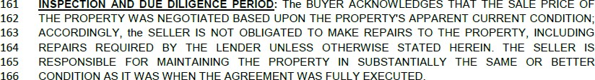

It is important to explain to a Buyer that the Seller is not obligated to make repairs to the Property including any repairs which are suggested or required by the lender unless repairs are otherwise provided for in the Agreement. The Seller is

responsible for maintaining the Property in substantially the same or better condition as it was when the offer was accepted. This is usually confirmed by a walk-through prior to closing.
If Buyer is not satisfied with the condition of the Property or the results of the Buyer’s due diligence investigation, the Buyer may choose one of the following options before the end of the inspection or due diligence period:

Lines 182 - 195
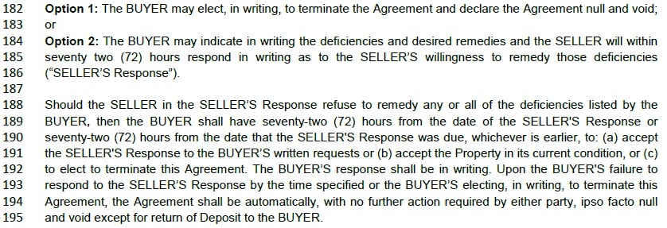

“Option 1: The Buyer may elect, in writing, to terminate the Agreement and declare the Agreement null and void;
Or
Option 2: The Buyer may indicate in writing the deficiencies and desired remedies and the Seller will within seventy-two (72) hours respond in writing as to the Seller’s willingness to remedy those deficiencies (“Seller’s Response”)
Should the SELLER in the SELLER’S Response refuse to remedy any or all of the deficiencies listed by the BUYER, then the BUYER shall have seventy-two
(72) hours from the date of the SELLER'S Response or seventy-two (72) hours from the date that the SELLER'S Response was due, whichever is earlier, to: (a) accept the SELLER'S Response to the BUYER’S written requests or (b) accept the Property in its current condition, or (c) to elect to terminate this Agreement. The BUYER’S response shall be in writing. Upon the BUYER'S failure to respond

to the SELLER’S Response by the time specified or the BUYER’S electing, in writing, to terminate this Agreement, the Agreement shall be automatically, with no further action required by either party, ipso facto null and void except for return of Deposit to the BUYER.”

Note that Option 1 gives the Buyer the right to terminate the contract for any reason or for no reason at all. The termination must be in writing and provided to Seller before the end of the stated inspection period.
The second option requires Buyer to indicate in writing the deficiencies and desired remedies to the Seller. The Seller will then have seventy-two (72) hours to respond in writing to the Buyer as to the Seller’s willingness to correct the alleged defects.
Should the Seller refuse to remedy any of the deficiencies listed by the Buyer, then the Buyer has seventy-two (72) hours from the date of Seller’s Response as defined in the Purchase Agreement, or seventy-two (72) hours from the date the Seller’s Response was due, whichever is earlier, to either:
(1) accept the Seller’s Response to the Buyer’s written request, (2) accept the Property in its current condition or
(3) terminate the contract.

Lines 197 - 200

“FAILURE TO GIVE WRITTEN NOTICE OF EITHER TERMINATION OR DEFICIENCIES AND DESIRED REMEDIES TO THE SELLER (OR THE SELLER’S DESIGNATED AGENT) AS SET FORTH IN LINES 161 THROUGH 180 WITHIN THE INSPECTION AND DUE DILIGENCE PERIOD SHALL BE DEEMED AS ACCEPTANCE BY THE BUYER OF THE PROPERTY'S CURRENT CONDITION.”
The provision in all caps above provides that if the Buyer fails to send a notice of termination prior to the expiration of the inspection period, the Buyer’s right to

terminate the Contract will expire. Further, any of Buyer’s decisions made after receipt of the Seller’s Response should be in writing. Note that the Purchase Agreement allows for email correspondence, so this notice could be delivered via Email.
If the Buyer fails to respond in writing to the Seller’s Response in the time specified, then the Contract is automatically void and the Deposit shall be returned to the Buyer. The parties should note which way this concept is addressed and mark their calendars to avoid inadvertently waiving the right to terminate the Contract. Some Licensees see this as an opportunity to renegotiate the Contract using the right of termination as leverage. This is not the intent of this provision.
Note: Some title companies and even some Licensees will prepare what is referred to as a “Critical Dates Chart” or a “Timeline” for their prospective Buyer or Seller. This is a table or chart that lists due dates and time periods listed in the Contract. See Exhibit C for an example.

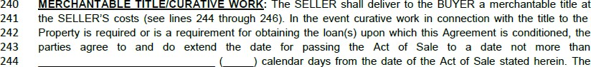
Title Review Period. Lines 240 - 244

“MERCHANTABLE TITLE/CURATIVE WORK: The SELLER shall deliver to the BUYER a merchantable title at the SELLER’S costs (see lines 244 through 246). In the event curative work in connection with the title to the Property is required or is a requirement for obtaining the loan(s) upon which this Agreement is conditioned, the parties agree to and do extend the date for passing the Act of Sale to a date not more than ( ) calendar days from the date of the Act of Sale stated herein.”

Merchantable title is a title to real property that is clear and free from encumbrances, litigation, and other defects, and that can readily be sold or

mortgaged to a reasonable Buyer or mortgagee. It is a title that a court of equity considers to be so free from defect that it will legally force its acceptance by a Buyer.
There is a difference between merchantable and insurable title. Merchantable title means “good title” and is not the same as insurable. Virtually any title can be insured if someone is willing to pay the premium and accept sometimes egregious exceptions to title insurance.
Whether title to real estate is merchantable is a question of law for the court. However, a merchantable title does not assume absolute absence of defect. It is merely a title that a prudent, educated Buyer in the reasonable course of business would accept. In other states it is referred to as good title, marketable title, clear title, or sound title.
If the title has defects, typically, the Seller is responsible for remedying title defects. Although not explicitly articulated in the Contract, we should assume that it is the Buyer’s obligation to object to title defects. In the event Buyer delivers to Seller a notification of its objections, Seller shall have until closing or an agreed upon number of days afterward to cure the title defects.
Seller has the right, but not the obligation, to cure or remove the title defects and deliver to Buyer evidence of such cure or removal; provided, however, that Buyer shall be deemed to have objected to and Seller shall have the absolute obligation to cure or remove all liens of any kind against the Property (liens are automatically considered items to be cured whether or not Buyer delivers notice to Seller), including, without limitation,

mortgage liens,
  - security interests,
  - tax liens,
  - abstracts of judgment,
  - environmental liens, and
  - materialmen’s and mechanic’s liens.

In determining what could be considered a defect, Louisiana courts take a “reasonableness” approach is defining merchantable title. The common definition of merchantability is “not suggestive of serious and substantial litigation.” Malcolm
- Meyer, Meyer’s Manual on Louisiana Real Estate (1992). The following is an example of a case law defining the term:
“Merchantable title is a title not subject to such reasonable doubt as would create a just apprehension of its validity in the mind of a reasonable, prudent and intelligent person; one that persons of reasonable prudence and intelligence, guided by competent legal advice, would be willing to take and pay the fair value of the land for. It has also been defined as "not perfect title, but rather title reasonably secure against litigation or flaws decreasing market value” Sinks v. Karleskint, 130 Ill. App. 3d 527 (Ill. App. Ct. 5th Dist. 1985).
I

Real Life Experience of a Title Attorney: “As title attorneys, we are asked on a daily basis to determine if the Property being examined has “merchantable title.” The litmus test is whether there is an issue with the title that could be suggestive of litigation or dispute. Would another attorney reviewing this title have a problem with the issue and require the issue to be corrected? If we feel that this is a possibility, then we would consider the title not merchantable, and would make requirements to get the title to become merchantable again.

On purchases, Louisiana law requires that we research the title back a minimum of 30 years. So, the first title question we look at is whether all prior owners have properly divested themselves of their interest. Many times, we have a missing spouse or heir, or the succession has not been opened to place the heirs in possession. Donations must be in proper form, and if not, they must be
ratified. There are many issues that we must look at regarding ownership to determine merchantability.

The second title question we look at involves encumbrances such as liens, judgments, mortgages, pipeline right of ways, oil & gas leases, utility servitudes, road right of ways, rights of passage, and restrictive covenants, to name a
few. Most properties contain one or more of these encumbrances, and they do not affect merchantability, but sometimes, the existence of one of these encumbrances, can cause a property to be not merchantable. It depends upon the circumstances of the particular transaction.” – Randy Olson, Prime Title, Lafayette, LA

At closing, the title should be free of all liens and encumbrances. However, Buyer can make other objections, such as an objection to oil and gas lease with no surface waiver or an easement that prohibits development.

Although title may be determined to be merchantable, depending upon Buyer’s intended use for the Property, the title exam may reveal issues that may affect Buyer’s plans for the Property. For example, there may be covenants, conditions, or restrictions on the Property that may restrict what a Buyer may build. If Buyer intends to build a barn, but a title exam reflects deed restrictions prohibiting animals this would be important to point out to a Buyer.
Example: An abstract of title might show that a certain Parish has a prohibition on certain types of dog breeds such as Pit Bulls or German Shepherds. While such a prohibition does not render title unmerchantable, it might be an important point to mention to your Buyer who happens to breed dogs for a living.

In the event the Seller needs to perform curative work in order to be able to provide a title to the Property that is deemed merchantable, or if curative work is required for obtaining the loan by the Buyer, a blank is provided to insert a date for extending the time for occurrence of the Act of Sale for the curative work to be completed. It is recommended to insert thirty (30) days in this blank to allow for the possibility of extensive curative work.
It is important to let your Buyer know that he or she should review title issues as early as possible. If there are title issues to resolve, closing may be delayed for the number of days specified in line 244. Seller warrants that he or she will deliver merchantable title. If he cannot deliver merchantable title within the number of days specified, he must reimburse all out of pocket costs incurred by Buyer and the Purchase Agreement will be null and void and Buyer has the right to demand a return of the Deposit.

There is a lot of case law surrounding the topic of what sort of effort needs to be made to create a merchantable title. Louisiana law requires Seller to make a “good faith” effort. Good faith efforts have been interpreted to mean “reasonable efforts” and only require that Seller use reasonable efforts to cure the objection in question. It shall not require Seller to incur any substantial expense, initiate any litigation or other legal proceeding or take any measures that Seller determines in good faith to be not is Seller’s best interest.

Section Three: Addenda
  - LREC Property Disclosures:
Disclosure is governed by state law. In other words, disclosure is treated differently among the states. Some states require a Seller to fill out a long form that explicitly asks about the Seller's knowledge of various material defects that might be present in the home. For example, the form might ask the Seller if he or she is aware of any material defects in the foundation, leaks in the roof, unsafe concentrations of radon gas, etc. Most states, however, do not require disclosure forms at all. Thus, in most states, the phrase caveat emptor - or Buyer beware - prevails.
In Louisiana, the majority of Sellers are required to provide a property disclosure form (“PD Form”) to potential Buyers. There are certain Sellers who do not need to complete the PD Form. These Sellers are exempt from the requirements to provide a PD Form because of their history, or lack thereof, with the Property.
See: https://www.larealtors.org/publications/2018/1/5/changes-to-residential- property-disclosure
Sellers who are claiming an exemption should complete page one of the PD Form by selecting the exemption from the list of exemptions and completing the blank shown below and signing page one. The Buyer should also sign this page upon receipt of the PD Form. See Louisiana Administrative Code Chapter 36.

Allowable exemptions include Sellers who own the Property by virtue of foreclosure, divorce and inheritance. Sellers of new construction are also exempt. See the attached Exhibit 3.a. for a full list.

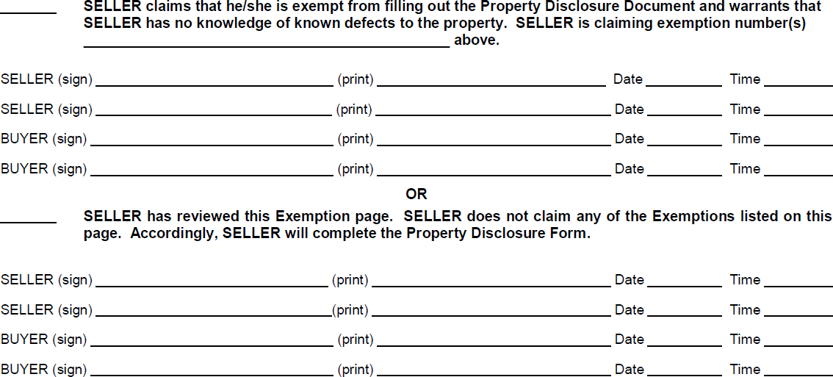

The LREC updated the PD Form in part as a response to a decision by the Louisiana Supreme Court in a case which highlighted possible ambiguities inherent in the PD Form. Specifically, there was a case which examined the choice between "no" or "no knowledge." That case was called Valobra v. Nelson, 14-0164 (La. 04/11/14), 136 So. 3d 793. The revised PD Form eliminates the choice of "no" and limits the Seller's possible selections to "yes" or "no knowledge." It is important to note that Seller is required to complete the PD Form "to the best of the seller's knowledge." But, this does not answer the question of whether or not certain knowledge should be imputed to Seller. In other words, should Seller be responsible for what they should know and not merely what they actually know?
Other additional new sections on the PD Form pertain to federal grants and loans. If a Seller has been the recipient of a federal grant, the requirements regarding these grants may affect a potential Buyer. For example, if a Seller has received federal dollars the Property may be subject to the "obtain and maintain" flood insurance requirement. Sellers should take care to correctly complete this

section to include the amount of the grant received. A complete example of this information is provided in the following box:

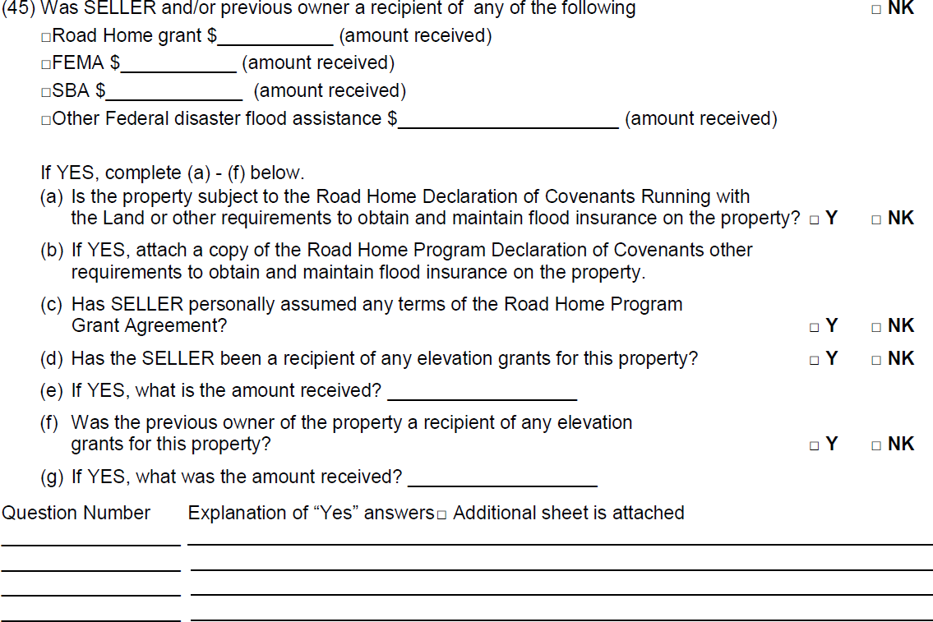

The Code of Ethics of the National Association of Realtors governs real estate firms and agents who are members. This Code calls for disclosure of all known pertinent facts about the property. For example, if the Buyer has spotted water damage on the ceiling, a Licensee should ask the Seller about it and tell the Buyer about the cause of the problem.
The Louisiana License Law states in §1455, number 27 as one of the 36 ways to lose your license that:
(27) Failure to disclose to a buyer a known material defect regarding the condition of real estate of which a broker, salesperson, or timeshare interest salesperson has knowledge.

Buyer Agency Agreement
See Exhibit 3.b.
A Buyer Agency Agreement is an agreement between a Licensee and a prospective Buyer. The Buyer will contract with the Licensee for the Licensee to seek to find Property for Buyer to buy. The Licensee must have a written agreement with the Buyer and must inform the Seller that he or she is representing the Buyer. The fee or commission may be paid by either the Buyer or the Seller, but should be spelled out explicitly in the Buyer Agency Agreement.
There are three basic types of Buyer Agency Agreements:
1. Exclusive Buyer Agency Agreement: The Buyer engages a single Licensee to search for a suitable property, and the Licensee is entitled to compensation no matter who finds the property, including the Buyer.
2. Exclusive-agency Buyer Agency Agreement: The Buyer engages the Licensee to search for a suitable property and that Licensee is entitled to compensation if anyone other than the Buyer finds a suitable property.
3. Open Buyer Agency Agreement: This agreement is nonexclusive and allows the Buyer to employ an unlimited number of brokers. The Buyer compensates only the Broker who actually locates the property purchased.
Attached as Exhibit 3.b., is a sample Buyer Agency Agreement. This is an Exclusive Buyer Agency Agreement. The form includes a blank for compensation to the Buyer’s Broker. The time to pull out this agreement is during a Licensee’s initial meeting with a potential Buyer. The form includes a term provision. However, there is an allowance for the Licensee to earn a commission subsequent to the term if the Licensee was procuring cause.

Condominium Agreement
See attached exhibit 3.c.
The purchase of a condominium constitutes a purchase in a common-interest community. A common interest community is real estate in which ownership of individual portions of the property carries an obligation to pay money to another person, usually an association, for maintenance, taxes, upkeep and insurance of property other than the individually-owned portion of the property.

In most common-interest communities involving residences, there is a homeowners' association charged with providing common services and maintaining the common areas. The homeowner's association may also have jurisdiction over use and occupancy within the individual units. Almost all common interest communities are described in a "declaration," "master deed," or "declaration of covenants, conditions, and restrictions" found in the land records.
A condominium is a common-interest community in which individual units are separately owned but the owners share an interest in common areas, for example, hallways, roofs, and exteriors. A condominium owner has title to his or her unit. For the purposes of income tax laws and other laws regarding real estate, a condominium is treated as a single-family home. But an association has the right to impose maintenance fees, demand escrow payments for large repair bills, and manage the overall operation of the entire building.

Condominiums vs. Townhomes
The Louisiana Condominium Act sets forth numerous provisions affecting the acquisition, ownership, alienation, and management of property which forms part of a condominium. Louisiana has no specific law on townhouses. It is widely understood that the owner of a unit in a townhouse project owns the land under the structure, while in a condominium the land is a common element and the owner only owns an undivided interest, however, this is not the law in Louisiana. Ownership can only be determined by referring to the condominium declaration establishing the condominium regime. Some declarations make all land a common element, and some grant sole ownership to the unit owners.
LREC has determined that Buyers of common interest property must be made aware of the associated documents that they may be required to abide by. Therefore, this addendum is attached when the subject property is a condominium and requires that the Seller disclose all fees, declarations, restrictions, covenants, etc. to which Buyer may be subject.

Contingency Agreement
See attached exhibit 3.d.
As we discussed above, a contingency is a stipulation that is added to a contract that will allow a party the right to terminate the contract without recourse under certain circumstances. Contingencies are favorable to the Buyer, but by no means do they ensure that Buyer will obtain the Property. As articulated in the body of the attached Contingency Addendum to Agreement to Buy or Sell, if Seller received an acceptable offer, Seller must notify Buyer and allow Buyer a period of time to remove the contingency.
The Contingency addendum is usually a contingency that allows a current homeowner to sell his existing home and is utilized by homeowners seeking to upgrade their existing home. However, a contingency could be any condition including but not limited to, Buyer’s receiving a settlement, job, finalized divorce, etc.
The contingency stipulates that the Buyer has the right to terminate the contract if he or she cannot meet the condition prior to closing. The contingency should articulate a time period for which the contract is in effect, which would give the Buyer that amount of time to sell his or her other property. As discussed above, the fewer contingencies used in your offer, the more attractive your offer will be to the Seller.

Flood Insurance Purchase Requirement Addendum
See attached Exhibit 3.e.
The failure to provide the Flood Insurance Purchase Requirement Addendum could be a very costly error. The reason that this could be costly is that the Seller could be required to reimburse the Federal government for any federal assistance dollars received by Seller.

When does a Licensee have to provide the addendum?

The Flood Insurance Purchase Requirement Addendum should be made a part of the Purchase Agreement if:

The Seller received Federal disaster assistance from FEMA, SBA or HUD and
the Property is in a Special Flood Hazard Area.

There is a duty to notify the Buyer of the “obtain and maintain” requirement in writing on or before the date the Property is transferred. The notification requirement applies to personal, as well as residential property. The notification should appear in the document transferring ownership as well as the Purchase Agreement.

Seller may be required to reimburse the Federal government for the amount of the assistance previously received by the Seller If the following events occur:
(1) Seller fails to provide this notice and the Buyer does not obtain and maintain flood insurance as required;
(2) Property is damaged by a flood disaster; and
(3) Federal disaster assistance is provided to repair, replace, or restore the damage.

Note that failure to “obtain and maintain” flood insurance also results in ineligibility for future disaster assistance for flood-damaged items.

New Construction Addendum
See attached Exhibit 3.f.
A Buyer purchasing a new home from a builder may or may not work through a Licensee. But, if you are a Licensee representing a Buyer or a Seller on a transaction involving new construction the New Construction Addendum should be attached to the Purchase Agreement.
A Buyer should be encouraged to consider having the finished structure inspected even though it is bright and shiny and new. A Buyer should be reminded that newness does not necessarily signify quality of construction. An independent inspection can give a Buyer reassurance in this area. This idea is allowed for in the New Construction Addendum.

If a Buyer is contracting with a builder on a home that is not built or finished, a Licensee will want to help a Buyer to ensure that they are getting what they think they are getting. For example, model homes typically include options, rather than standard features. The model home may have expensive light fixtures and crown molding or better-quality kitchen cabinets and appliances. Whether or not the upgrades are part of the purchase price should be noted in the Purchase Agreement or the New Construction Addendum.
The builder should provide a complete list of standard and optional features. The Purchase Agreement should include a specific list of all options. A Licensee should also delve into conveyance of the builder’s warranty. If possible, you will want a warranty that is insured by an insurance company, rather than a warranty guaranteed only by the builder.
Finally, the builder should provide you with evidence that his or her subcontractor’s and material suppliers have waived any liens they might have against the property in the event the builder does not pay them for their work. Specified dates for completion and occupancy should be included if the home is not yet built. You can provide for a penalty or for the right to cancel the contract if the builder exceeds these dates. www.americanbar.org

Case: In Richard v. Alleman, the plaintiffs alleged they made verbal demands on the defendant builder to remedy problems with construction, followed by demands sent vial certified mail, all of which went unanswered. The judge made a determination that the builder came to the property but refused to fix the problems.
According to La. R.S. 9:3145, the buyer must give the builder written notice, by registered or certified mail, within one year of knowledge of the defect, advising the builder of all defects and giving the builder an opportunity to repair the defects. The appellate court found that plaintiff’s failure to list all of the defects in their letter was not a bar to recovery.*

Notice of Ministerial Acts
See attached Exhibit 3.g.
The Notice of Ministerial Acts, attached hereto as Exhibit 3.g., is to be used when a Licensee is not representing a Buyer or Seller. In the spirit of protecting the consumer, this form must be proffered to give notice to a consumer when a Licensee is not representing a particular Buyer or Seller. For example, if an interested Buyer approaches a Licensee at an open house the Licensee will provide the Notice when the conversation becomes substantive.

"Ministerial acts" are those acts that a Licensee may perform for a person they are not representing and that are informative in nature. Examples of these acts include but are not limited to:

(a) Responding to phone inquiries by persons as to the availability and pricing of brokerage services.
(b) Responding to phone inquiries from a person concerning the price or location of property.
(c) Conducting an open house and responding to questions about the property from a person.
(d) Setting an appointment to view property.

(e) Responding to questions from persons walking into a licensee's office concerning brokerage services offered or particular properties.
(f) Accompanying an appraiser, inspector, contractor, or similar third party on a visit to a property.
(g) Describing a property or the property's condition in response to a person's inquiry.
(h) Completing business or factual information for a person represented by another Licensee on an offer or contract to purchase.
(i) Showing a person through a property being sold by an owner on his or her own behalf.
(j) Referral to another Broker or service provider.
LREC receives numerous inquiries regarding the activities of secretaries and assistants. The following information is based on the most frequently asked questions. It is not all inclusive, and it is not intended to replace the advice of competent legal counsel.

Unlicensed secretaries and assistants can:
1. Answer the phone and forward calls to licensee

2. Submit listings and changes to a multiple listing service

3. Follow up on loan commitments after a contract has been negotiated

4. Place signs on listed property

5. Order items of routine repair as directed by licensee

6. Prepare flyers and promotional information for approval by Licensee and supervising broker

7. Type contract forms as directed by Licensee and supervising broker

8. Act as courier service to deliver documents, pick up keys, etc.

9. Schedule appointments for Licensee to show listed property

10. Secure public information documents from courthouse, sewer district, water district, etc.

11. Have keys made for company listings

12. Write ads as directed by Licensee and supervising Broker and place advertising (promotional information, newspaper ads, etc.)

Unlicensed secretaries and assistants can NOT:

1. Host an open house

2. Prepare promotional material or ads without the review and approval of Licensee and supervising broker

3. Show property listed for sale

4. Answer any questions on listing

5. Discuss or explain a contract, listing, or other real estate document with anyone outside the firm

6. Be paid on the basis of real estate activity, such as a percentage of commission, or any amount based on listings, sales, etc.

7. Negotiate or agree to any commission, commission split, management fee or referral fee on behalf of a licensee
Any time a Licensee is providing services for a Buyer or Seller that they are not representing the attached addendum should be used.

One Time Listing with Representation
See attached Exhibit 3.h.
The form attached hereto as Exhibit 3.h. is an employment contract. In other words, it is a contract in which the Seller agrees to pay a commission to the Broker and in exchange Broker agrees to attempt to find someone to purchase owner’s property upon the Seller’s terms. The agreement typically contains the amount of the commission, the term of the contract and the terms of the sale.
Example: When you are representing a Buyer, who is purchasing a For Sale by Owner or new construction from a builder, you would present this form to the FSBO Seller or the builder at which point you would become a dual agent.

One Time Showing without Seller Representation
See attached Exhibit 3.i.
In contrast to the one-time listing, if you are NOT acting as a dual agent and you show a FSBO Property to your Buyer, you would present the Seller with the form attached hereto as Exhibit 3.i. When a Licensee is conducting a one-time showing without representation, in addition to this form, the Licensee must provide the Notice of Ministerial Acts.

Right of First Refusal
See attached Exhibit 3.j.

A Seller may agree that he or she will not sell a Property without first offering it to a certain Buyer. The right given to the Buyer in that case is called a right of first refusal.

The right of first refusal may be enforced by specific performance. Acts 1993, No.
841, §1, eff. Jan. 1, 1995

In other words, the Seller cannot sell the Property unless and until the Seller has offered the Property to the party who holds the right. From a Licensee’s perspective, the Right of First Refusal Addendum is not unlike the Contingency Addendum. However, the Right of First Refusal goes one step further and requires the Seller to allow the Buyer to remove the contingency if and when Seller receives an offer on the Property.

The Right of First Refusal Addendum allows the Buyer an agreed upon amount of time to match the offer received by Seller. This can be a powerful tool for a Buyer and should be used if the Buyer is emotionally invested in a certain Property.
The Civil Code leaves many areas unanswered, so it is important that parties cover these in the Right of First Refusal Addendum. The Right of First Refusal becomes operative only if the Seller has an offer he deems “good” and wants to accept. Usually, the Buyer who holds the Right of First Refusal must exactly match all terms of the offer the Seller wishes to accept.

Option vs. Right of First Refusal

An option contract is an agreement between a buyer and seller that gives the purchaser of the option the right to buy or sell a particular asset at a later date at an agreed upon price.
A Right of First Refusal is a contractual right that gives its holder the option to enter a business transaction with the owner of something, according to specified terms, before the owner is entitled to enter into that transaction with a third party.
In the case of an Option, the grantor must give the grantee a stipulated time to accept or reject an offer. On the other hand, the grantor of a Right of First Refusal only has to give the grantee the offer before giving it to another party or before accepting an offer from another party.
Options and Rights of First Refusal may not be granted for a term longer than ten (10) years, unless the right is granted “in connection with a contract that gives rise

to obligations of continuous or periodic performance” (e.g., lease) in which case the Option or Right of First Refusal may be granted for as long a period as required for the performance of the obligations (e.g., a lease with an option provides for a twenty-year term the right to the option lasts for twenty (20) years because the lease term is 20 years). LA CC 2628 If a longer time is stipulated in the contract, then it is reduced to ten years.

8. MyLREC Portal
Review of MyLREC Portal Features

How to Access Your MyPortal
1. Visit the LREC website at LREC.gov
2. Click on the “Current Licensees” tab at the top of the screen 3. Choose your license type from the sidebar. Options are:
a. Active Salesperson/Broker
b. Broker Company
c. Inactive Salesperson/Broker
d. Reciprocal
e. School
f. Vendor
g. Pre-licensing Instructor
h. Timeshare
**Note that after selecting your license type the following screen will have a number of options:
a. User ID and Password Lookup
b. MyLREC Portal
c. Post-licensing Education Requirements
d. Continuing Education Requirements
e. License Information/Maintenance
f. Termination/Transfer of Sponsorship
g. Transfer to Inactive Status
h. Errors and Omissions Insurance
These links provide you with important information for licensees and enable you to accomplish many activities online.**
4. Log in to the MyLREC Portal
How to retrieve your User ID and Password
Note – Because the user ID and password require a birthdate this feature will not work for a company lookup. Have the qualifying broker of the company license contact the LREC via email for this information.
Checking and Forwarding your MyLREC Email
Every licensee has an LREC email account through which the LREC communicates information to the licensee. Your MyLREC email can be forwarded to your personal or other email accounts. It is important to access your email account as renewal information, Boundary Lines newsletters, and other important information is sent to licensees via this email account.
Before accessing your MyLREC email account you will need your user id and password. If you do not know your user id and password you can find it by using the User ID and Password Lookup in the appropriate licensee section under the Current Licensees tab. You will need your license number, date of birth and zip code to do the lookup. If you do not know your license number you can find it by clicking on the appropriate link under “Licensee Search” on the LREC home screen.
Once you are logged in to your MyLREC Portal, choose “MyLREC Email”
In your e-mail, click on “Options” in the sidebar and choose “Auto Forward” from the menu of Options.
Type one or more email addresses you would like your LREC e-mails forwarded to in to the “Forward address” box and click “Save.” Be sure to leave the “After forward, save a copy to local mailbox” box checked.
Please visit the MyLREC Portal and explore the possibilities.

Case Studies

Richard v. Alleman, 2011-1770; La. App. 1 Cir (5/2/12)

Plaintiffs filed suit on May 19, 2003, seeking to recover damages for breach of contract and the warranties contained in the Louisiana New Home Warranty Act (LNHWA). Plaintiffs alleged in early 2002, plaintiffs contacted defendant builder about building their new home; plaintiffs entered into a contract for defendant builder to construct the home pursuant to a turn-key package; and there were problems from the beginning of the construction due to defendant builder’s use of substandard building materials or substandard methods in construction. Plaintiffs alleged they made verbal demands on the defendant builder to remedy the problems, followed by demands sent via certified mail, all of which went unanswered.

Defendant builder acknowledged receipt of the demands by plaintiffs, but defendant builder alleged plaintiffs failed to comply with La. R.S. 9:3145. According to defendant builder:

1. Plaintiffs failed to list in their letter all problems to be remedied by defendant builder; and
2. When defendant builder made efforts to remedy the problems listed in plaintiff’s letter, plaintiffs ordered defendant builder off their property.

Since plaintiffs did not list all of the defects in their demand letter and since defendant builder was not given an opportunity to fix the problems, defendant builder contended he should not be liable.

A bench trial was held. During trial there was a factual dispute concerning whether defendant builder was given an opportunity to remedy the problems alleged by plaintiffs. Defendant builder alleged he came to the home to fix the problems, but plaintiffs ordered him off the property. Plaintiffs denied this

allegation and testified builder came to the home, but advised plaintiffs he would not fix the problems.

The Judge weighed the credibility of the parties and found the plaintiffs testimony more credible. Accordingly, the Trial Court made a factual determination that defendant builder came to the property, but refused to fix the problems.

Defendant appealed. According to La. R.S. 9:3145, the buyer must give the builder written notice, by registered or certified mail, within one year of knowledge of the defect, advising the builder of all defects and giving the builder an opportunity to repair the defects.

The appellate court held that the trial court made a factual determination that the plaintiffs had complied with the notice provisions that would not be disturbed on appeal. The appellate court accepted plaintiff’s testimony that plaintiffs made verbal demands on the defendant to remedy the issues, followed by demands sent via certified mail, all of which went unanswered.

Additionally, the appellate court found that plaintiffs’ failure to list all of the defects in their letter was not a bar to recovery. According to the Court, defendant builder failed to perform any of the requested repairs, whether outlined in the letter or not. Since the defendant builder failed to make any repairs, it is assumed that the defendant builder would not have repaired any additional defects. The trial court’s ruling was affirmed.

H.L. "Rye" Tuten, III Tuten Title & Escrow, LLC
A Full-Service Real Estate Closing Company 326 Settlers Trace
Suite 101 A /Lafayette, LA 70508
Phone: 337-524-1703
www.TutenTitle.com www.facebook.com/Tutentitle

Myers v. Kayhoe: Buyers Satisfy Purchase Contract Condition with One Loan Application
March 1, 2006
Maryland’s highest court has considered whether buyers could fulfill a purchase contract’s financing contingency by submitting only one loan application, which was then rejected by the lender.
On April 12, 2002, Steven Myers and Linda Barrett (“Buyers”) entered into a contract to purchase the home of Douglas and Ruth Ann Kayhoe (“Sellers”). The purchase contract contained a provision stating that the contract was contingent upon the Buyers obtaining a 30-year loan for $245,000 at a 7% interest rate (“Financing Contingency”). The contract further provided that the Buyers “agree to make written application for the financing…within five (5) days from the date of Contract Acceptance,” and went on to state that the purchase contract would be null and void if the Buyers failed to obtain financing within thirty days from contract acceptance. The Buyers also made a Deposit at the time of contract of acceptance. The purchase agreement stated that the prevailing party in any litigation could recover their attorney’s fees from the losing party.
Due to some problems the Buyers had selling their existing home, the parties delayed the effective date of the purchase contract until June 6, 2002, at which time they signed an addendum stating that the April 12th agreement was re- enacted with all of its provisions in force. The Buyers then applied for financing from NovaStar Financial (“Bank”). The Bank rejected the application because the appraisal overstated the value of the property. The Buyers did not apply for another loan even though they received offers to help them arrange alternative financing, and they canceled the purchase contract pursuant to the Financing Contingency. The Sellers retained the Buyers’ Deposit following cancellation.
The Sellers later sold their residence for a price lower than the Buyers had agreed to pay for the property. The Sellers sued the Buyers for breach of contract, and the Buyers counterclaimed for their Deposit. The trial court ruled in favor of the Buyers, but denied them recovery of their attorney’s fees. Both parties appealed the trial

court’s rulings, and the state’s highest court decided to accept the case before the intermediate appellate could rule in this case.
The Court of Appeals of Maryland affirmed the trial court’s award to the Buyers, but reversed the trial court’s denial of attorney’s fees to the Buyers. The court first considered the Sellers’ argument that the Buyers had a duty to make a good faith effort to obtain financing and that only making one loan application failed to satisfy this duty. The Sellers had based this argument on cases where courts had imposed such a duty upon buyers.
The court declined to impose such an obligation upon the Buyers here, as the language of the purchase contract only required the Buyers to submit one loan application. The Financing Contingency’s language (“agree to make written application”) is singular and so the court found that it only required the Buyers to make one loan application. Contract law principles also required the Buyers to make a bona fide, reasonable, and prompt application to obtain the financing specified in the Financing Contingency, but there was no evidence to suggest that the Buyers had not made complied with this requirement. Since the express terms of the purchase contract and contract law established that the Buyers only needed to make one good faith loan application, the court ruled that the Buyers had meet their contractual obligation and so affirmed the trial court’s award of the Deposit to the Buyers.
Next, the court considered whether the Buyers had waived the Financing Contingency. The Sellers’ real estate professional testified that the Buyers had told her that the “loan’s in place” prior to their terminating the purchase agreement. Based on that testimony, the Sellers argued that the Buyers had waived the Financing Contingency. In order to claim a waiver, a party must show an express agreement between the parties to waive a contractual provision by the party for whom the contractual provision was designed to benefit. In this case, there was no evidence that the Sellers’ real estate professional ever told the Sellers what the Buyers had allegedly told her, let alone an express agreement between the parties. Therefore, the court rejected this argument.

Finally, the court considered the denial of the attorney’s fees to the Buyers. The trial court had ruled that the terms of the original purchase agreement didn’t apply, as the second agreement on June 6th had replaced the original agreement. The court rejected this, finding that the June 6th addendum had incorporated the original terms of the agreement. Therefore, the court ruled that the Buyers were entitled to recover reasonable attorney’s fees and so the case was sent back to the trial court for further proceedings on the amount of attorney’s fees the Buyers could recover.
Myers v. Kayhoe, No. 35 Sept. Term 2005, 2006 WL 300447 (Md. Feb. 9, 2006). [This is a citation to a Westlaw document. Westlaw is a subscription, online legal research service. If an official reporter citation should become available for this case, the citation will be updated to reflect this information].

Gaskill v. Jennette Enter., Inc.: Jury Will Decide If Seller Can Cancel Purchase Contract for Buyer's Failure to Obtain Financing Prior to Closing
December 1, 2001
The North Carolina Court of Appeals has recently considered whether a seller could cancel a sales contract containing language that time was of the essence when a buyer had failed to obtain financing by the time established in the purchase agreement.
Eliot Tod Gaskill ("Buyer") entered into a contract to purchase property from Jennette Enterprises, Inc. ("Seller"). The contract contained a number of provisions, including one that the Buyer was to obtain financing by August 30, 1999 ("Loan Commitment"). Closing was set for September 10, 1999, and the Seller also added the following language to the purchase contract in a section entitled "Other Provisions and Conditions": "[a]ll closing costs to be paid by buyer except for deed preparation to be paid by seller. Time is of the essence!!".
On September 2nd or 3rd, the Buyer informed the Seller that he had not yet obtained financing. At that point, the Seller told the Buyer that the contract was cancelled and the Seller was going to sell the property to another purchaser. The Buyer informed the Seller that he would secure financing by the closing date. On September 10th, the Buyer had allegedly secured financing and informed the Seller that he was ready to proceed with the closing. The Seller took no action regarding the sale of the property. The Buyer then filed a lawsuit, seeking specific performance of the purchase agreement or, alternatively, damages for breach of contract. The trial court ruled in favor of the Seller, and the Buyer appealed.
The North Carolina Court of Appeals reversed the trial court and sent the case back to the trial court for further proceedings. The court first considered the Buyer's argument that the "time is of the essence" clause was an unenforceable provision in the purchase contract. The Buyer based his argument on a couple of North Carolina cases where courts had found that similar language in contracts had no legal effect. The court rejected the Buyer's argument, as the court found

that this language was specifically inserted into the agreement by the Seller and the Buyer had signed the agreement following the insertion of this language.
The court next considered whether the "time is of the essence" language applied only to the closing date or to the entire agreement. Looking at other cases that had considered this issue, the court found that, in a footnote, the Supreme Court of North Carolina had stated that if a loan commitment had to be completed by a certain date prior to the closing, the contract should contain both that date as well as specific language in that clause indicating that "time is of the essence." Another North Carolina court had found that a purchaser who had failed to obtain financing from a specific lending institution (as required in the purchase agreement) was entitled to specific performance because the failure to obtain financing from this particular institution prior to closing was not detrimental to the seller. Looking at these two decisions, the court ruled that the trial court should not have ruled in favor of the Seller. The court ruled that a jury needed to decide whether the "time is of the essence" provision applied to the Loan Commitment date. Therefore, the court sent the case back to the trial court for further proceedings.
Gaskill v. Jennette Enter., Inc., 554 S.E.2d 10 (N.C. Ct. App. 2001)

References:
2009 Louisiana Civil Code
Louisiana Administrative Code LREC.gov www.americanbar.com

